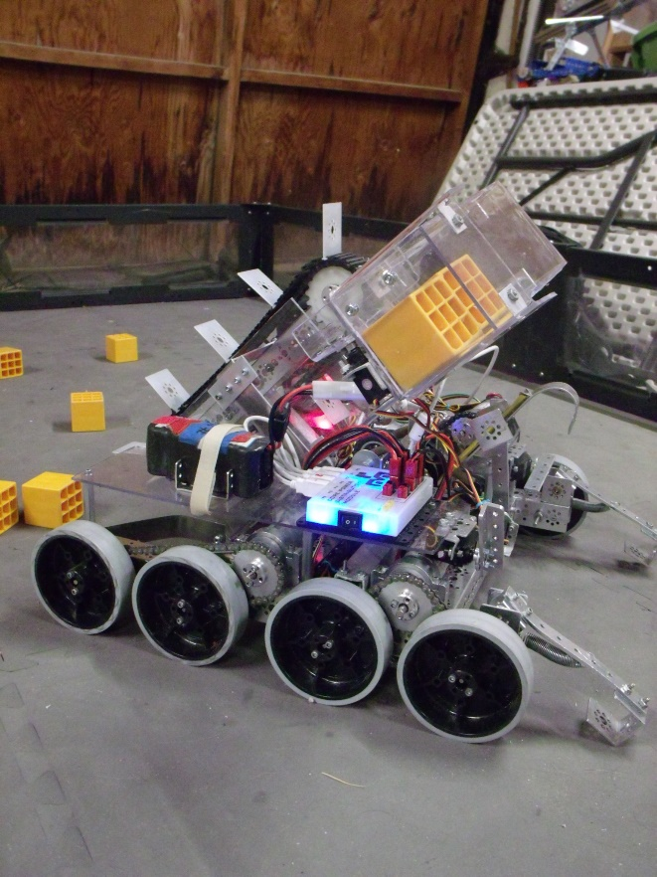

dylan stinson

[Company name]

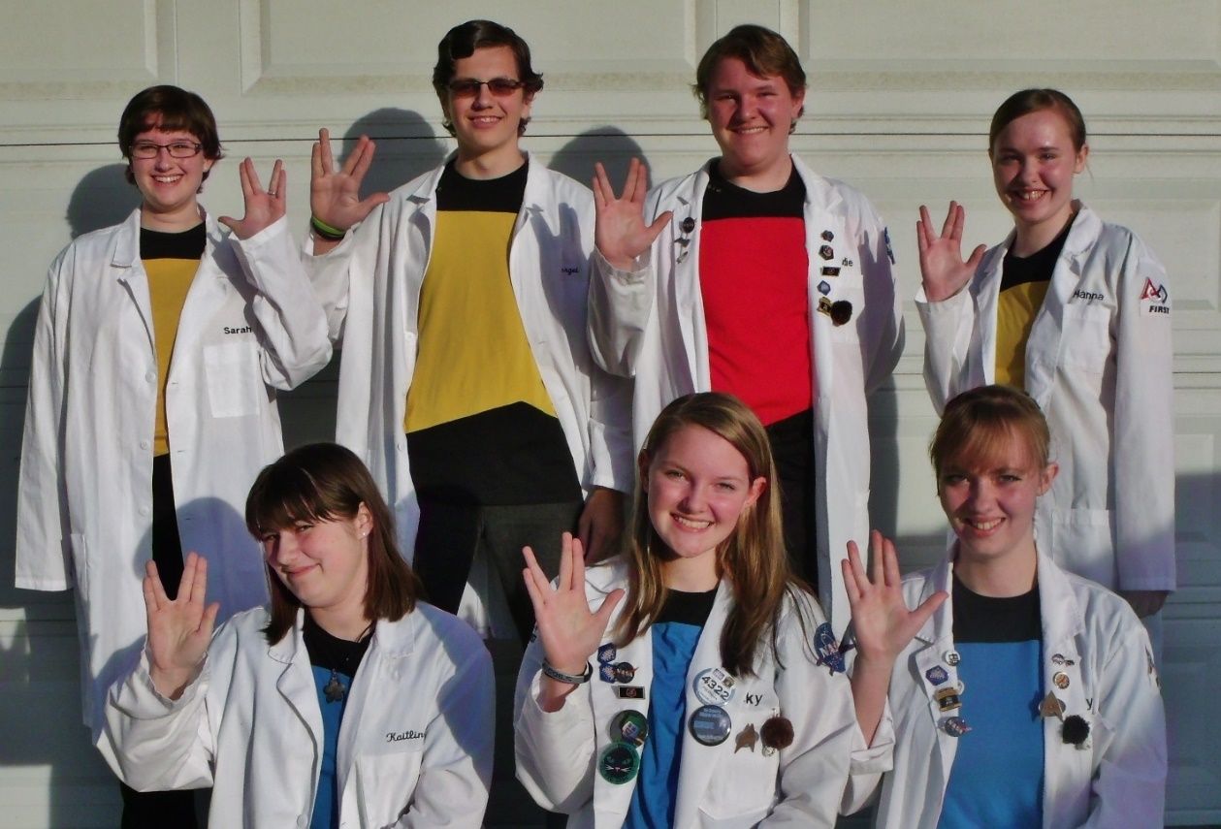

PHI Ω ENGINEERING NOTEBOOK

*Table of Contents*

A Brief Summary of Our Year 5

BIOS 7

MEETING LOG 13

HARDWARE 77

SOFTWARE 99

STRATEGIC / BUSINESS PLAN 106

TEAM ORGANIZATION 117

Appendices 120

Teleop 120

Autonomy 125

# A Brief Summary of Our Year

This has been a big year for Team 4322, PHI Omega. We’ve really had the opportunity to apply our “PHI” (Power through Higher Innovation) in every aspect of the team this year. The end of last year started the new season off with a bang! As we returned from the Western Super-regional Competition in Oakland, CA, last spring, FIRST announced that all of the software programs we have been using as a team for years, were going to be changing! Soon after, we said goodbye to two valued seniors, our hardware lead, and PHI member of four years, and our software lead, and PHI member of two years.

We gave ourselves a few weeks of rest and then as soon as summer hit, it was outreach time! We did several different outreach events throughout the course of the summer, where we were able to reach out to everyone in our community from young kids to grandparents! Then we began the important task of fundraising. We wrote up a sponsorship letter, we set up events through local businesses, and we even had a large donation given to us from a friend who took a great interest and admiration to what we were doing as a team!

Then the official robotics season began! We started up with our annual Kick-Off meeting where we were joined by our sister-team 452 PHI Alpha. We began pulling together the work and ideas we came up with over the summer so that we could apply them to this year’s game. We welcomed one new team member, and began official documentation of our progress with the hardware and software parts of the team, through the Engineering Notebook. Hardware took off with brainstorming, and lots of discussion among team members. Software was started from scratch, but we had several very willing team-members who put effort into it from the get-go!

Soon, we had a robot chassis, working mechanisms, and lots of power-tools working away! We had people focusing on their laptops while they worked through mathematical formulas that would be converted into working autonomies, we had a regularly updated meeting log, we had members learning to drive our robot, and we were able to help other local teams by sharing what we had accomplished in software so far!

This year has been as challenging for us as any other year, maybe even more-so since we’ve had such large changes in some aspects of it, but as we set our focus to treating each other better, and centering around our God who gave us everything we have in our garage, it’s safe to say, that wherever the competition takes us, we can be content.

# BIOS





*Name:* Eddie Pierce

*Grade:* 12

*Years on team:* 4

*Favorite Job on the Team:* Hardware design and construction

*Hobbies:* Writing books, gaming, pencil sketching, researching.

*Random Fun Fact:* While not widely known, there is actually a trinity of nerd-dom. Star Trek and Star Wars are the major two, but there is a little known third: Stargate…

*Name:* Kaitlin Cox

*Grade:* 12

*Years on team:* 4

*Favorite Job on the Team:* Driving, software, and notebook

*Hobbies:* Creative writing (mostly fanfiction), art (pencil and digital), CGI effects and 3d animation, game design, obsessing over fandoms, taking personality quizzes, and a whole load of other things that would take forever to mention.

*Random Fun Fact:* Keraunomania is a term describing an abnormal attraction to lightning. Better hope the lightning doesn’t have the same level of attraction to you.

*Name:* Holly Creech

*Grade:* 12

*Years on team:* 2

*Favorite Job on the Team:* Outreach

*Hobbies:* Writing, playing and teaching piano, and making sure everybody else has their bios together ;)

*Random Fun Fact:* Disney Imagineers watched every episode of the Twilight Zone at least twice while creating Tower of Terror for their amusement parks.





*Name:* Sarah Hooker

*Grade:* 12

*Years on team:* 1

*Favorite Job on the Team:* Software

*Hobbies:* Playing my musical instruments, arranging my own music pieces, drawing, reading, and obsessing over fandoms.

*Random Fun Fact:* The Mantis Shrimp can see 16 different colors (humans can only see 3), and they practice ritualized fighting.

*Name:* Becky Pierce

*Grade:* 9

*Years on team:* 2

*Favorite Job on the Team:* Programming

*Hobbies:* Playing volleyball and softball, and watching Supernatural all day.

*Random Fun Fact:* The exact middle of Disneyland is a brass dot underneath Sleeping Beauty’s castle.

*Name:* Hanna Creech

*Grade:* 10

*Years on team:* 2

*Favorite Job on the Team:* Hardware

*Hobbies:* Arranging and playing piano, drawing, photography, sarcasm, and swimming.

*Random Fun Fact:* In England, dying on royal property is punishable by death*.*

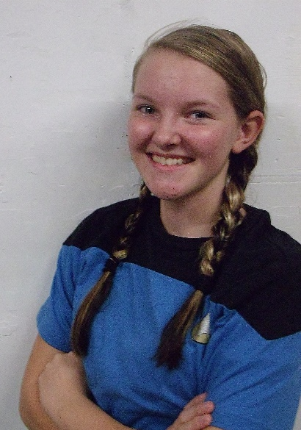



*Name:* Sergei Cox

*Grade:* 8

*Years on team:* 2

*Favorite Job on the Team:* Hardware

*Hobbies:* Robotics, softball, not coming up with hobbies, paintball, and listening to Radioactive.

*Random Fun Fact:* Two plus two equals twenty-one, and waffles are not plaid pancakes.

***The Mentors***



Tim Cox is an engineer in the controls and dynamics branch at the NASA Armstrong Flight Research Center. This is his second year mentoring an FTC team but he has mentored an FLL team in previous years. He enjoys teaching the engineering process and especially spending time with his son and daughter who are on the team.

Quinten Pierce is a software engineer for Spirent Communications.  Both of his children, Eddie and Becky, are involved in the PHI Omega team.  This is Mr. Pierce's second year mentoring an FTC team, although he mentored an FLL team for 3 years, building that team up from scratch.

# MEETING LOG

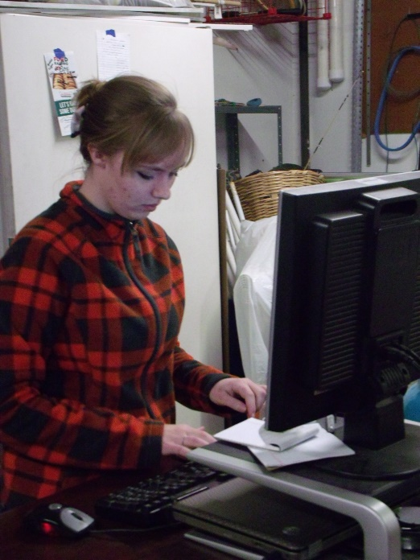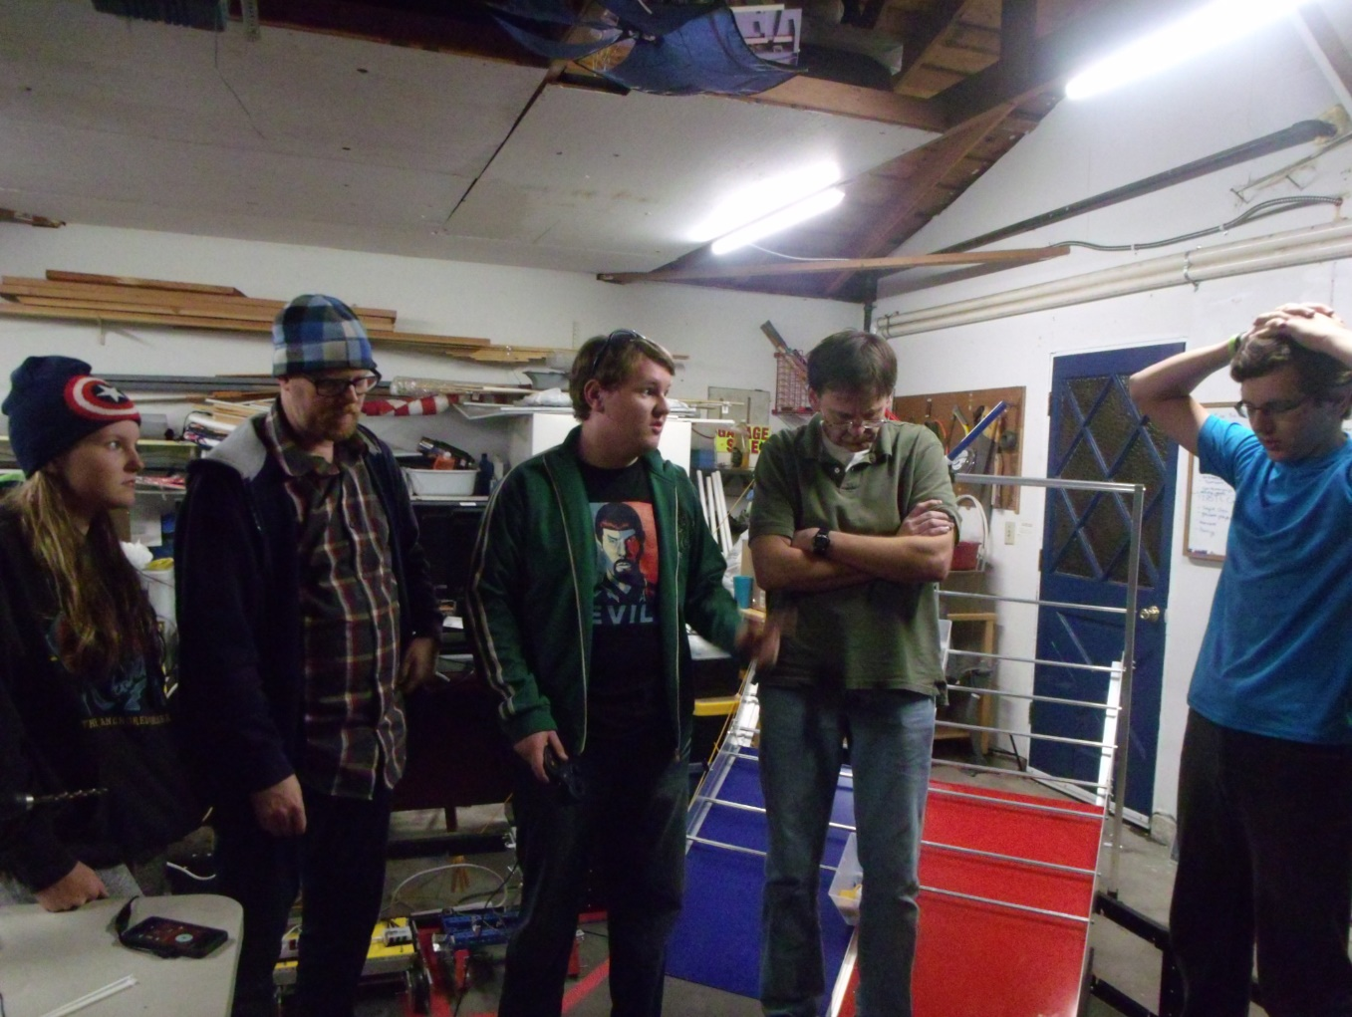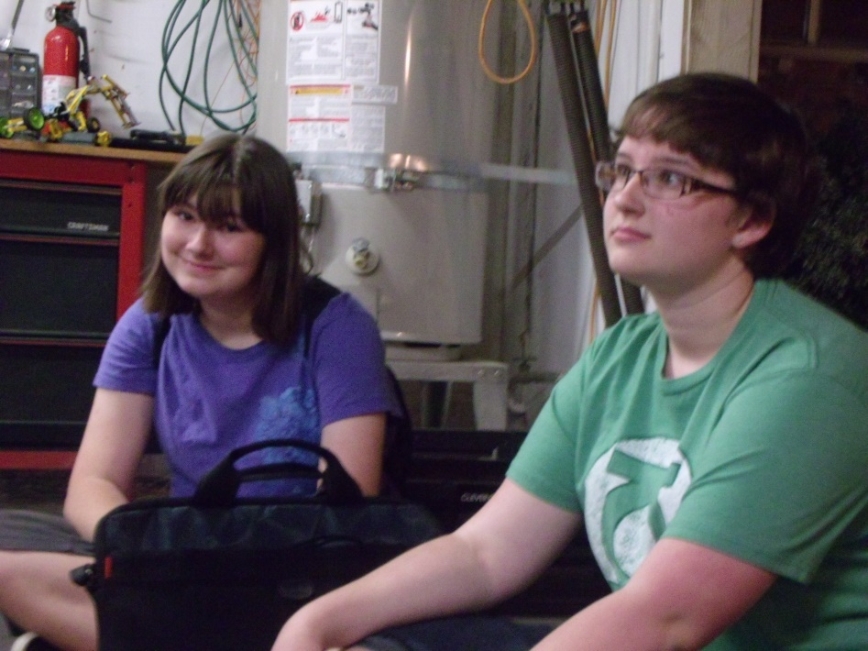

|  |
| --- |
| *STARDATE*: *6/15/15*  *Author Name*: Holly  *Attendance*: Sergei, Kaitlin, Holly, Hanna  *Goals*:  Tonight was our first official meeting of the year. Last week was spent moving all our stuff from one garage to a new location. Again, we are meeting in a garage, but we are making an effort to be more organized this time. Over the week, we went through every box, and organized all of our parts and papers. Our main goal for tonight was to setup for Vex Summer Workshop, which is one of our favorite ways to reach out to our community.  *Accomplishments***:**  Tonight we were able to show the garage’s new layout, and make some rules for keeping it permanently organized. We played around with the team’s new phone a bit, and got to spend some quality time with our fellow teammates. (Yes, “quality time” included putting certain senior members in the pool!) |

|  |
| --- |
| *STARDATE*: *6/29/15*  *Author Name*: Eddie  *Attendance*: Holly, Hanna, Eddie, Becky, Sergei  *Goals*:  -Continue work on the new chassis  -Discuss who is attending Thursday Night on the Square, as well as where and when, it is  -Practice crimping new power-pole connectors  -Discuss improved notebook format  -Organize loose metal parts  *Accomplishments***:**  Tonight we started off our meeting in our usual manner of discussing new information before starting any work. We started out by talking about Thursday Night on the Square, bringing up details about who is going, where it is, what time it takes place, etc. Along with this, we discussed a new notebook format, displayed in a small amount in these first entries. The later entries after the season starts will show the format much better. The opening of the meeting was ended by our hardware lead showing off the new prototype parts for the robot. After our meeting opening, a few of the team members organized our metal parts we moved, putting them into a rolling tool chest a team member donated. While this was happening, another couple team members and a mentor were experimenting with how to attach the new power-pole connectors to batteries for the new electronics system. We decided to end the meeting a little early and closed with a debriefing. |

|  |
| --- |
| *STARDATE*: *7/6/15*  *Author Name*: Sergei  *Attendance*: Sergei, Kaitlin, Holly, Hanna, Sarah, Becky, Eddie  *Goals*:  -Look into fundraising for the year  -Continue work on the new chassis  -Fit a servo controller  -Consider who might fill each of the certain jobs on the team  -Begin work on K9 robot  *Accomplishments***:**  We continued to work on our prototype for this year’s chassis. We also tried to fix a servo controller the servo controller did not work. When we plugged the NXT cable to that controller and plugged it into another one that made it give power to the motors plugged into it. We also looked at the new chassis that we had NASA cut we found a few things wrong with it that we tried to change in the new pieces. We also all came up with ideas for fundraising. |

|  |
| --- |
| *STARDATE*: *7/13/15*  *Author Name*: Sarah  *Attendance*: -Holly, Hanna, Sarah, Becky, Sergei, Eddie-  *Goals*:  -Finish the K9 robot  -Test the new software and hardware setup.  -Find computer chargers  -Setup fundraisers for the 3D printer  -Finish sponsorship letter  -Finish TNOTS summary  *Accomplishments***:**  We worked on the K9 bot and actually finished as much as we are able to with the parts we currently have. We continued to work on our prototype for this year’s chassis. We worked on the sponsorship letter, and it is now almost finalized. We also got the robot cleaned up after Thursday Night on the Square. |

|  |
| --- |
| *STARDATE*: *7/27/15*  *Author Name*: Holly  *Attendance*: -Becky, Eddie, Holly, Hanna, Sergei, Kayla, Cierra, Luke-  *Goals*:  -Start the 3D printer building process  -Setup new computers for coding, 3D modeling, and Auto Desk Inventor.  -Setup Jethawks fundraiser on August 29  -Look into getting new team uniforms -Look into talking to the Lancaster/ Palmdale Chamber of Commerce about sponsoring us  -Update the brochure    *Accomplishments***:**  Tonight we worked on building our new 3D printer. We setup our new computers so that we could do coding, 3D modeling, and Auto Desk Inventor on it. We set a date for our Jethawks fundraiser. We are going to call them, and see if we can do our fundraiser on August 29th. We also decided to look into talking to the Lancaster/Palmdale Chamber of Commerce as another possible sponsor. We also spent time searching and trying to agree on a new Star trek uniform, because last year the uniforms were too warm to wear at competitions. Lastly, we were able to begin updating the team brochure. |

|  |
| --- |
| *STARDATE*: *8/3/15*  *Author Name*: Hanna  *Attendance*: -Holly, Hanna, Sarah, Sergei, Kaitlin, Eddie, Scott, Tim-  *Goals*:  -Setup fundraisers with Jethawks Stadium, and possibly Lowes, Yankee Candle, Krispy Kreme, Yogurtland, Jersey Mike’s Subs, and/or Sweet Frog  -Setup outreach at the Antelope Valley Fair  -Look at new the programming kit  -Download the FTC app  -Setup wifi for the garage  *Accomplishments*:  We started the meeting by opening in prayer and discussing our goals. Unfortunately, the notebook that was started at the beginning of the summer got accidently deleted. So during the night team members worked on re-writing our lost entries. Later that evening we came up with another idea for our Jethawks “first pitch” arm because our previous arm wasn’t going to work for what we needed it to. We also got to edit an outdated brochure. |

|  |
| --- |
| *STARDATE*: *8/10/15*  *Author Name*: Sergei  *Attendance*: -Holly, Hanna, Sarah, Sergei, Eddie, Becky, Tim, Kaitlin-  *Goals*:  -Setup Jethawks fundraiser  -Complete Brochure, and add pictures. Send completed brochure to team Alpha  -Work on setting the notebook back up  -Discuss parts list  -Talk about the 3D printer  -Set up the router in the garage  *Accomplishments***:**  **F**irst we all talked about the fund raiser and we decided that we would go ahead with it. So we had some members go out and buy them and every team member needs to try to sell them.  After that we started putting our chassis together we had NASA recut the side panels because we found that when we put it together we could not tighten our wheels so we needed to redo it. We put the two side panels with the wheels and they worked. As we kept working we found that the mounting holes of the old motor mounts do not match the mounting holes for the new ones and we drilled the holes for the new ones. We drilled the holes so now the robot can have both kinds of motor mounts.  To test our new system without building a whole robot we connected our system together into a test bench (see figure 1). We connected a motor to this system. We also put some servos on it. We also played around with crimping Anderson Power Pole Connectors because you need some to put the system together.  Once we did all we could that night on the chassis we started working on our phones. We were running into a problem with Android Studio. Android Studio failed to build the FTC app because we were running API 19. Once we changed the version to API 21, the FTC app built successfully. We then found that the phone wasn’t being recognized by the computer. After reloading the driver software for the computer, and re-plugging the phone in a couple of times it seemed to recognize the phone. On one computer we also needed to select ADI interface in the device manager and activate. Finally, we got Android Studio to recognize our phone.  We then were trying to program the phone but we ran into a problem that did not allow us to download the program onto the phone. But after we looked through the manual we found that it was because we were trying to download it to the wrong phone. We were supposed to download it to the robot phone not the driver phone. Once we tried to download it to the right phone it worked and we could spin a motor on our test bench. |

|  |
| --- |
| *STARDATE*: *8/17/15*  *Author Name*: Becky  *Attendance*: -Holly, Hanna, Sergei, Kaitlin, Sarah, Eddie, Cierra, Kayla, Luke-  *Goals*:  -Discuss kickoff  -Discuss fair/fair prep/pick awards  -Vex paper-combine  -Notebook bios  -FLL field trip, discuss  -Team uniforms  -Trading cards  -Complete Jethawks arm  *Accomplishments***:**  First we opened in prayer. Next we put zip-ties on the robot’s wheels to be able to drive on concrete at the fair. After we finished with that, the team started learning some of the new coding.  Tonight for coding, we started working on the trading cards we would be handing out at competition. Also, we programmed the base code for the Jethawks arm. One of our NXTs stopped work, so we tried to fix it. While some were working on that, the rest of us started on the bios. We made the outlines for them tonight, and plan of finishing them next week. |

|  |
| --- |
| *STARDATE*: *8/24/15*  *Author Name*: Sarah  *Attendance*: -Becky, Hanna, Holly, Sarah, Sergei, Eddie-  *Goals*:  -Set up the bugbot  -Make final arrangements for Jethawks  -Sign up for GitHub  *Accomplishments***:**  We made progress on our notebook tonight, finally starting to catch up on the meeting logs. We finished most of our bios, and we hope to finish the rest as soon as possible. Pretty much all we have left on our bios is our pictures. We typed up the Antelope Valley Fair Outreach summaries for this past Friday and Saturday for our notebook as well. We continued to work on making the trading cards, finding pictures suitable for some really fun ones. We got Khan tightened up and ready for Jethawks and the AV Fair for this weekend as well. We’re hoping we’re prepared for everything going on this weekend. We did get the bug-bot set up as well. We finished finalizing some of the code, so it is ready to drive and is working really well. We plan to do more work on it later, but it is ready to show off and play with at the fair at least. We did download GitHub on one of our computers, and we each plan on making our own accounts at home this week. |

|  |
| --- |
| *STARDATE*: *8/30/15*  *Author Name*: Hanna  *Attendance*: -Holly, Hanna, Sarah, Becky, Eddie, Sergei-  *Goals*:  -Fair debrief  -Fair write-up  -Vex Write-up  -Jethawks debrief  -Jethawks write-up  -Kick-off meeting prep.  -Discuss future fundraising  -New chassis prep.  -Improve Engineering Notebook  -Set-up new controller  *Accomplishments***:**  Tonight we opened in prayer. We focused on teaching the new members of the team software and hardware. The team worked on learning the new java programming. We completed a chassis for the purpose of testing our java programming on. Some of the team members completed some more trading card designs (we’re using Star Trek trading cards as a giveaway for this year). Because the new programing system requires a phone being connected to a controller by a cord we prototyped a phone holder. The holder we prototyped is basically just a custom made phone case that is made to be hooked on to an arm. |

|  |
| --- |
| *STARDATE*: *9/14/15*  *Author Name*: Holly  *Attendance*: -Eddie, Becky, Hanna, Sarah, Holly-  *Goals*:  -Kick-off write-up  -Measure garage window for curtain  -Disassemble bot  -Disassemble field elements  -Sort Lego parts  *Accomplishments***:**  Last Saturday, we had out robotics’ season Kick-off meeting. We were introduced to the new game, Res-Q, and began to prepare for future meetings. Tonight we worked to disassemble last year’s field elements. We are getting the new game elements soon, so we had to make room in preparation for them. We got the chassis we have been working on over the last few weeks built, and were able to practice driving it with some of our new programming. We also disassembled our robot from last year, Khan, in order to recycle parts for this year’s robot. We spent a lot of the night continuing our progress in learning the new programming for this year. We also began prototyping new ideas for a chassis and other mechanisms that would suit the game this year. |

|  |
| --- |
| *STARDATE*: *9/17/15*  *Author Name*: Kaitlin  *Attendance*: -Sergei, Kaitlin, Sarah, Hanna, Holly, Becky, Eddie-  *Goals*:  -Prototype  *Accomplishments***:**  Tonight we created a risk-benefit chart and weighed the various options for scoring this year. Based off our top options, we brainstormed ideas for mechanisms that could accomplish our goals. Next broke into groups and sketched concepts for some of these ideas, and then presented these ideas to the other groups and mentors for review. We also discussed the engineering process with some of our mentors and how we can follow it through our prototyping, build, and competition stages this year. |

|  |
| --- |
| *STARDATE*: *9/21/15*  *Author Name*: Sarah  *Attendance*: -Kaitlin, Sarah, Sergei, Holly, Hanna, Becky, Eddie-  *Goals*:  -Prototype  -Progress in learning programming  -Discuss Promote Award Video  -Work on Notebook  -Discuss future fundraising  *Accomplishments***:** Tonight we worked on prototyping some of our ideas. We are beginning to see what will work and what will not. We prototyped a flipping-mechanism and a conveyer belt with Legos, and we worked on an idea for a scoring mechanism with cardboard and metal. We also counted our blocks to see if we had enough to share with our sister team for practicing with the elements in the garage. We also got mostly caught up with Notebook entries. |

|  |
| --- |
| *STARDATE*: *9/24/15*  *Author Name*: Sergei  *Attendance*: -Sarah, Hanna, Holly, Sergei, Kaitlin, Eddie, Becky-  *Goals*:  -Promote Video-“What is our definition of success?”  -Prototype  -Demonstrate Chassis  -Autonomy Concepts, field picture as reference  -Trading Cards  *Accomplishments***:**  We started the meeting with some brain storming about how we could get some of the tasks on the field done. We came up with a few ideas one was to have a robot that would on the bottom have a guide that would guide the debris to a bucket the bucket would have a spinning brush on it that would intake the debris. The bucket would store the debris for the ride then when the robot arrives at it destination the bucket would lift and dump the items. We also came up with one that would have just a bucket that had a spinning brush on it that would take the items in and lift to dump them.  Another thing that we worked on was building a new chassis this chassis is an off shoot of the kraken so it has high ground clearance. We got a lot done on this chassis we also modified it with new metal shopped parts to make it work better. We also worked on chaining another chassis so that it could drive this required a lot of work because of the way it was built. We had to take a lot of it apart so that we could put the chain on. Eventually we got this done. We then tested this chassis and found that one of its motors was not working so we had a job for the next meeting, changing out a motor. |

|  |
| --- |
| *STARDATE*: *9/28/15*  *Author Name*: Holly  *Attendance*: -Holly, Hanna, Sarah, Eddie, Kaitlin, Sergei-  *Goals*:  -Discuss FLL Outreach  -Thank-you letter to private donor  -Kick-off write-up  -Continue prototyping  *Accomplishments***:**  Tonight we took pictures for the notebook bios. We spent a lot of the night working on our prototype chassis’. We are currently working on two. One, is a low-riding chassis. We worked on putting the electronics on it in an organized way so that it could drive by the end of the night. The other chassis is a fifth version of the Kraken chassis. We worked on chaining and gearing the K5 tonight. We also made other prototypes for scoring mechanisms, and ways to get up the mountain with cardboard. One is a series of wheels on each side of the robot to help the robot from falling in between the bars. The other, is an idea to catch the balls and score them into the buckets on the mountain, despite what color we are. We also wrote out a summary of our kick-off meeting. |

|  |
| --- |
| *STARDATE*: *10/1/15*  *Author Name*: Hanna  *Attendance*: -Eddie, Sergei, Holly, Hanna, Kaitlin, Becky-  *Goals*:  -Assemble new field  *Accomplishments***:**  So tonight we assembled our field. First, we thoroughly cleaned the field so that the tape would stick better, and then we taped it. Next we put together our color sensor and tested it multiple times to insure there were no malfunctions. The team put together the base of our mountain, then mounted the stand and foundation. We started putting together the cliff hanger attachment. We tested how many balls and blocks we could fit into one tub. Lastly we thought out some new ideas for our chassis and discussed some more prototypes to try the following week. |

|  |
| --- |
| *STARDATE*: *10/5/15*  *Author Name*: Sarah  *Attendance*: -Sarah, Holly, Hanna, Sergei-  *Goals*:  -Promote video  -Color sensor  -Notebook  -Prototyping  *Accomplishments***:**  It was a dark and stormy night…. Or not. It had rained previously, and it was chilly, but it wasn’t necessarily *stormy* anymore.  We worked on the promote video tonight, drawing maps of how to logically organize our thoughts. We also traded ideas on how we could organize our video and set it up. We also worked on updating the notebook, like finishing up our bios and catching up on notebook entries that we’ve gotten behind on. We also took some of our cardboard prototypes and made metal versions of them so that we can better test them. |

|  |
| --- |
| *STARDATE*: *10/8/15*  *Author Name*: Sarah  *Attendance*: -Sergei, Becky, Eddie, Kaitlin, Sarah-  *Goals*:  -Prototype  -Work on new chassis  -Progress in software  -Work on color sensor  *Accomplishments***:**  Tonight we worked on prototyping more mechanisms for our robot. We have several ideas, and we should be able to fully test several soon. We also worked on our new chassis. We know what we’d like to try now, and we worked on finalizing the design. We also worked with the color sensor programming, seeing what will and will not work. We hope to have a working program for the color sensor soon. It is proving a challenge, but we know it will be overcome in time with patience. |

|  |
| --- |
| *STARDATE*: *10/10/15*  *Author Name*: Sergei  *Attendance*: -Holly, Hanna, Sergei, Eddie-  *Goals*:  -Work on chassis  -Wire robot  *Accomplishments***:**  We decided to call an additional meeting so that we could have more time to work on the robot. We wanted to allow out programmers more time. In previous years, we would run late in our season with hardware so we want ted to speed things up. We started the meeting with working on out new chassis we wanted to add some cross bars to reduce the amount of play in out chassis. The chassis would have some play side to side we did not wantthis to happen so we cut two metal bars and attached them.  After that we worked on wiring our chassis to do this we first had to cut a plastic piece to have a plate that we could mount the electronics to. After we cut this, we attached the motor controllers and wired the drive motors. Then we started working on a new intake system. The intake system is a tread that we have paddles attached to and as the tread spun it would intake the balls and blocks. We first had to make the tread a certain length and then we attached it to a C channel. We then powered this belt and attached it to the chassis at about a 45 degree angle. We then wired this and we put a shield around it so that the items would have something to slide against. We did this out of card board because this is a prototype and we don’t want to waste materials.  Chassis  Intake  Once we finished all this we decided to test it. But before we could test it, we had to write up some code for it. So we used the code from a previous robot and modified it. We then ran this code and when we tried to drive the robot the robot went really slowly. For a while we tried to figure out why and then we found that this was because of the stick shaping that we had. The stick shaping only allowed us to give a little power to the motors causing it to be slow. Once we figured this out we changed it and that allowed us to run full power. Then we drove the robot around and found that it could pick up the blocks and ball easily. The problem that we had though was driving up the ramp the robot would go till about the first churro and then it would slide down. This was because the wheels did not have enough grip on the metal surface. It was the momentum that got the robot that far. So we ended the meeting with this and thought about what we should do. |

|  |
| --- |
| *STARDATE*: *10/12/15*  *Author Name*: Becky  *Attendance*: -Hanna, Sarah, Kaitlin, Holly, Sergei, Eddie, Becky-  *Goals*:  -Sand down wheels  -Add weight to the robot  -Work on lift-mechanism  -Discuss robot name  -Work on color sensor  -Work on gyro turn  -Discuss promote award video  -Write thank-you letter to private donor  *Accomplishments***:**  Tonight we tried sanding down our wheels on the robot to see if it gave more traction up the ramp. It helped some, but the sanding didn’t do enough to the wheels for them to gain enough traction. We also made a prototype of our idea for the lift mechanism to be able to pull our robot up. The mechanism is a three stage arm that has bungee cord attached inside so when we need the mechanism, it can be released with no extra motors needed.  Tonight we also accomplished some things in software. Our software team made some adjustments to our code for our encoders to be able to make autonomies a lot easier. Some of our software people also started working on fixing the errors in our gyro code. We also discovered the exact distance the color sensor can be away from the side buckets. |

|  |
| --- |
| *STARDATE*: *10/15/15*  *Author Name*: Kaitlin  *Attendance*: -Eddie, Holly, Hanna, Kaitlin, Sergei-  *Goals*:  -Code conversions from C to Java  -Finish the intake mount  -Mount the motor controllers  -Develop spring loaded arm design  -Fix the encoder drive program for the bug bot  *Accomplishments***:**  Tonight we began working on converting the old gyro turn, written in C, into Java for use this year. We also finalized the intake mount, as well as placed a plastic mounting plate for the motor controllers on the bottom of the robot. Then, we zip tied down the cables for the drive motors, worked on a spring-loaded arm design for hanging from the pullup bar, and fixed the encoder drive program for the bug bot. |

|  |
| --- |
| *STARDATE*: *10/19/15*  *Author Name*: Hanna  *Attendance*: -Kaitlin, Sarah, Hanna, Holly, Eddie, Becky -  *Goals*:  -Spinners, normal wheels, bottom plate  -Color sensor  -Notebook AV Fair write-up  -Set-up fundraisers with local businesses  *Accomplishments***:**  We opened the meeting by discussing ways we could better work as a team, different ways we could encourage and help each other etc. Week we worked on making a channel for the balls and blocks to go under our tread system. We made the channel by heating a piece of plastic and reforming it to sit at a 90 degree angle. Unfortunately, our channel ended up not work for what we needed it for so we had to cut off half of the angle so that it was a flat sheet of plastic. We hope to use that sheet of plastic for the bottom of the channel and to add sides unto it next week. |

|  |
| --- |
| *STARDATE*: *10/8/15*  *Author Name*: Holly ~Ephesians 4:1-3~  *Attendance*: -Eddie, Holly, Hanna, Sarah, Kaitlin, Sergei-  *Goals*:  -Work on intake/scoring mechanisms  -Work on Gyro turn  -Work on encoder  -Set-up two fundraisers  *Accomplishments***:**  Tonight we continued working on the intake system for our robot. We worked on cutting plastic to make a prototype version of a tunnel that the conveyer belt and plastic flaps can use to pull the whiffle balls into a bucket. We have been pretty successful in pulling the whiffle balls into the mechanisms, but we are still working on the blocks. We also spent time prototyping possible mechanisms that could be used to pull our robot up the ramp. Later in the meeting, we agreed on two dates to aim at for fundraisers. Hopefully, they will be scheduled in the next few days. We got the gyro turn functioning correctly, and the encoders are working well, too. We had the move-function working correctly, too. Overall, it has been one of our most successful meetings so far. |

|  |
| --- |
| *STARDATE*: *10/26/15*  *Author Name*: Sergei ~Romans 12:9-12 ~  *Attendance*: - Hanna, Sergei, Kaitlin, Sarah, Holly, Eddie-  *Goals*:  -Prototype button-pressing mechanism  -Make more space on the robot  -Brainstorm lift-mechanism  -Brainstorm zip-liners mechanism  -De-bug software  -Work on move-function/turn-function  *Accomplishments***:**  Today we mostly were focusing on hardware. We started the meeting with a prayer. After this we started by splitting people into two groups 1 work on intake 2nd worked on prototypes. The second group first worked on prototyping a mechanism for pushing the buttons on the rescue beacon. They came up with a little plastic v that is on a servo so that we could push either button depending which way the servo moves.  Tread belt  Support bar  Old configuration  We had the second group work on the intake the intake id a piece of tread with paddles that will collect the balls. We needed to do a couple things on it 1 move the bar that it is attached to and put it at an angle 2 shorten the belt and 3 make a bottom plate so that the balls/blocks have something that they can roll against.so we started by removing the intake belt off the old support then we shortened the c channel that the tread is attached to it. We did this so that we could get the robot to be shorter. We put the new support bar at a 45 degree angle this also allows us to have the max amount of mounting space. We then attached the support bar to the chassis and the conveyor to the support bar. We then cut a few metal pieces that would attach the bottom plate to the intake. We then cut the metal and attached it with screws. We planned it to spit out the balls on the side at the top.  New configuration  Support bar  Tread belt  We also worked some on the bug bot. we wanted to have some encoders on the robot but we were using Andy marks and one of the encoders did not work and we did not have enough to change it. We then had to find some older tetrix motors and find some encoders for it. We then had some new people to take the Andy marks off and then attach the encoders to the new motors and then attach the motors to the robot. So we had some more experienced people show them how to attach the encoders and the motors. We did this and it worked. Lastly we worked on the gyro turn we had to convert the code from robot c to java. We finally got it transferred and we got all of the bugs out of it. We then could turn the robot and the gyro read numbers. Our next step is to work on getting the gyro accurate. We then ended the meeting with debrief and a word of prayer. |

|  |
| --- |
| *STARDATE*: *10/29/15*  *Author Name*: Sarah ~1 Corinthians 4:6~  *Attendance*: -Sarah, Holly, Hanna, Sergei, Eddie, Becky-  *Goals*:  -Finish intake  -Substitute c brackets for stand-offs  *Accomplishments***:**  We finished the mechanical prototype of our intake tonight. We tested it, and it works really well. It seems like this idea could really work for competitions. We also made progress on software. We troubleshot one of the motors, as one of our wheels was not moving. After our troubleshooting, it was discovered one of our motor controls was bad, so we replaced it, and all four wheels moved; the problem was solved. We also worked with some of our code. We tried to fix up our gyro code, but it seems to be having a few more bugs that need to be worked out. |

|  |
| --- |
| *STARDATE*: *11/2/15*  *Author Name*: Becky ~1 Corinthians 13:4-7~  *Attendance*: -Hanna, Becky, Sarah, Eddie, Sergei, Holly-  *Goals*:  -Make bucket  -Mount top-plate  -Zip-tie wheels  *Accomplishments***:**  Tonight we started out with opening prayer. After finishing with that, we started to discuss our goals for tonight. There were a few hardware preparations to be made to the robot before we could do anything to it, whether it was hardware or software.  Hardware was able to make a bucket for this year’s game. It is made out of clear plastic and is held together by three screws and metal brackets. They were also able to cut and mount the top-plate. They needed this to be able to start mounting all the motor controllers and wires needed to run the robot. Due to a slight setback with the top-plate, the hardware team was unable to test the zipties on the wheels. They wanted to see if having the zip-ties on attached to the wheels would make climbing the ramp easier. We are going to attempt this next meeting.  Software was able to complete the bug-bot and test out driving. The newer members of our team were able to see if they had any interest in driving this season. They also were able to test out the gyro code and the light sensor code we had finished in previous meetings. |

|  |
| --- |
| *STARDATE*: *11/5/15*  *Author Name*: Sarah ~1 Corinthians 12:20-25~  *Attendance*: -Eddie, Becky, Hanna, Holly, Sergei, Kaitlin, Sarah -  *Goals*:  -Add conveyor belt code  -Gyro turn  -Change out gears drive chain  -Wiring  *Accomplishments***:**  Tonight, we worked on making a code for the conveyor belt. We also worked on and tested our code for the gyro turn. The gyro is still debugging, but it is getting better. Hardware-wise, we changed out the gears and drive chain, and we also added new wheels to our robot. Hopefully these new wheels will help us be able to drive up the ramp better. We have a theory for the lift mechanism as well. We think we could use a tape measure to lift the robot and hold it on the top bar. |

|  |
| --- |
| *STARDATE*: *11/9/15*  *Author Name*: Hanna  *Attendance*: -Holly, Hanna, Becky, Eddie, Kaitlin, Sergei-  *Goals*:  -Change out the wheels  -Lift  -Bucket  *Accomplishments***:** As usual, we opened this week’s meeting in prayer. Unfortunately, we didn’t complete our goal of making the lift, however we completed our other goals. The first goal we completed was change out the wheels. The wheels we had previously were regular Tetrix and we switched them out for Andy Marc Hi-grips. Another thing we did was work on our bucket that was made with the intention of connecting onto our scoring mechanism. The bucket hooks on at angle so that the items can fall into the goals with ease. One thing we worked out was getting the floor objects to come out of the bucket because the items had a tendency to get stuck when the same item got collected repeatedly (such as, getting 2 or more blocks in a row). We were able to fix this problem by alternating between the different objects (block, ball, block, ball, block). We debriefed, set our goals for next week, and closed in prayer. |

|  |
| --- |
| *STARDATE*: *11/12/15*  *Author Name*: Kaitlin ~Colossians 3:17~  *Attendance*: -Sarah, Kaitlin, Eddie, Hanna, Becky, Sergei-  *Goals*:  -Start working on the color sensor autonomy code  -Prototype mechanisms to carry climbers and press the buttons on the beacon  -Redo the wiring  -Fix the second bucket  -Work on the promote video  *Accomplishments***:**  We began working on the base code for the color sensor autonomy tonight, as well as started prototyping mechanisms to carry the climbers and press the beacon buttons. We redid the hardware on the robot, and also worked on brainstorming for the promote video. |

|  |
| --- |
| *STARDATE*: *11/14/15*  *Author Name*: Sergei  *Attendance*: -Hanna, Holly, Sergei, Eddie-  *Goals*:  -Complete the robot’s lift mechanism  *Accomplishments***:**  Today we called an extra hardware meeting to get some more things done so that we could give the robot over to software. We started with a word of prayer and then we went into our goals. We had multiple goals for the meeting. First, we wanted to work on our lift second we wanted to work on our bucket and third we wanted to work on the bug bot.  We started out working on our bug bot we needed to re-mesh the gears on it so that it would drive properly. Before the wheels had too much friction on them because the chain was at an angle this would burn out the motors because there is too much pressure on them. So to fix this we had to just move the gears on the motor in a little bit this made the angle better reducing some friction. But we found that there still is too much friction so next meeting we have to make the chain bigger.  After that, we started in on the lift mechanism. We decided on a measuring tape that had a hook on it that would be extended. This measuring tape then would be reeled in once it was hooked on the bar to lift the robot. We wanted to be able to move the height of the tape using a servo so that we could use it to hang and also for pulling up to score in the bucket. We found we only needed one tape measure that was centered on the back of the robot. Originally we thought of putting two one on each side of the robot to lift evenly. We then saw another team do it with one so we decided to give it a try. First, we had to clear the area where the spool would go because it had the legacy module and the sensor module in it so we needed to take them off and move them. Then we had to work on a spool we recreated a spool that we had previously used.as we were working we found that we could not mount the spool directly to the top plate because it was not strong enough. To fix this we had to cut a piece of metal that we then would bolt to the chassis that that had two c channels that would sandwich the spool come up through the top plate this gave us something to mount the spool to. We also needed to cut a hole in the top plate were the winch would sit. After we did this, we attached the winch and we spun it. We decided that it spun like butter (whatever that means). We then decided to power the winch we first started by attaching two tetrixs motors to power the winch then when we started to reattach the intake we found that one of the motors prevented it from attaching in the right place. We then tried to power it with one tetrix motor chained one to one gearing. Since we were now done with the actual winch, it was time to attach our measuring tape. We riveted a twelve foot measuring tape on to it. And reeled it all in.  After we got the measuring tape on, we thought that we should test it so we hooked up a battery to the motor powering the motor and put the robot on the ramp. We then manually attached the hook on the high bar and ran the motor we found that we could lift the robot. After we tested, it with a high bar, we then tried it on a lower bar. We found that it did pretty well it did eventually get caught up but it was as high as we needed it. Over all it was a success. After we tested it reeling in, we then needed to work on making the tape measure come out. When we spun the spool in the direction that would make it come out it would not come out it would just un-wind around the spool. To fix this we thought that we could attach a couple of spinners to pull on the measure as it unreeled so we got an axel and sowed some non-slip grip around it but we have not tried it yet. Another thought that we had was to have a tight piece of metal around the spool so that the tape measure would be forced out but we could not get the metal to have the right force on the spool. So we did not put that on  As we worked, a cousin of one of the team mates came over to see what we were doing so we showed him our robot and showed it lifting. We also showed him how the tape measure would not come out. He gave us a couple of ideas one was to have a smooth surface sunder where it comes out to reduce the friction and second to change the gearing so that the motor spun more slowly. We first tried to put a smote surface to support the tape and this helped a little. After that, we decided to try and re-gear the motor we put it on 1-2 gearing. To do this we found we had to take the whole spool apart so we took the axel off and put on a bigger gear on the spool then we re-attached the spool and re-chained it. After we did this we tested it and we found that slowing it did not help that problem any.  Even thought it was a mostly hard ware day we also were working on some software on the bug bot. We worked on the approach for autonomies. We worked on getting a move function and a turn function that we could quickly change some variable and reuse the parts for more complicated chains. This was a base like that we could use for other autonomies. We had some problems 1 we would tell it to turn 90 degrees but it would on lee turn 45. To fix this we had to put in some delays. We also had to explore how to command the old tetrix motor controllers. We were playing with how to read and write to them. Another problem was when we made the motors go straight with the encoders and then commanded a turn the two front wheels which hade the encoders would not turn. We think that this is because we are using the wrong run to position mode but we never reset them. The encoders are already at their commanded value so they do not turn thinking that they are already there. So we want to figure out how to run it without using a run to position mode.  We got a lot dine this meeting but there still is more to do. We want to make the tape measure come out right and to be able to change the height of it. We also want to make the bucket so that we could quickly switch positions so that we could score on both teams. |

|  |
| --- |
| *STARDATE*: *11/16/15*  *Author Name*: Becky ~John 13: 30-35~  *Attendance*: -Becky, Eddie, Sarah, Sergei, Kaitlin, Hanna, Holly-  *Goals*:  -Fix the lift mechanism  -Work on the shields  -Go over some basic software  *Accomplishments***:**  Tonight we started our meeting with prayer. After we finished with that, we went through our goals for the night. The hardware team wanted to fix the lifting mechanism. They wanted to figure out how we could make it more reliable. Hardware also wanted to start working on our shields for the robot. They thought of a certain shape they wanted and made some adjustments to it to fit the robot.  Software sat down tonight and learned some basic programming. Due to the change in what device we use to make the robot function, our software team had to start from the bottom. They were shown a basic Teleop and the several components needed to make it work correctly.  By the end of the night, software had learned most of the basic parts of the java language, and hardware had fix the lift mechanism problem. After that, we debriefed and closed in prayer. |

|  |
| --- |
| *STARDATE*: *11/19/15*  *Author Name*: Holly ~James 2:19~  *Attendance*: -Sarah, Hanna, Eddie, Holly, Sergei-  *Goals*:  -Get the lift working  *Accomplishments***:**  Tonight we worked on our engineering notebook. We are working on putting pictures into it that show what we have done during the season so far. We also focused a lot on hardware. We worked on improving our lift mechanism, and getting it working the way we wanted it to We spent some time on the turn gyro, and the move function, using encoders, in software. |

|  |
| --- |
| *STARDATE*: *11/21/15*  *Author Name*: Sergei  *Attendance*: -Sergei, Eddie, Hanna, Holly-  *Goals*:  -Get the measuring tape to come out  -Put a servo on to change the height of the tape.  *Accomplishments***:**  Today we called an extra meeting so that we could get some more hardware things done before the first tournament. We started off by working on the some ideas on how to make the tape measure come out. Our first idea was putting some dry lubricant strips on a piece of metal and then holding the metal against the spool of tape. To do this we had to cut the dry lubricant into strips because it started out as a tube. Then we had to drill some holes in the strips and screw them onto a piece of metal. The metal was folded so that it would mesh against the spool so that it would keep constant tension. We tried putting the lubricant on in a couple of different ways first by having many little strips and then by having two. This did help some but the tape would still back up on the spool.  Another idea that we had was to have a spinner that would pull the tape as it was coming out. This spinner consisted of a Lego wheel that would spin on top of the tape this would keep constant tension of the tape. So the tape would be sandwiched between that and some of the dry lubricant. When we tested this the first time, we found that the tape would still get backed up. Because of this, we thought that we should speed up the speed of the wheel that pulls on the tape. We were trying to do this the meeting before but we did not have much time so we did not make it very well and some of our holes did not line up. So we remade it but we did not get a chance to test it.  One of our team mate’s cousins came to loan us a soldering iron. He also gave us a few more thoughts. One of his ideas was to put pressure just on the back of the tape. To test this we ran the winch while he put his finger there to see if it made a difference, it did help. He also looked at out piece that was opposed to tension it. His thought was that it did not have a big enough indent in the center. But we could not do anything without damaging the material and making it not work properly.  After the cousin let, we had an idea based on some of his thoughts. The idea was to have a spring loaded wheel that would press against the back of the spool. This wheel would not be motorized. So we decided to try this idea so we used a couple of Lego parts and attached them to the chassis then we used surgical rubber tubing to spring lad the wheel against the spool. We also added some of the dry lubricant on the front of the spool. After we did this, we put the robot back together so that we could properly test it. To do this we had to cut a hole in the top plate. But we eventually got it back on.  We got it all together and then we wanted to test it. Our first test was to motorize the spool and have it coming out the right angle. It came out pretty well. Then we decided to put it on the ramp and have it extend and then pull the robot back in. the tape measure would extend okay but when we tried to reel the robot up the motor would stall. We first thought that this was because the wheel on the back put too much friction on the spool but when we took away the wheel, it still had problems. To fix these problems we decided to try putting on an Andy mark and then changing the gearing to a more torque setup. So we did both of these things and the robot now lifted once again. But the problem we had now was that the chain would slip because of the give in the metal channel that the motor was attached to. But we did not have time to fix this.  Lastly, we worked on something that would change the height that the tape measure would come out. Our thought was a servo that would have a c bracket attached to it. So we bolted the servo on to the chassis and we then put and arm with a c bracket on the servo. We think that this will work but we did not have time to test it. |

|  |
| --- |
| *STARDATE*: *11/23/15*  *Author Name*: Hanna ~Phil. 2:3-4~  *Attendance*: -Kaitlin, Sergei, Hanna, Holly-  *Goals*:  -Put the servo on  -Build a bucket and put it on the robot  -Do driver-practice  *Accomplishments***:**  Tonight we worked on several different things. The first thing we worked on was an arm for autonomy. The arm is for dropping the cliffhangers in to the rescue shelter, at this point, it’s basically an axel attached to a servo, attached to a pole. What we intended on it doing was tipping and sliding the cliffhangers in to the shelter. Our team was able to work on our give-away a bit more. We also worked on a chart that shows the evolution of our robot through the year. Last, but not least, we worked on an idea that allows the angle of our lift to change. |

|  |
| --- |
| *STARDATE*: *11/30/15*  *Author Name*: Sarah ~Romans 12:1-2~  *Attendance*: -Sergei, Holly, Hanna, Eddie, Sarah, Kaitlin-  *Goals*:  -Finish Hardware  -Work on the shoot  -Add hooks  -Driver practice  -Judging practice  -Progress in notebook  -Get the stick on the servo working for the beacon  *Accomplishments***:**  Tonight we added hooks to our robot. These should be able to help us hold on to the pull up bar. We also worked on the mechanism to lift the robot. We made some progress on the notebook, and we also worked on a mechanism for putting the guys in the bucket in autonomy. We did some judging practice as well. We made sure everyone knows what topic they will be covering in the judging. Software wise, we made a formula for stick shaping so we can play around with the variables and constants. |

|  |
| --- |
| *STARDATE*: *12/3/15*  *Author Name*: Kaitlin ~Ephesians 4: 31-32~  *Attendance*: -Holly, Hanna, Eddie, Sergei, Kaitlin, Sarah-  *Goals*:  -Driver practice  -Complete hardware  -Mount new gyro  -Mount lift mechanism  -Replace motor  -Make phone mount  -Adjust back hooks  *Accomplishments***:**  Tonight we added a servo to control the position of the tape measure. We needed to better be able to control the angle of the measuring tape, and the servo mechanism allows us to have better control as we go to hang. Aside from the fact that the measuring tape sometimes hops out of its track, the mechanism is very effective.  We also added a new top plate to the robot that allowed us to place the electronics nearer to the front to give us more room in the back. This seemed fairly effective.  In addition, we added a chute to the robot. Before building the actual chute, we made a cardboard prototype that could hold 3-4 pieces of debris. Then we built the real chute out of plastic and rivets and attached it. This proved a better shape that could drop debris more easily into the buckets. However, attaching it proved problematic because the paddles on the intake couldn’t easily slip through. To fix this, we added an extension on the end of the intake to push the chute further out. Once we did this, the chute worked well.  The meeting tonight went fairly well, and was productive, despite a few setbacks. Next meeting we hope to get in some driver practice and work on autonomies, as well as finish up some hardware. |

|  |
| --- |
| *STARDATE*: *12/10/15*  *Author Name*: Becky ~Eccl. 4:9~  *Attendance*: -Holly, Hanna, Sergei, Eddie, Becky, Sarah, Kaitlin-  *Goals*:  -Packing  -Judging practice  -Driving practice  *Accomplishments***:**  Tonight, we opened with prayer. After that we went over what we had planned for the night. Only one of our members had never driven before, so it was going to be a little easier teaching them to drive. We went through a few drills with everyone before starting real driver practice. It was only two days before the competition, so that meant we had to have a lot of driver practice that night.  When any of our members wasn’t driving, they were packing or making sure the notebook was done. We had to make sure we packed everything we needed for the competition. We even pack things we don’t use on our robot. Our notebook was done, but we had to make a few adjustments to it.  During our debrief, we discussed what the competition was going to be like. We hadn’t been to one since last year, and a few of us needed a refresher on what it was going to be like. After this, we closed with prayer. |

|  |
| --- |
| *STARDATE*: *12/17/15*  *Author Name*: Hanna ~Phil. 4:13~  *Attendance*: -Hanna, Holly, Sergei, Kaitlin-  *Goals*:  -Unpack from tournament  -Switch our robot wheels  -Strip down robot  *Accomplishments***:**  As usual, we opened our meeting by praying and sharing a verse. We then continued on to discuss our plan for the night. The first thing we hoped to do was recreate the situation and issues we incurred during the Palmdale qualifier so that we would be able to figure out what was wrong and how to fix it. A few of the situations we hoped to recreate were, static issues (causing our robot to shock itself) and connectivity problems (which caused us to not be able to drive). Unfortunately we weren’t able to recreate the situation.  Even though we weren’t able to recreate connectivity problems, we still have ways to hopefully solve our problem. One of the things we’d like to try to fix the problem is replacing the USB cords that came with our kit, and also re-routing wires properly. We proceeded to work on cutting down the static by striping down our robot to the chassis. We found that part of our problem was excessive use of plastic for shielding and such, because plastic stored the static, acting like a battery. Reducing the amount of plastic should help our static problem as well as our connectivity problem (because the issues seem to be connected to each other)  One other reason we stripped down our robot was because of shortage in room, thus far we haven’t had room for arms used during autonomy and such, so we plan to mount our electronics in a more forward position leaving the rear open for whatever is needed. When we stripped down the chassis, we did it carefully and in large chunks so that anything we want back on, can be put back on with ease.  Another thing we did tonight was switch out the Andy Mark high-grip wheels for Tetrix because the high-grips didn’t grip much besides the floor, making it harder drive, and therefore, not being useful. Later that evening several team members, who had finished their work for the night, decide to *loudly* entertain us by opera singing through “The Twelve Days of Christmas”. Another thing the team did was discuss the possibility of switching back to our old giveaway, tribbles, rather than using our new one, trading cards. Our software team worked on enabling tank drive as an option for the driver control period. The team unpacked from our tournament.  We debriefed what we had done that evening and closed in prayer. |

|  |
| --- |
| *STARDATE*: *12/21/15*  *Author Name*: Sergei  *Attendance*: -Hanna, Holly, Sergei, Eddie-  *Goals*:  *Accomplishments***:**  Inline image 7Because of the results at the competition, we are working on the process of rebuilding the robot. The last meeting we removed everything from the chassis. Today we began rebuilding the robot we started by moving one of the support bars forward some. We did this so that we could have some more space on the front of the robot. Previously our lift mechanism was crowded. In addition, we wanted to free up some space for autonomy mechanisms.  Bar we moved  Where we were going to put the electronic plate  Once we moved the bar forward we started planning how the electronics would be mounted. We wanted them all on one plate. We researched which materials would be best. We wanted something that does not collect static electricity. The best material would be metal. However, we thought that this would be too hard to work with so we then tried to use acrylic plastic because we thought that this would be better. Once we cut the right seize of acrylic we began to look into other spots to put it. We were planning to put it straight up on one side of the robot but we found that this would be hard to do and might not work the best. Once we thought about it, we decided that it might be better to but two small plates on either side of the intake. We are going to try to get the metal from NASA.  As we were working on this, we also started to mount the intake. Because we moved the bar forward we needed to work the mounting. We had to mount on a metal square tube that fit inside the c channel of the intake. We had to trim this to make it fit. However, we ran into some issues. We first could not get it in the right place because of the side panels on the intake. They were made for the previous configuration. Because of this, we took off the side and tried to figure out how to attach it. We tried different things like having the bar straight up. We also tried to change the angle of the bar when we ended the meeting, we had it almost done but it still needs some more work. |

|  |
| --- |
| *STARDATE*: *12/28/15*  *Author Name*: Eddie ~1 Peter 3:8-12~  *Attendance*: -Holly, Hanna, Sergei, Eddie-  *Goals*:  -Determine final location of drive motors  -Chain up drive train  -Remount intake with proper mounting arm  -Figure out mounting location for lift mechanism  -Mount electronics  *Accomplishments***:**  Last meeting, we discovered the new motor mounting locations were not going to provided us with enough space to mount the drive controllers in their desired location, this being in between the two motors of each side. We tried several different ways to accomplish this.  First of these was to raise the front drive motors up to mount the drive controllers underneath. However, the motor risers ended up being too weak. Another method was to mount the drive controller over the drive motors. However, it was going to end up being very complicated to mount them. Finally, we found a method that worked better than the others. The drive controllers are now mounted vertically, bolted to the motor mounts with long screws.  Another of the things we did is fix the mounting situation for the intake. Last meeting, we were able to get it mounted to the chassis again. However, the intake was very wobbly, and we did not trust that it would properly support the weight of the chute. It also sat at the wrong angle, sticking outside of our 18 inch cube. To fix this, we actually shortened the intake by around 3 inches, cutting down the overall weight and size. The intake is now mounted, this time without wobble.  While hardware did this, software was busy changing our code to better match how the robot is going to be set up. Our measuring tape direction arm is going to be set up differently, most likely with a different servo location, so we need to change the code to match its new location. On top of this, the drive controllers have been replaced with new controllers, so the configuration on the phones will end up changing.  Unfortunately, these few tasks took much of our time, and we only were able to complete them. Next meeting, we plan to chain the drive of the robot and get our lift mechanism reattached. |

|  |
| --- |
| *STARDATE*: *12/29/15*  *Author Name*: Holly  *Attendance*: -Holly, Hanna, Sergei, Eddie-  *Goals*:  -Work on the lift mechanism  -Fix drive train  -Set up fundraiser  *Accomplishments***:**  The main thing we worked on tonight was the lift mechanism. We transplanted it from an old frame, to a new one. The new frame is smaller and more compact. We also changed the directional control. We made it extremely more compact, and geared it (1 to 1) with a Tetrix motor. We may switch motors, but a Tetrix motor will work for now.  We now have more room on the robot to add other mechanisms in the future, so, as a whole, we found the more compact lift mechanism a success. We did have to take some time to figure out and adjust how we wanted to control the directional controller. The mechanism is working as well as can be expected for a more-finalized prototype.  Another, smaller task we worked on was the chain for the drive system. We had to make each chain longer, and we had to move the gears forward, because we moved the motor’s locations.  We also began looking into setting up a fundraiser at the beginning of the New Year. We talked to several local businesses and began looking for a date that would work for the team to host the event. We did have trouble contacting some of the managers due to their busy work schedules, and the fact that we were blocked from their emails. We have a time set to contact a manager at Perkies Coffee tomorrow, and hope we can set a date and a time for the fundraiser soon.  Overall the meeting was successful. We didn’t make as much progress on the robot as we had hoped to make, but we got more done than we have at other recent meetings. Over the course of the next few meetings we wish to get our winch working, complete the wiring of the robot, mount the chute, put the hooks back on the rear of the robot, and work on new coding for the autonomous mechanisms on the bot. |

|  |
| --- |
| *STARDATE*: *12/30/15*  *Author Name*: Hanna  *Attendance*: -Holly, Hanna, Sergei, Eddie-  *Goals*:  -Make a cover for tape-measure lift  -Fix servo guide  -Install electronics  *Accomplishments***:**  The first thing we worked on today was a bottom cover for our tape measure lift. We did this by simply placing a piece of metal to act as a tongue for the tape. The reason we did that, was in hope that it would stop the tape from pushing out the back. Putting the tongue ended up increasing our problem rather than fixing it because it caused more friction than without the tongue.  During our previous tournament in Palmdale, we had had trouble with our hanging hooks initializing before we wanted them to initialize and causing problems by preventing us from climbing the mountain (because the hooks would get jammed). The idea we had to fix this was by putting stops. Initially we did have stops, but they weren’t long enough, and therefore, often didn’t serve its purpose. So far our solution has worked and hasn’t had any problems.  Back to our lift mechanism, we tested it and found there to be reoccurring issues, mainly the tape pushing out the back. One reasons the tape did this, as I mentioned previously, was friction of the tape against the bottom tongue. We were able to fix it though, by bending the tongue into a better position. We also tried fixing our problem by putting a dry lubricant pushing down on the tape. The dry lubricant didn’t help, so we took it off. Another thing we tried to fix the problem, was by putting a larger and stronger Lego wheel pushing against the tape and tensioning the wheel better. Between that, and bending the tongue, we were able to fix that problem.  We also tweaked our servo guide to work the way we wanted it to. One thing we tweaked was the length of the servo guide, we made it longer than its original length. We discovered that it didn’t rotate enough, so hopefully we’ll be able to fix that in the near future.  Lastly, we installed the electronics. Today went particularly well, we met the deadline of finishing “redoing” our robot, and so far, through our testing, we haven’t had issues. Next meeting we should hopefully be able to focus on software. |

|  |
| --- |
| *STARDATE*: *1/4/16*  *Author Name*: Sarah ~John 15:12-13~  *Attendance*: -Holly, Hanna, Sergei, Eddie, Kaitlin, Sarah-  *Goals*:  -Wire robot  -Test drive  -Discuss Perkies fundraiser  -Complete old meeting logs  -Promote video  -Work on software section of notebook  *Accomplishments***:**  Tonight we began by rewiring the robot. We didn’t get a chance to test it yet, but we plan to next meeting. We also worked on mounting the phone to the robot, but these attempts failed, so we plan to continue working on this next meeting. We mounted the Core and Legacy modules to the robot as well when we rewired the robot. We also named the robot tonight. We all had pre-discussed a few names, so we all wrote our votes down on a paper and put the papers in a hat. We decided that whatever name had the most votes (if any) would be the name of the robot. There was one vote for Odyssey, two for Nova, and three for V-ger….so our robot is named V-ger. Tonight with software, we worked on a code for the autonomy which will use the gyro to enable the robot to know when it is off-course during autonomy. We also reviewed changes we need to make in the software section of the notebook. |

|  |
| --- |
| *STARDATE*: *1/7/16*  *Author Name*: Becky ~Luke 6:37-38~  *Attendance*: -Sergei, Eddie, Becky, Kaitlin, Sarah-  *Goals*:  -Test robot  -Adjust codes  -Work on the software section  -Mount gyro  -Fix servo  -Work on autonomy mechanisms  *Accomplishments***:**  Tonight we reattached our hooks to the back of our robot. These are used to stabilize the robot on the top bar when hanging in end game. We made a few modifications to them so if they accidently get released, they won’t be dragging on the floor during the driver-controlled period. We haven’t had the chance to test them yet, but we plan on doing it in the near future.  We also worked on the autonomy mechanisms we planned on using in the future. One of the mechanisms we made was a servo-controlled C-channel that was attached to the upper half of our robot on the front. This was going to be used to push the button on the rescue beacon to change its color. We also haven’t been able to test this mechanism out.  Our software team was able to make a few modifications to our Teleop. They had to make these modifications because the hardware team made a few adjustments to the chassis. This caused the robot to be smaller in size, making the Teleop and autonomies already downloaded on the robot to change in the smallest amount. We were able to test the Teleop to make sure it worked before we finished the meeting.  Overall, the meeting was quite successful. We were able to finish the hardware modifications needed for the robot to be ready for our fundraiser that was coming up on the 9th. We went over who was going to be at the fundraiser at what time, and then we concluded with prayer. |

|  |
| --- |
| *STARDATE*: *1/11/16*  *Author Name*: Sergei ~Luke 6:35-36~  *Attendance*: -Holly, Hanna, Sergei, Eddie, Becky, Sarah-  *Goals*:  -Install new gyro  -Install color sensor  -Work on autonomy with color sensor  -Add pictures to meeting logs  -Work on Promote Award Video  *Accomplishments***:**  Once the meeting was started, we began by talking about our goals. Our main goals were to add some mechanisms for autonomy. We wanted to mount our new gyro and color sensor. As well as that, we wanted to work on our mechanisms that would press the beacon.  We started by putting out robot on the ground near the rescue beacon. Then we looked at how far in the buttons would need to be pressed before it registered. We found that they would not need to be pressed in very far. While we were testing this, we dropped the battery pack and the two power wires ripped out. We first thought that we could not fix them without soldering them. However, with more close examination we found that we could rig it to work. We also added longer wires on it so that we could put it in a more secure spot. Because we fixed the beacon, work could be continued on the button pressing.  Intake  Servo 2  Servo 1  We looked on the robot for where we could put two servos to press the buttons. We found that we had space by our intake. We started by putting on servo #1. We could do this one more easily because we had a c channel there to mount it to. Once we mounted the servo, we then worked on the paddle that would press the button. This consists of a metal strip that attaches to a servo horn on one end and on to a c bracket on the other. The c bracket was then attached to a piece of plastic. The piece of plastic was there to increase the range of the button pressers. The autonomies are not always accurate so this would give us a little bit of wiggle room.  **Color sensor**  The first servo arm was considerably easy to install. The second on was a little bit harder because it was mounted to the plastic on the side shield of the intake. To figure out the location where it needed to be we put the robot on the floor next to the beacon. We then found the height that it needed to be at. (Which is the same as the other one) what was nice was that it lined up perfectly with the plastic side shield. By using a vertical mount, we attached the servo to the robot. The next step was to copy the arm that was on the other servo and attach to this one. This concluded our work on the servos for this meeting.  The servos would not do us much good without being able to read the color of the beacon. This means that we need a color sensor. Our next step was to attach the color sensor. We knew the height that it would need to be at. Therefore, we looked on the robot for where to put it. We had some trouble because we knew where we wanted to put it but the servo arms were in the way. To fix this we ended up putting the servo under the servo arm at an upward angle.  The last thing we did for hardware was mount the new gyro. The gyro needed to be mounted for use for autonomies. The gyro ended up being mounted on a plastic piece in the middle of the robot. This was easy because we had the middle open.  As well as hardware, we also worked on our notebook and our software. We did a write up for the Lockheed Martin family day. We also added pictures into our meeting log because we missed that for our last tournament. For software, we worked on some move functions for pressing the color beacon and we worked on a program that would bring the robot back on track if it were messed up by the debris.  For next meeting we need to test out autonomies and put some craft foam on the button pressing arms. We also need to test our teleop. |

|  |
| --- |
| *STARDATE*: *1/14/16*  *Author Name*: Hanna ~1Cor. 13:13~  *Attendance*: -Holly, Hanna, Sergei, Eddie, Becky, Sarah, Kaitlin-  *Goals*:  -Driver Practice  -Practice autonomy  -Record for Promote Award Video  *Accomplishments***:**  Once again we started off by praying, setting our goals for the evening, and breaking into to several groups. After opening the meeting, we started working on software. The first thing we did in software was work to de-bug our teleop, basically fixing minor issues and attempting to clean up the code. The second thing we did was continue to work on our autonomy. The autonomy we worked on was where we drive from the starting position over to a floor goal and press the alliance color side of the beacon. We’re using a color sensor to be able to tell which side needs to be pressed. So far our autonomy has gone fairly well, but we still have a bit more work do to. Unfortunately we had to stop working on software to allow the hardware team to work on some different thing. All and all we got a decent amount of software done and it went well, however there’s still a lot to be done.  We weren’t planning on doing much hardware, but had more to do than planned. When testing our autonomy we discovered that part of our intake was dragging on the floor and leaving small marks, thankfully we were able to figure out that the problem was just nuts/screws on the bottom of the intake that stuck out a bit too far. We fixed that by putting a piece of plastic over the nuts. Another thing we did was remake the plastic paddles on of our autonomy mechanisms to be larger. We also added a craft foam covering to the paddles. One thing we did was take off the hook on our tape measure, cut off a couple inches on our tape and re-attached our hook. The reason we did that was in hope of strengthening the tape. It seems to have worked. Last in hardware, we switched the motor on our winch.  The Team also worked on the promote video. We recorded several sections of the video. Another thing we did was put the video together by, adding the script, adding the music, and editing the whole video, we then sent it in. Tonight was a good and productive meeting overall. |

|  |
| --- |
| *STARDATE*: *1/16/16*  *Author Name*: Sarah  *Attendance*: -Hanna, Sergei, Eddie, Kaitlin, Sarah-  *Goals*:  -color sensor autonomy  -track gyro program  -robot shielding  *Accomplishments***:**  Today was mainly a software meeting. First, we began work on an autonomy that would press rescue beacon buttons in autonomy. The plan was that this autonomy would function much like our parking zone autonomy. It would move out from a starting point and park by the rescue beacon. When there, the robot would use a color sensor to read the color on the right side. Using this information, the robot should then be able to press the appropriate button. We began accomplishing this in the code by measuring distances and angles to figure out how far to command the robot to move. This never got really accurate, but by the end it did come close almost every time. Next, we tackled the challenge of programming the reading of the color sensor and the pressing of the buttons. We attempted to accomplish this by using if-then statements in the code. If the light on the right is this color, do this. This is where we ran into some problems. The color sensor wasn’t reading the color properly. By the end of our session today, we still hadn’t figured out if the problem was the color sensor or our code, so we plan to fix this issue next meeting.  We also worked on our program that will track the movements of the gyro in autonomy in order to make sure we’re moving straight. At this moment, we’ve only been using the gyro to calculate angles, but with this new program, we could also make sure we’re moving in a straight line during autonomy, which will help limit the effect of the debris on our autonomies. We ran into many…entertaining issues while testing this…everything from small, short movements in an endless straight line to a full out sprint towards the leg of the table (where it rammed itself and continued to move at full speed until we managed to turn it off). At the end, it worked beautifully. We even purposely bumped it off track, and it corrected its course. It was a proud moment in Phi history.  During the process of all this testing and coding, we also worked on designing and prototyping new shields for our robot. We cut and taped together cardboard shields and frequently placed them on the robot until we were sure it was what we wanted. The final shields will have to be completed next meeting, but based on the cardboard prototypes, we will have a safe and stylish little V-ger. |

|  |
| --- |
| *STARDATE*: *1/18/16*  *Author Name*: Holly ~Ecclesiastes 4:12~  *Attendance*: -Holly, Hanna, Sergei, Eddie, Becky, Sarah, Kaitlin-  *Goals*:  -Build shields for robot  -Driver’s practice  -Complete notebook  *Accomplishments***:**  One thing we worked on tonight was the shields for the robot. We made cardboard and duct-tape prototype shields on an extra meeting over the weekend, but tonight we began to make the shields we hope to use at the upcoming competitions out of poly-carbonate. We bought a sheet of polycarbonate material and took the measurements on the robot that we needed. We then cut out the different parts of the shields we will need with a belt-sander. When we have all the parts cut out we will use plastic brackets to assemble the shields. We did have trouble measuring some of the parts, so we had to remake them a few times. We are making good progress on them, though, and hope to have them done before the end of the night.  Another thing we spent time on tonight was driver’s practice. We had some of the more unexperienced team members practice lifting the robot onto the high-bar, and were able to fix some minor errors with the robot.  In software, we made minor adjustments with the move function and turn function to improve precision. The software team helped hardware in fixing some of the minor errors we ran into during driver’s practice.  We also worked on completing the Engineering Notebook tonight. We made sure we were up to date on meeting logs, added to our Strategic Plan section, and worked on improving the software section.  Overall it was a very successful night, and we are in good shape to be prepared for the tournament Saturday! |

|  |
| --- |
| *STARDATE*: *1/20/16*  *Author Name*:  *Attendance*: - -  *Goals*:  *Accomplishments***:** |

|  |
| --- |
| *STARDATE*: *1/21/16*  *Author Name*: ~~  *Attendance*: - -  *Goals*:  *Accomplishments***:** |

|  |
| --- |
| *STARDATE*: *00/00/16*  *Author Name*: ~~  *Attendance*: - -  *Goals*:  *Accomplishments***:** |

|  |
| --- |
| *STARDATE*: *00/00/16*  *Author Name*:  *Attendance*: - -  *Goals*:  *Accomplishments***:** |

|  |
| --- |
| *STARDATE*: *00/00/16*  *Author Name*: ~~  *Attendance*: - -  *Goals*:  *Accomplishments***:** |

|  |
| --- |
| *STARDATE*: *00/00/16*  *Author Name*: ~~  *Attendance*: - -  *Goals*:  *Accomplishments***:** |

|  |
| --- |
| *STARDATE*: *00/00/16*  *Author Name*: ~~  *Attendance*: - -  *Goals*:  *Accomplishments***:** |

|  |
| --- |
| *STARDATE*: *00/00/16*  *Author Name*: ~~  *Attendance*: - -  *Goals*:  *Accomplishments***:** |

|  |
| --- |
| *STARDATE*: *00/00/16*  *Author Name*: ~~  *Attendance*: - -  *Goals*:  *Accomplishments***:** |

|  |
| --- |
| *STARDATE*: *00/00/16*  *Author Name*: ~~  *Attendance*: - -  *Goals*:  *Accomplishments***:** |

|  |
| --- |
| *STARDATE*: *00/00/16*  *Author Name*: ~~  *Attendance*: - -  *Goals*:  *Accomplishments***:** |

# HARDWARE

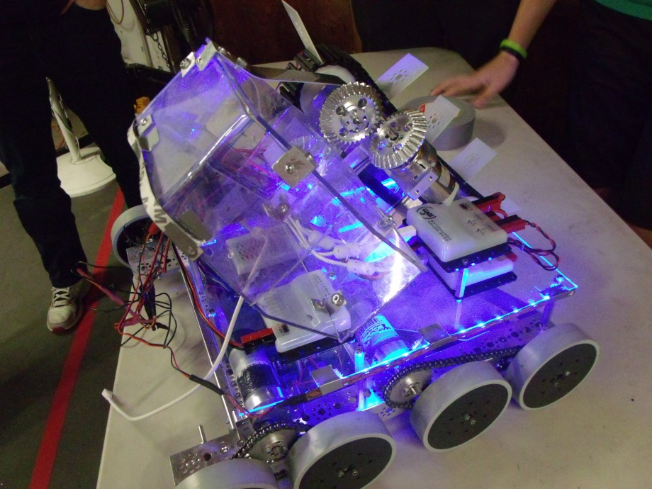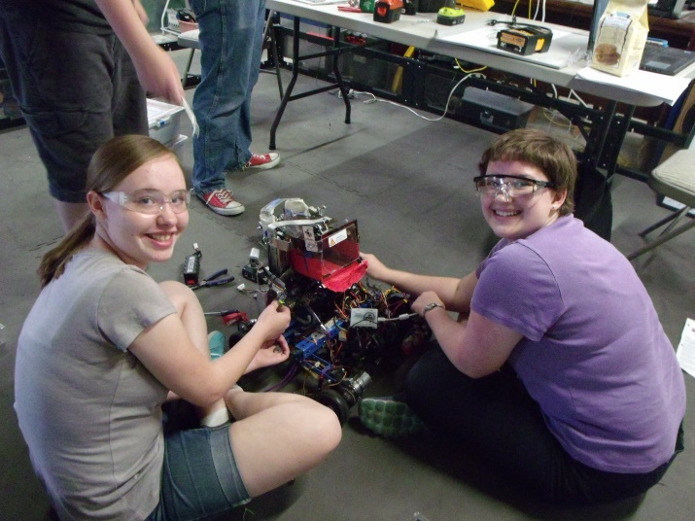

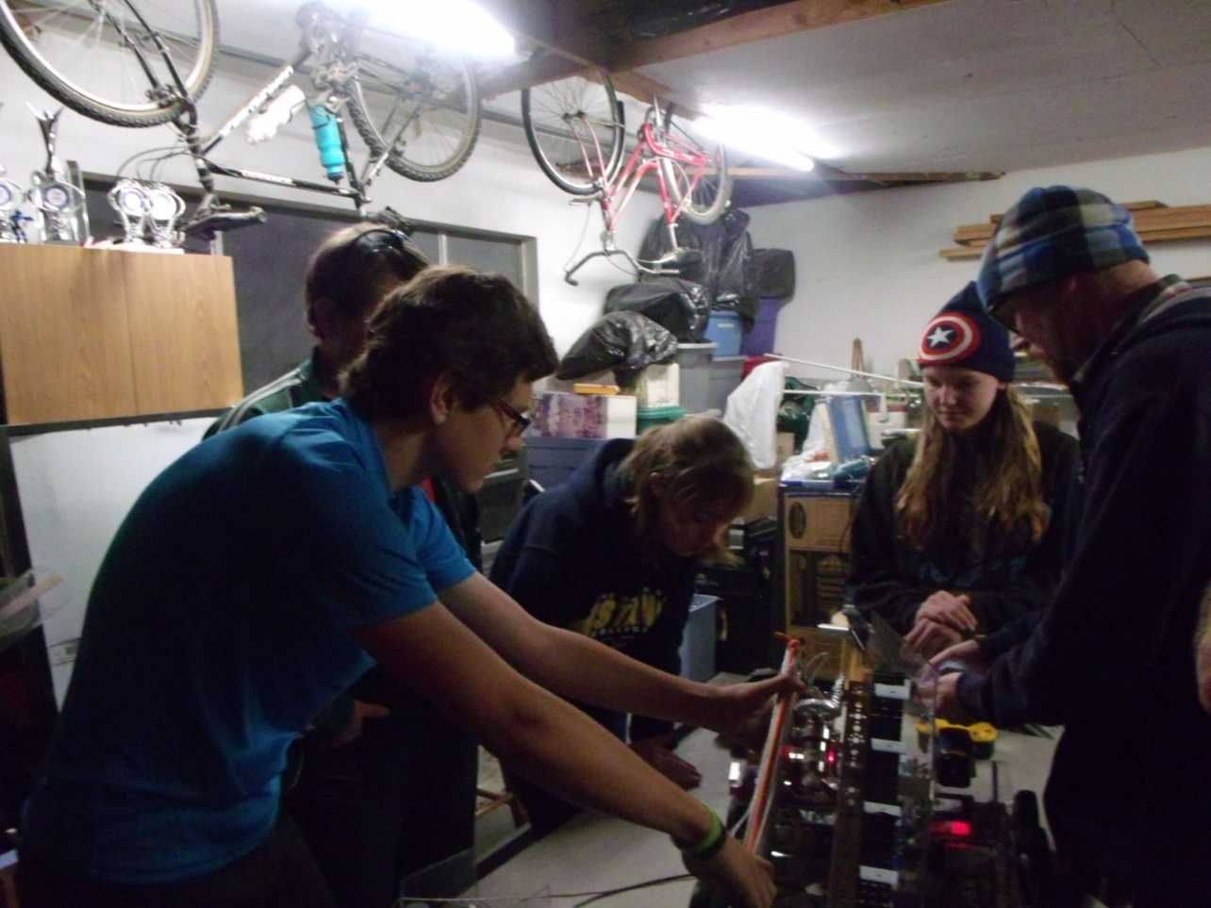

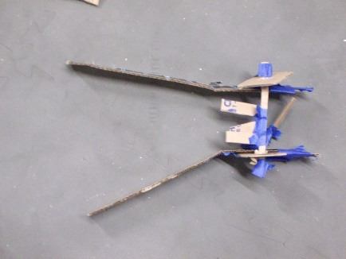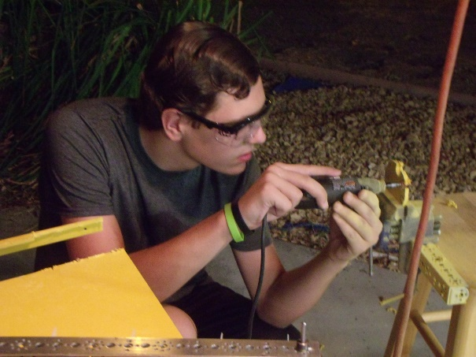

September-November

Front spinners to hook

onto churros

***Robotics: the final frontier. These are the adventures of the robotics team PHI Omega. Its ongoing mission: to explore strange new ideas, to seek out new designs and new mechanizations, to boldly go where no team has gone before.***

**Hardware Log**

**Star date 6/1/15-9/14/15**

In a different course of action from what our team usually pursues, we decided to design, prototype, and construct our robot’s chassis before the season began. We are did this in hopes of having a completed and working robot chassis before the game is released, providing us with more open time before our first competition to develop scoring mechanisms (whatever those may turn out to be).

We’ve been hard at work over the course of our summer off-season, scouring every source we can think of to determine the most advantageous parts of a chassis. From this work, we’ve been able to determine what we think is the best course of action for a robot chassis.

This chassis had several desired qualities. While these qualities were not necessary, they were things we had seen in the past and thought would be nice.

1. The chassis had to be low to the ground. Low ground clearance would give us more vertical mounting space on the robot as well as lower the center of gravity.
2. The chassis had to be of decent weight. A heavy chassis is a hard-to-move chassis. We wanted a chassis that could stand up to a decent amount of side-to-side force from another robot without being shoved.
3. The chassis had to be fast. Even with the hefty weight desired, we wanted the year’s robot to be fast. This would allow us to navigate the field at a reasonable speed, playing off of our semi-aggressive driving style.
4. Finally, the chassis had to be modular. A modular chassis makes for easy mounting of scoring mechanisms when they are constructed. This was a must.

Since we knew what were the most desired qualities for our future robot chassis, we began work. Soon, the chassis design began to take shape. The chassis was to have four wheels, each powered by one motor. Each side of the drive train would be sandwiched in between two “bulkheads”. These bulkheads, in simple terms, were aluminum plates cut to a shape that would fit properly. Several different shapes and sizes were considered for these bulkhead panels (blueprints behind this log). Along with this, a similarly constructed top plate was to be used for cross-support of the robot. The last piece to the puzzle was a polycarbonate electronics plate which would be mounted on risers above the main chassis. In the end, the finalized versions of these pieces came together into the chassis we are now testing.

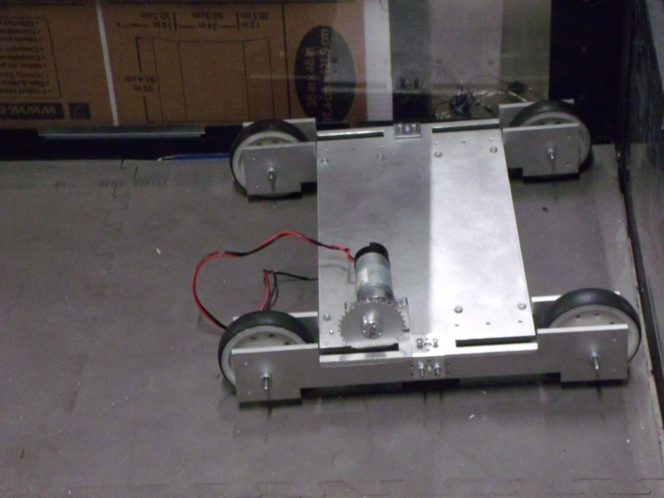

Incomplete V-Ger Concept Chassis

In progress of working out motor mounting

The V-Ger chassis has maintained all the qualities that the CAD concepts we developed had. The chassis has four bulkhead panels, two each side. These side panels were cut for us by NASA using their water jet. The panels are each made of ¼” aircraft aluminum, ensuring rigidity. Likewise, the top plate was made in the same fashion and is constructed of the same thickness metal as well. The side panels have been bolted together using lengths of all-thread with locknuts on either side of the panels. In between the bulkhead panels are sandwiched two sets of 3D printed blocks, one set per side. These blocks are to create the perfect gap for the drive train, giving no more space than needed and improving rigidity.

The top plate is held down by two different means. Each side has a modified Tetrix thin L-bracket holding the plate down from the top. Along with this, 2 of the thicker Tetrix L-brackets are used inside of each drive assembly, underneath the top plate to hold it. The plate is bolted into each of the L-brackets, completing the strength of the chassis.

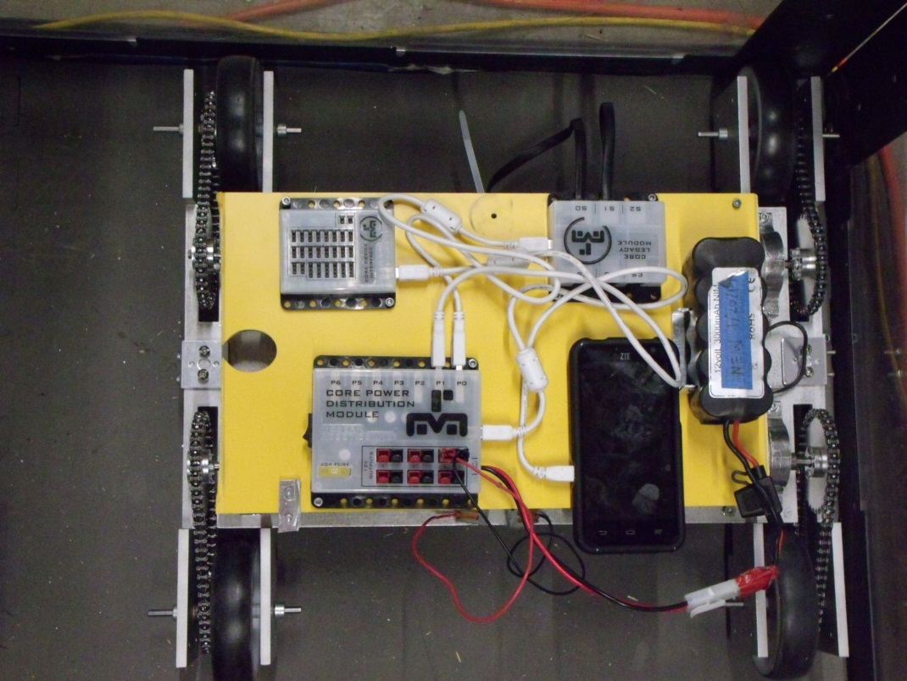The chassis is now complete, electronics and all. A weight test was performed on it (one of our team members putting a foot on the chassis and gradually pushing more of their weight on it), and the chassis seems to have a pretty good weight tolerance. From what we can tell, we have put up to forty pounds of force on the weakest part of the assembly, the center of the top plate where it is unsupported. Even under this stress, there is minimal bending in any part of the chassis.

Picture of completed V-Ger Concept Chassis. All motors have been mounted on the top plate and chained to the drive wheels. Not knowing whether this robot is to be the competition robot, we have replaced the aforementioned electronics plate with a piece of plastic cut from last year’s field.

Unfortunately, we did not meet our hoped deadline, and the construction of the chassis has ended just after the game was announced. Having watched the game video, we are not sure whether the V-Ger chassis will be up to the task of climbing the ramp. We do not have our field as of yet, but we are preparing for the worst. Already, we are rapidly developing a new chassis design with more ground clearance.

**Hardware Log**

**Star date 9/28/15**

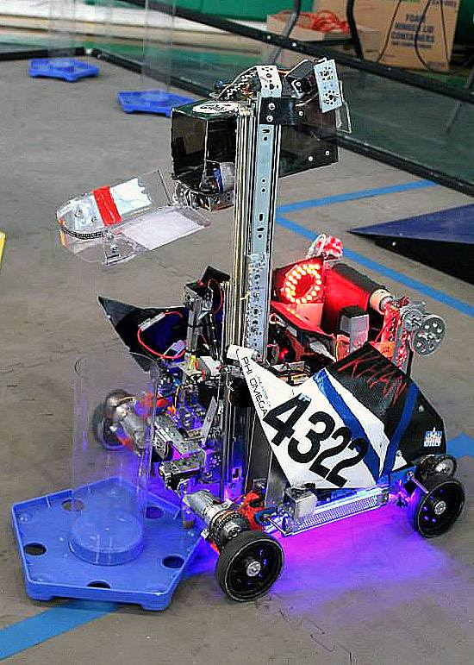 With the game being released and our field elements built and placed, we have now had a chance to field-test the V-Ger concept chassis. As it turns out, our fears were well-placed. The low ground clearance of the chassis is a major issue. Though not capable of driving up the ramp itself, we tested this by placing the chassis over a set of the churros. Unfortunately, the squared-off sections which hold the wheels on the chassis are catching on the churros going up and coming down. This would cause the robot to get permanently stuck on the ramp during the game if we attempted any climbing whatsoever. Due to the amount of modification that would be required to make the chassis work, we have resolved to move on to another design we’ve had in the works.

Enter the Kraken chassis project. The Kraken chassis was designed by a previous member of PHI Omega several years ago. It was built with ground clearance and rigidity in mind. This design worked so well that our team ended up updating the chassis last year, bringing about the birth of what we called the KR4.

Knowing the strengths of the Kraken chassis style, we decided to attempt another update. While the KR4 was an excellent little chassis, it had a few flaws that popped up at the end of the season, after almost 6 months of wear and tear.

Enter the KR5, the totally renovated version of the Kraken chassis that we know and love. This chassis needed to improve upon the strengths of the original Kraken as well as those of the KR4. This involved a few design qualities that neither model had. First of all, the wheels had to be supported better. Every Kraken to date has had an issue with wheels bowing under the weight of competition mechanisms. Therefore, we implemented what was on the V-Ger Concept, a sandwich plate design which supports the wheels from both sides. Along with this, we wanted to improve the cross-supports of the previous Kraken models. All original versions of the Kraken used standard Tetrix beams to bolt both sides of the drive train together. However, this version of the chassis was not to include this. Our sister team, PHI Alpha, had been working on an updated Kraken at the same time we were developing V-Ger. Their model of the Kraken included a metalshopped plate that took the place of the Tetrix beams. By using this, their version was more rigid and more compact. They graciously allowed us to use their blueprint, which we sent to NASA to get 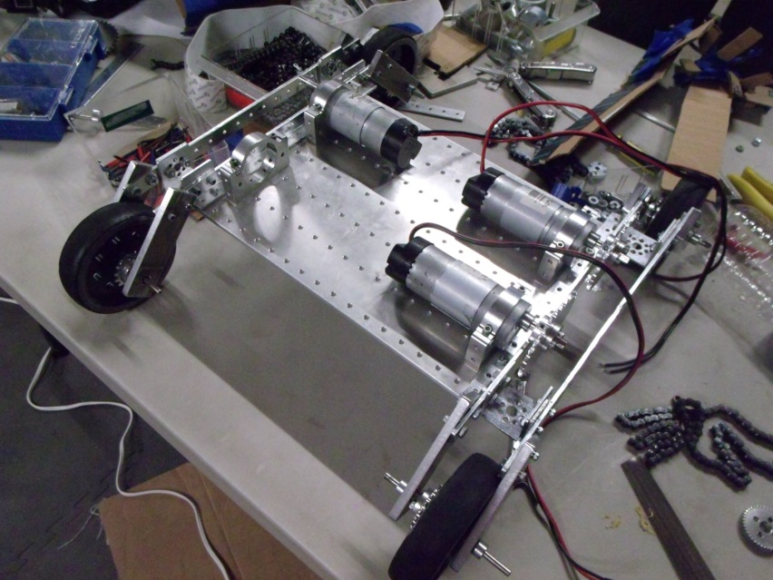our part cut by their waterjet. When all of these parts were combined, the KR5 was born.

PHI Omega’s FTC Cascade Effect robot: Khan

Implemented advanced KR4 chassis

KR5 chassis in mid-motor mounting

Note sandwiching of wheels and modular top plate

Completed KR5 ready for testing

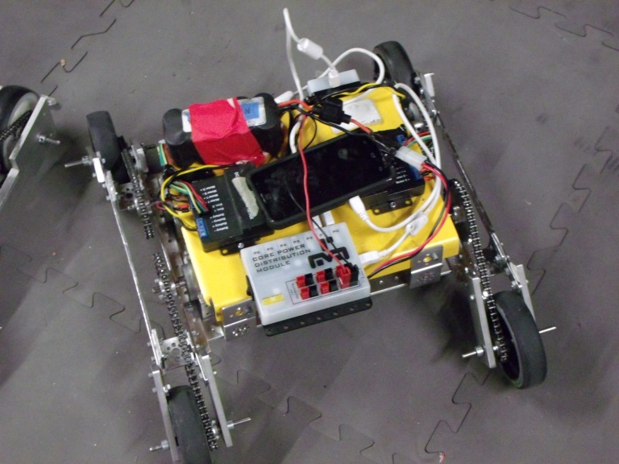 Now that the KR5 has all of its electronics mounted, we’ve had a chance to drive it. From first experience, all of us like the zippy response the drive provides. It is a true dream to drive. Unfortunately, after testing on the full field, things are starting to look bleak. This chassis is experiencing a problem we did not think we would encounter: grip issues. Even with four-wheel-drive, the KR5 is having problems getting any purchase on the ramp. We are afraid that even the KR5 will not be up to the test of this year’s game. In light of this, we have begun a frantic search for yet another chassis design we can use that may give us a better chance. One idea that has arisen is to increase wheel count. More wheels should equal more grip and provide us with more purchase on the ramp. A hardware team has been set to look into this idea and see if it is worth using. While this is going on, we have begun looking into scoring mechanisms for the KR5 or whatever chassis we may end up with.

**Hardware Log**

**Star date 10/12/15**

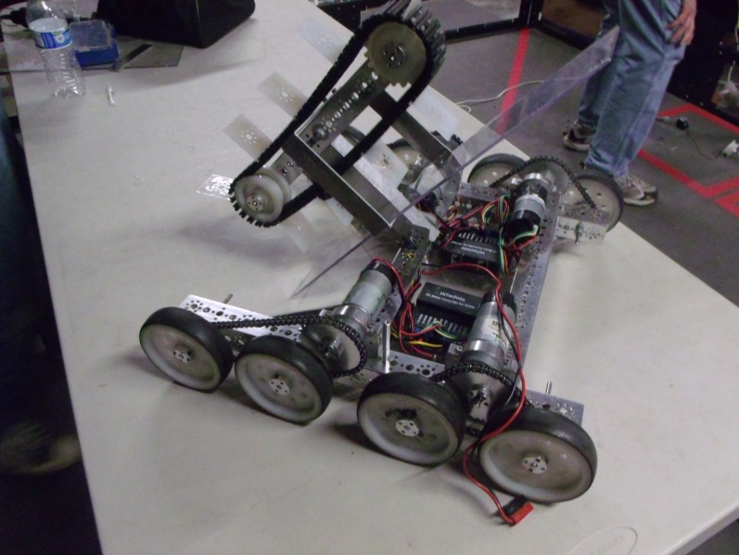We believe we have just accomplished the impossible. In the span of a little over a week, we have designed and built a new chassis for the robot. While we wish we could have used one of the previous two chassis, we are running out of time, and we had to make a choice. Because of this, we have decided that this chassis will be used.

The new chassis uses an 8 wheel drive design. By doing this, we hoped to improve the grip the chassis has. In order to compact the amount of space taken up by electronics, the drive controllers have been mounted on an underslung plate. This plate is bolted to the undercarriage of the chassis, allowing us to unscrew four screws and drop the plate, giving us access to the drive controllers once they are covered by the inevitable mechanisms that will almost certainly take up the rear of the robot.

Current chassis with Stage 3 prototype of current scoring mechanism mounted

While we were still figuring out our chassis crisis, we worked on a couple of intake ideas. Our first idea used a guide on the bottom of the KR5 chassis that would funnel the scoring elements into a channel made of plastic. Mounted in the channel would be a motorized brush that would shove the balls and blocks into a bucket on the back of the robot. The bucket would be on a rotational, self stabilizing arm that would lift the bucket off the ground and overhead the robot. The arm would use a chain-based system to keep the bucket level at all times. By doing this, we would be able to score in the buckets on the ramp. There were several pros and cons for the mechanism

Concept for undercarriage intake system

Pivot bar

Bucket

Spinner

V funnel

Pros:

* Used undercarriage of chassis
* Was simple
* Was easy to operate
* Required little maintenance

Cons:

* Required high ground clearance
* Could high-center on churros
* Required inordinate amount of chain

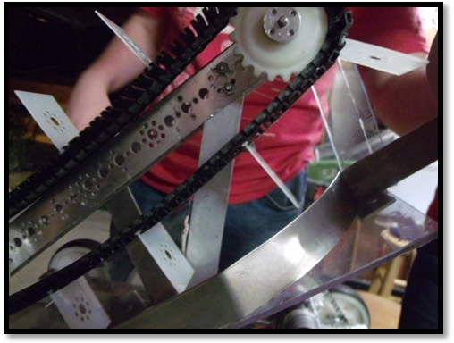Due in part to these cons, although due more to our chance in chassis, we could not effectively use this intake system and began work on another. Our new idea was a conveyor belt that would spin and intake the balls and blocks. This idea came from a similar mechanism our sister team PHI Alpha used in the previous year. This intake used Tetrix tread in combination with paddles at certain increments to push game elements up a bottom plate bolted to the mechanism. The bottom plate would provide the elements something to slide against. We tried to make sure that the distance between the belt and the bottom plate was a little more than a ball’s diameter. We first made the bottom plate out of cardboard for testing purposes. After seeing that the mechanism worked, we rebuilt the bottom plate using plastic. At first, we attempted to shape a piece of plastic with guides on either side to keep balls and blocks from sliding out. Unfortunately, after several hours of heating the plastic still would not bend properly. A whole meeting ended up being wasted by this. Instead, we switched to a multi-part plate. The “floor” of the plate used a piece of plastic cut from the failed heat-bent one. The side guide was made of a thin aluminum strip. In concept, the idea worked excellently. However, we later discovered that the metal strip was not angling the blocks correctly as it pushed them out and was therefore causing them to get stuck. To fix this, we rebuilt the plate once more, this time using nothing but plastic. A back plate was built to angle blocks so as to push them out better.

Conveyor with metal side shield

Pros

* Simple in design
* Used in past robots, providing better knowledge for operation.
* Efficient

Cons

* Space hog; very large in size

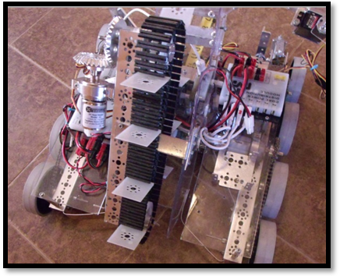

Once we decided this was the mechanism for us, there were a few modifications we wanted to do. There were two major things. First of all, the main beam to which the whole intake was mounted needed to be changed in angle. Second, the conveyor needed to be shortened. We started by removing the intake belt off the old support and shortening the C-channel to which it was attached. This was done in order to shrink the overall length of the intake, giving more space back to the robot. While doing this, we put the new main mounting bar at a 45-degree angle. We then cut and attached several metal supports for the bottom plate of the intake. In the end, we planned for the intake to spit balls and blocks out to the right side of the robot.

Conveyor with new plastic

Tread belt

Support bar

Old configuration

New configuration

New Support bar

Tread belt

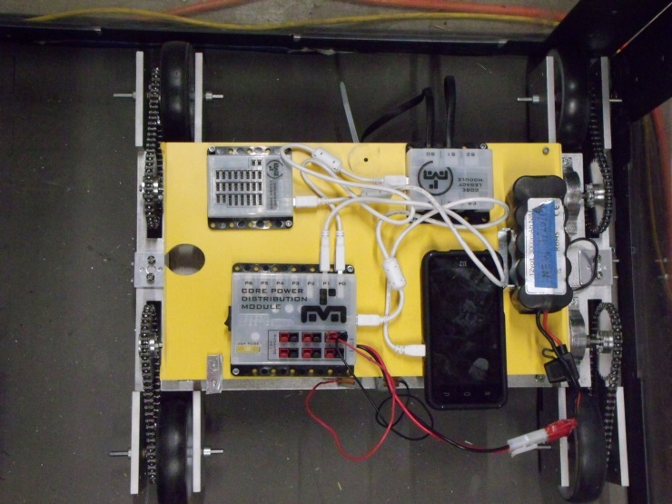 As we are not using the V-Ger chassis, we handed it over to the software team for them to use as a test mule/bugbot while we continue work on the competition robot. There were a few things that needed to be done to it before the software team could use it, however. Due to the nature of our autonomies, we wanted to have encoders on the bugbot. We also wanted AndyMark motors on it so as to make it as close to the competition robot for programming as possible. Unfortunately, one of the AndyMarks we had planned to mount had a bad encoder, and we didn’t have any more of the motors to replace it. We then had to find some older Tetrix motors and encoders for them. We assigned some of our newer team members to remove the AndyMark motors and replace them with the Tetrix ones. This also involved putting the encoders on the motors, something one of our more experienced team members taught them how to do. This fixed the problem and allowed software to use the robot.

V-Ger chassis ready to be used for software testing

Now that we have a functioning chassis for the competition robot, we are well on our way to having a fully-functional robot. Hopefully within the next few weeks we will complete the finalized scoring mechanisms, allowing us time for driver practice.

**Hardware Log**

**Star date 10/29/15**

Still working on our ongoing mission: to explore strange ideas, to seek out new designs and new mechanisms, to boldly go where no team has gone before.

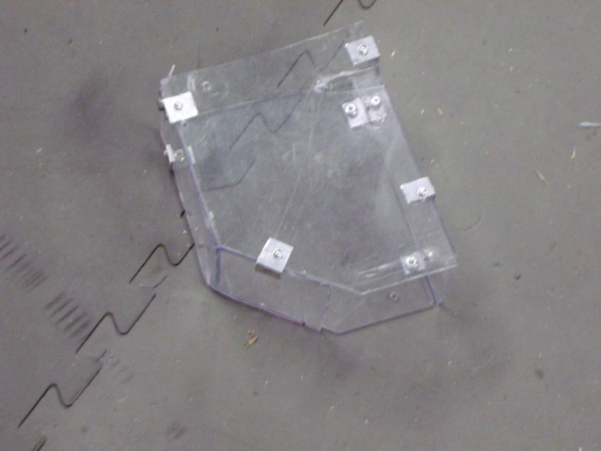On that note, we have worked on more hardware! We have “completed” our intake. This means that we have fully completed the plastic around the intake.

After we finished our intake, it was time to make the bucket. We started with a squared-off bucket with capable of holding 5 balls or blocks. The output end of the bucket was the size of one game element. Made of the same clear plastic, the bucket was held together in strategic points with L-brackets and rivets. Due to a lack of electronics to run the robot, we could not properly test this bucket yet. On to the electronics then.

Bucket

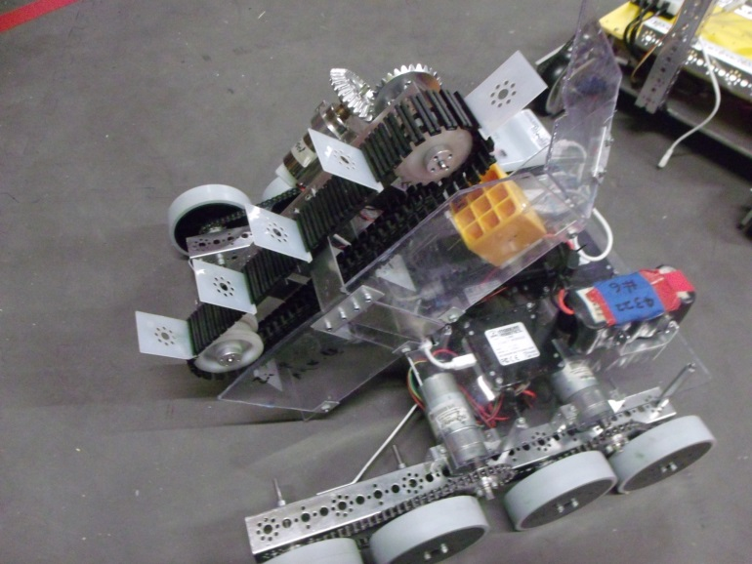Like the V-Ger Concept, this chassis was to incorporate a modular electronics plate that would bolt on above the drive motors. With the drive controllers in the base of the robot, this gave us more space to fit other electronics on the plate. These included the Core Power Module, the Legacy Module (due to us using old motor controllers for drive), a new motor controller for the intake, and a new servo module. The advanced sensor module was a possibility, but we weren’t sure whether we were going to use it yet. The top plate was cut from a single sheet of polycarbonate, a large bay cut out to fit the intake in the front.

Electronics plate

Robot with completed intake and electronics plate

Now having electronics on the robot, we could finally drive the robot. At first, it seemed to drive okay. However, we soon realized that our motors were struggling to move the robot. This was due in part to one major reason. At that time, our drive train was geared three-to-one. This was to maximize speed and maneuverability. Unfortunately, under the weight of our heavy intake, the motors were having a hard time working. To fix this, we changed the gear ratio down to a two-to-one. While it is not as fast and zippy any more, it has fixed our motor-killing issue.

When we drove the robot, we found that we could not go up the ramp. The wheels did not have enough grip on them. To fix this we tried a few different things. The first thing that we tried was a spinning wheel that goes on the front of the robot. This wheel has a couple of notches cut out of it so that it could grip the churros. We cut these wheels out of plastic from last year’s field parts. The wheel was cut to be smaller than a standard wheel so as to prevent our robot from damaging the field. Once we made the wheel, we had to test it. We bolted the climbing wheels on in place of our front drive wheels and tested. By driving full speed at the ramp, we could get the new wheels to lock over the first churro. This was better than before but it was not good enough to use. In addition, when we were driving forwards and quickly reversed direction the robot would enter into a rocking motion that would mess up the drive of the robot. This made driving the robot very difficult.

The team also tried to put some non-slip draw liner on the wheels. We did this to see if we could easily increase the traction on the wheels with a quick fix. We first tried it on the front two wheels. This did not help so we eventually tried it on all the wheels. However, after some further testing we found that the wheels still did not have enough traction and the non-slip grip would come off the wheels.

The wheels we made

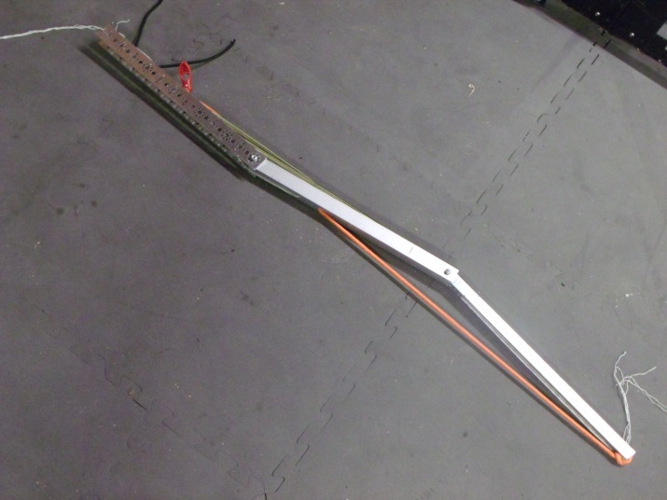We had heard of wheels from AndyMark that supposedly had more grip than standard Tetrix wheels. After consulting with other teams from our area, we decided to buy a set of them. However, we have to wait until we get them.

Scissor-style lift arm

In the mean time, we have begun work on a lift mechanism. At first, we looked into a scissor-lift-style mechanism which would be under tension from bungee cord. As we released a cord from a spool using a motor, the scissor would expand out the back of our robot to the top bar of the ramp. Then we could pull it back in with the same motor. After a short amount of testing with prototypes, however, we decided to scrap this idea due to its complexity. On to a new idea!

Bungee for extension of arm

After talking with a previous mentor of our team, we were recommended a measuring tape. The idea was to extend a measuring tape with a hook on the end of it up to the bars on the ramp to climb. Currently, we are looking into a way to motorize the spool of a measuring tape. Then we will begin building it.

**Hardware Log**

**Star date 11/12/15**

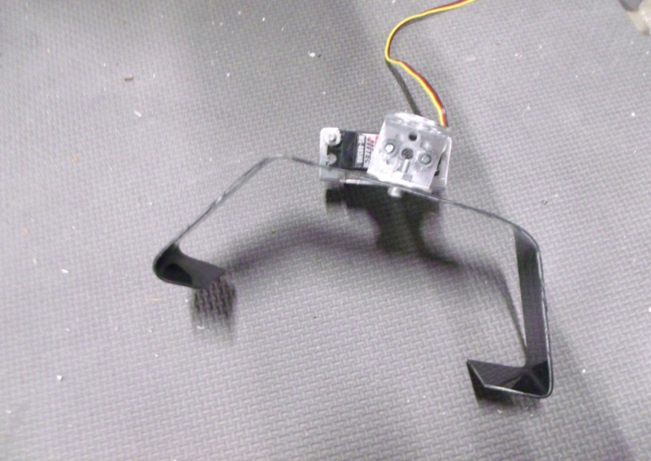Today we got some new AndyMark high-grips! Of course, the first thing we wanted to do was mount our new wheels and see if the robot could climb. This was slightly more problematic than it sounds, though. Traditionally, we put an axle hub on both the drive gear *and* the wheel. However, with AndyMark wheels this is harder to do. Our robot cannot accept such a configuration, as the AndyMarks would stick out further than the standard wheels. Instead, we have bolted the wheels directly to the drive gears and *their* hubs using longer screws. This did not take very long so we got to test it. We tried driving up the ramp but the robot would just slide back down. As it seemed that the new wheels did help normal drive, we decided to keep them.

As important as tele-op hardware is autonomy hardware, so we started prototyping an idea for a button pusher that would trigger the rescue beacon. Our idea was to have a V-shaped piece of plastic attached to a servo. This servo would move and push the button based on what color a color sensor saw.

Servo for rescue beacon

To allow software to work as we worked on hardware we had to fix some things on the bugbot. The wheels had too much friction on them because the chain was too tight. This made the motors canted, causing too much tension in the drive train, eventually causing the motors to burn out from continuous over-stressing. To fix this we had to just move the gears on the motor in on the drive shaft a little bit. This alleviated some of the problem. However, even after doing this, the bugbot was still experiencing similar problems. The only way to fix this was by lengthening the chain. This fixed it.

After that, we started in on the lift mechanism. After a little more thinking, we decided we wanted to be able to move the height of the tape using a servo. This would allow us to use the tape for hanging in end game *and* use it for climbing the ramp. Originally, we were going to use two different spools on the front of the robot directed backwards. However, we found we only needed one tape measure that was centered on the back of the robot. This idea was borrowed from another team which used a similar mechanism at a competition. They had posted a video of the robot climbing on the internet, but only a minimum amount of the workings to the mechanism were shown, and only for about five seconds at that. We had to reverse engineer the mechanism from a tiny amount of video. To begin work on the mechanism, we first had to clear the area where the spool would go. Unfortunately, the Legacy Module and advanced sensor module were in the way. This required a redesign in the electronics plate of the robot. In the first version of the plate, all electronics were mounted rear of the intake. With this version, however, we needed to move everything around. The top plate needed to be rebuilt.

We started over and made a new top plate which wrapped around the intake on the front of the robot, allowing us to move all the electronics forward on the robot. Now, all of the electronics on this plate sit either to the side of the conveyor or in front of it.

Now we could begin work on the lift mechanism. We constructed a spool for the tape measure based on a design for a winch from a previous year. Because of the lack of mounting space in the center of the robot, we had to make more space. We cut a 1 inch aluminum square tube down to a size that would fit width-wise in the robot, allowing us to bolt it to the main frame. The spool was mounted between two C-channels cut to fit over this new mounting point.

While working on the lift system, we had to remove the top plate so we could access the chassis of the robot. Once we got the spool bolted on, we tested the fit of the top plate for the robot. We found that the top plate did not fit over the new spool, so we had to cut a large bay in the center of the plate that would fit around the spool. After we did this, we attached a set of two drive motors to one of the support channels for the spool and chained it to the spool. However, when reattaching our intake, we realized that one of the motors obstructed the intake from being remounted. Now knowing this, we decided that we could possibly run it with one motor. We removed the offending motor and rechained the system. Since we were now done with the actual winch, it was time to attach our measuring tape. We riveted a twelve-foot section of our measuring tape to the spool and reeled it all in.

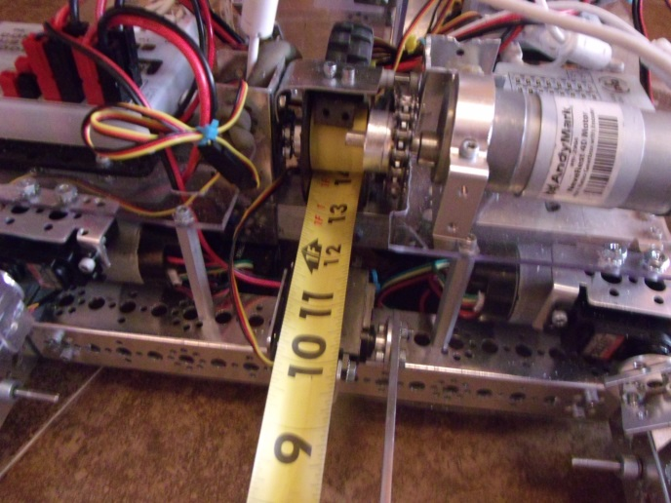Once we got the measuring tape on, we thought that we should test it, so we put the robot on the ramp. We then manually attached the hook on the high bar and powered the spool’s motor directly from a battery. The robot was lifted with ease. After we tested it with the high bar, we then tried it on a lower bar. We found that it did pretty well, eventually making it to the position we would need it in for scoring. Overall it was a success. After we tested reeling it in, we then needed to work on making the tape measure come out. Spinning the spool in the direction that would eject the tape caused it to unspool around the spool instead of out the back of the robot. To fix this we thought that we could attach a couple of spinners to pull on the measure as it unreeled. We got an axel and sowed some non-slip grip around it but we have not tried it yet. Another thought that we had was to have a tight piece of metal around the spool so that the tape measure would be forced out, but we could not get the metal to apply the proper force to the spool, so we decided not to use that idea.

As we worked, a cousin of one of our teammates came over to see what we were doing, so we showed him our robot and showed it lifting. We also showed him how the tape measure would not come out. Being an engineer working for Lockheed Martin, he offered a couple of ideas. One was to have a smooth surface under where the tape came out to reduce friction that the tape experienced. Second was to change the gearing so that the motor spun more slowly. We first tried to put a smooth surface to support the tape. This seemed to help a little. After that, we decided to try to re-gear the motor. Originally, the assembly was run on a one-to-one setup. We dropped it to a one-to-two drive. However, this solution did not actually fix the problem at all.

Picture of current spool set for lift mechanism

We got a lot done this week but there still is more to do. We want to make the tape measure come out right and have an adjustable output height. We also want to make the bucket so that we could quickly switch positions so that we could score on both teams.

**Hardware Log**

**Star date 12/7/15**

*Ding ding ding! Competition in one week! Prepare yourselves!*

It’s almost here! The robot needs to be ready! What are we going to do!?!? Wait. Why are we stressing? It’s already done! Yay for us! We finally finished the robot. Of course, there are a few things we really wish we had time to make better, but we also really don’t want to take the robot apart now. So what have we been up to since last hardware log?

First of all, our intake has been upgraded! The bucket that it previously had, after multiple trials, has been discovered to jam with balls and blocks. A couple weeks of thinking allowed us to come up with a solution to this problem: we replace the two-ball-wide bucket with a one-ball-wide chute! While cutting down the total storage space for game elements in the system, we have also cut down the likelihood that anything will get stuck in it. The chute is has also been built with a quick-release system and a perfectly symmetrical shape. This is for one very important reason that requires a little bit of explaining.

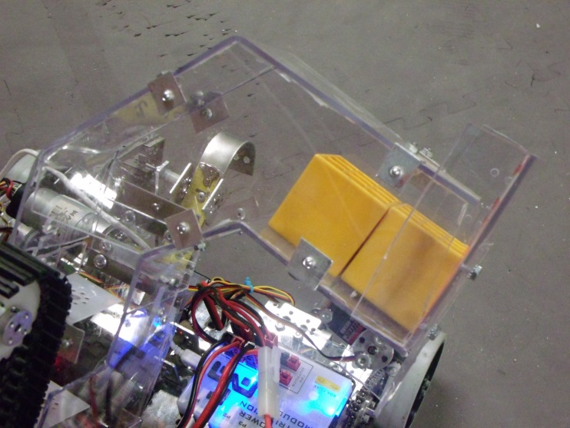 Due to the fact that we only have one half of a field set, we have been building our intake as if the ramp is the same on both sides. This would mean that we could output all game elements out one side of the robot for both alliances. However, we recently realized that this was not true, and the ramps are mirror opposites of each other. This means that we need to be able to output from both sides of the robot. Enter the quick release chute system. The new chute allows us to switch our output side in a matter of seconds, perfect for those times when there is only one minute in between matches. Two hooks on either side of the intake in combination with matching screws on the chute that lock into the hooks allow us to rotate the chute end-over-end and flip our output end.

Hard to see, but this is the quick-release hook.

The Chute

On the other end of the robot, our lift is finally working! We can now both pull the measuring tape in *and* push it out. The solution to our unspooling problem was actually quite easy to find. Through a combination of an unpowered roller on the back of the spool and a smooth cover on the front, the output now works pretty well. Of course, once the tape extends past about four feet, the problem seems to start showing itself again, but for now it works perfectly fine.

When testing our lift, we realized that we were going to need some way of holding the robot at the top. When the program ends at the end of a match, the spool motor’s power is dropped, and the robot begins to fall. To fix this, we put a couple of spring-loaded hooks on the back of the robot that can be dropped when we’ve pulled ourselves all the way up to the top bar of the ramp. The robot then is allowed to lower onto the top bar, hooks now supporting it instead of the measuring tape.

For the most part, this is the extent of what we’ve completed since last hardware log. There are still a couple more things we need to do before our competition. The robot needs still needs shields, but those shouldn’t take too long to complete. Also, the phone needs a mount. However, that is almost complete and should be ready by the end of our meeting tonight. All in all, we’re pretty sure the robot is ready to go!

**Hardware Log**

**Star date 12/21/15**

We just finished our first competition, the Palmdale Qualifier. During the competition, we encountered a few surprises. The fuse in our Core Power Module blew just before judging. We also encountered a few connection issues we thought to be caused by loose cables. A brief chat with a few other teams told us we weren’t the only ones with this problem. The data cables that had come with the basic kit were not the best and were causing most teams trouble. Finally, the static gremlins have returned.

A Fuse-Blowing Discovery

When we first got to the competition we had some led lights on the robot. We were edge-lighting our last-minute lexan shields with them. However, when we first arrived we discovered that the robot’s main power would not turn on. After some searching, we found that our main fuse had blown. We exchanged the dead fuse for the one on the V-Ger concept, which we had brought to competition for judging. After judging, we thought about why the fuse was blowing. During driving practice a few days before, we had added our lights onto our robot, but had to cut out a couple dead strands from our wiring pigtail. We determined that a poor insulation job was causing a short in the wiring for the lights, blowing out our main fuse. Due to a shortage of time, we decided just to take the lights off the robot for now.

The Shocking Truth

During the competition matches, our robot was constantly experiencing one bot-killing bug. When we positioned the robot for climbing the ramp, it would lose control and all the motors would go weak. This would allow the robot to roll to the ground and would cause us to lose control of the robot for the remainder of the match. After some testing and observation, we decided that it was static. After observing a few matches, we determined that the static was possibly building up in the rear hooks. These hooks would occasionally be released accidentally, dragging the ground as the robot drove around. For the last few matches of the competition, we did a temporary adjustment and wrapped the hooks in electrical tape to prevent static buildup. In a post-competition brainstorm, we also determined that the large quantities of plastic the robot was built from could be acting as a capacitor for the static to build up in. Most of the electronics were bolted to these plastic parts, giving the static a direct channel to reset our robot when it was grounded.

Because we needed to fix this problem, we started working on the process of rebuilding the robot. Since the plastic was the likely culprit of the problem, our first order of business was to eliminate as much of it as possible. The process started with the removal of all of our mechanisms from the chassis. We took all of our main components and the electronics off. After that, we began reconstructing the robot. In order to gain a little bit of space back for mounting mechanisms, we moved one of our cross-beams in the chassis forward.

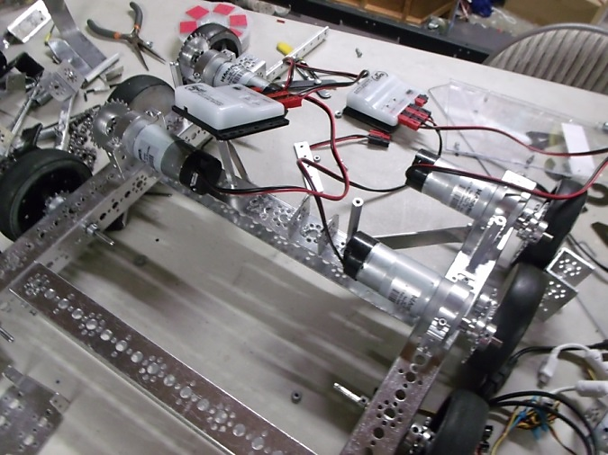

Bar we moved

Robot stripped down to chassis

Once we moved the bar forward we started planning how the electronics would be mounted. We wanted them all on one plate. We researched which materials would be best. We wanted something that does not collect static electricity. The best material would be metal. However, due to the difficulty with working its size and shape, we decided to switch to acrylic. Once the acrylic was cut, we looked into places to put it. The first choice was to mount it vertically on the side of the robot, all the electronics mounted to it for modularity and ease of access. However, the thickness of the acrylic we purchased and a lack of overall depth for mounting caused us to once again change ideas. The final idea is to mount each drive controller, as well as the possibility of mounting another similarly-sized controller, just above the motors. We will ask NASA to make these parts out of metal for us.

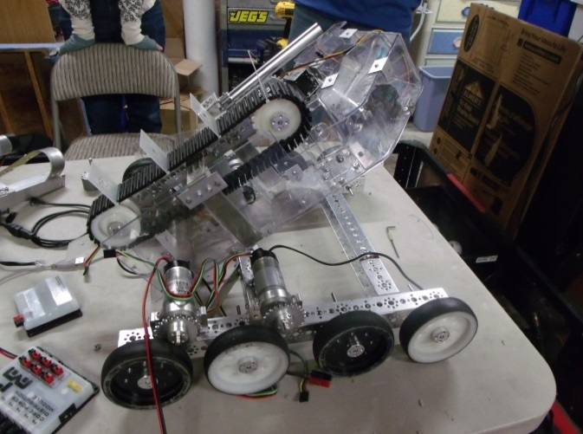

Where we were going to put the electronic plate

As we were working on this, we also started to mount the intake. Because we moved the front cross-beam of the chassis forward we needed to change the mounting. The angle and length of the mounting arm for the conveyor belt must change to accommodate its movement forward on the robot. We encountered problems with getting the right size and angle for the mounting. We tried shortening the beam and mounting it straight up, however, this caused other problems with mounting our lift mechanism. Currently, we do not have a finalized mounting beam, but we have almost finished a new one which should work.

In addition to all this, we have also changed out our wheels. We were previously using Andymark Hi-grips. However, as we were driving we found that we could not turn properly because of the increased grip. They caused the robot to jump and skip slightly as it turned, creating problems with smooth driving. Because of this, we reverted to the standard Tetrix wheels. They are about the same size as high grips but turn better due to a slightly lesser grip. The mounting situation for the Tetrix wheels is also slightly more trustworthy. Due to the deep hub of the Andymarks, the wheel and drive gear must be mounted to the same hub in order for the robot to fit within dimensions. This caused wheel wobbling problems, as the whole robot rested on one axle hub for each axle. With the Tetrix wheels bolted straight to a hub, separate from the drive gears, the robot is now much sturdier on its wheels.

**Hardware Log**

**Star date 1/13/16**

We are continuing work on the rebuilding of the robot. Once we reconstructed the chassis, we began work on the drive. We discovered the old motor mounting locations were not going to provided us with enough space to mount the drive controllers in their desired location, this being in between the two motors of each side. In order to fix this, we experimented with several different motor-mounting positions.

First of these was to raise the front drive motors up on risers to mount the drive controllers underneath. However, the motor risers ended up being too weak, allowing the mount to flex and bend. Another method was to mount the drive controller over the drive motors. However, this turned out to be more complicated than desired, and the idea was dropped. Finally, we determined a method that worked better than the other ones did. The drive controllers are now mounted vertically, bolted to the motor mounts with long screws. With the motor mounts in place, we now had to re-chain the robot’s drive. Each chain had changed slightly in length with the motor shift, so we quickly resolved this by adding a couple links to each length.

We also were able to complete the mount for the robot’s intake. This allowed us to bolt it to the chassis again. However, the intake was very wobbly, and we did not trust that it would properly support the weight of the chute. It also sat at the wrong angle, sticking outside of our 18-inch cube. To fix this, we actually shortened the intake by approximately 3 inches, cutting down the overall weight and size. The intake is now mounted, this time without wobble.

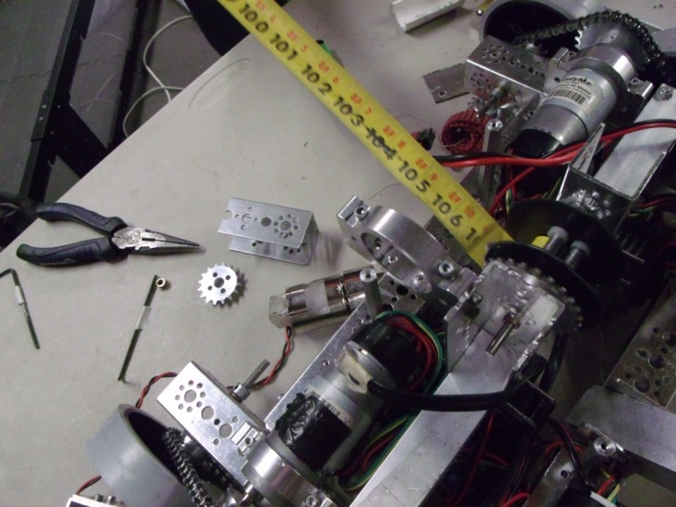

Long square aluminum tubing

Old lift configuration

One main thing we worked on was the lift mechanism. We transplanted it from an old frame, to a new one. The new frame is smaller and more compact. In order to change this, we had to redesign the lift. The main concept was still the same. We were able to use the same spool and tape measure. What we did need to change was how the spool was attached to the chassis. Previously we had a long piece of square aluminum tubing. This tubing ran across the width of the robot. We did not like this because it took too much space and was hard to work with. To make the switch we used two small c channels that were about 4 inches long. They are mounted to the side of one of the main channels. The spool was sandwiched in between these two. Another thing that we kept the same was the wheel on the back. This wheel keeps the tape measure from unwinding improperly. However, even though the wheel helps a lot we still needed a metal tongue underneath the spool to keep it from coming out the bottom. We then put the motor up above the spool. We geared the motor and the spool 1-1. At first, we were concerned that we would not be able to lift at that speed, but it works excellently!

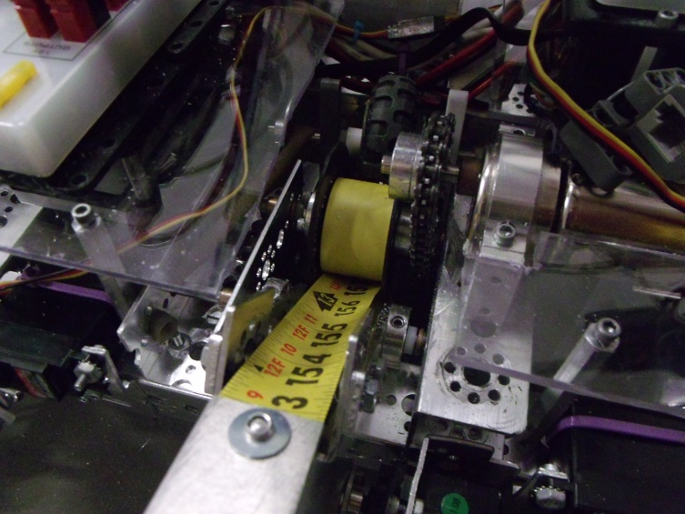

Two c channels

Spool sandwiched in between c channels

Wheel to keep tension on the spool

New lift configuration

We also changed the directional control for the tape measure. Our old control worked but it was not the best. We had multiple problems with it.

**Old Way**

**Pros**

* Controlled the direction
* Quick
* Easy to construct

**Cons**

* Unstable
* Measuring tape had tendency to jump out of guide
* Rather large
* Had to be lowered during hanging



You cannot really see the lever arm but it is here

C bracket

Servo

**New Way**

**Pros**

* Compact
* Quick
* Semi-quick to build
* Low amount of needed space
* Does not need to be lowered to lift

**Cons**

* Slightly harder to construct

The new control system is built into the lift. It uses the same C-channels to mount as the lift does. The way it is built it is more solid. The tape also does not jump out of it very easily. The guide works by having the measuring tape sit inside of a C-bracket that is hinged on the side nearer to the spool. We then have a servo that has an arm on it. When the servo moves it pushes on the C-bracket. This then lifts our measuring tape.

During our previous tournament in Palmdale, we had had trouble with our hanging hooks initializing before we wanted them to initialize and causing problems by preventing us from climbing the mountain (because the hooks would get jammed). When the hooks initialized they sometimes would drop causing lots of problems for our drivers. The idea we had to fix this was by putting hard stops. Initially we did have stops, but they were not long enough, and therefore, often did not serve their purpose. We also added some mechanical stops that limited how far down the hooks could go down. So far, our solution has worked and we have not encountered any problems.

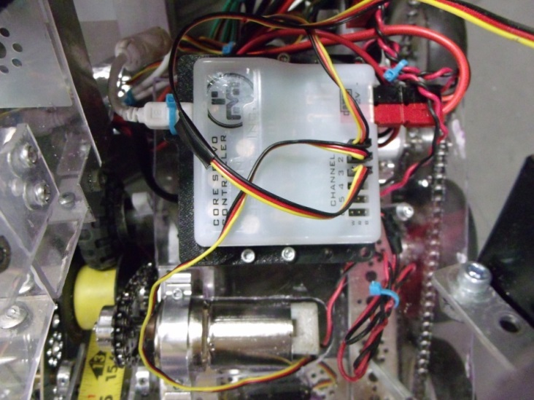We also finally finished wiring our robot. This completed the long process of rebuilding the robot. Now we could move on to new horizons.

We wanted to mount our new gyro and color sensor. As well as that, we wanted to work on our mechanisms that would press the rescue beacon.

Button pressing mechanism

**Autonomy mechanism**

As well as needing components for the tele-op, the robot also needed some for autonomies. We decided our best course of action was to build a mechanism for pressing the buttons on the rescue beacon.

We began by measuring the height of the buttons on the beacon from the floor. We did this by putting out robot on the ground near the rescue beacon. Then we looked at how far in the buttons would need to be pressed before it would be registered by the beacon. We found that they would not need to be pressed in very far.

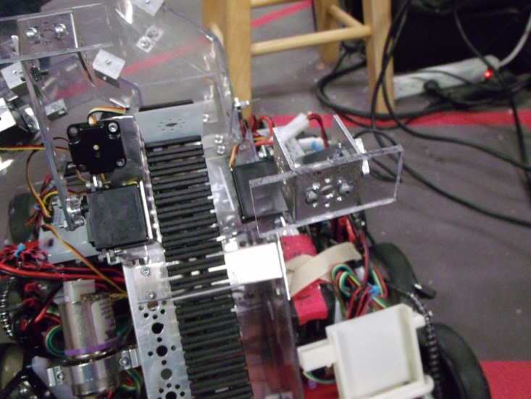

Intake

Servo 2

Servo 1

We looked on the robot for where we could put two servos to press the buttons. We found that we had space by our intake. We started by putting on servo #1. We could do this one more easily because we had the main C-channel from the intake there to mount it on. Once we mounted the servo, we then worked on the paddle that would press the button. This part consists of a short beam mounted to a servo horn on one end with a flat plate of plastic mounted to a C-bracket on the other. The piece of plastic is there to increase the width-wise range of the button pressers. The autonomies are not always accurate, so this would give us a little bit of wiggle room.

The first servo arm was considerably easy to install. The second one was a little bit harder because it was mounted to the plastic on the side panel of the intake. To figure out the location where it needed to be we put the robot on the floor next to the beacon. We then determined the height that it needed to be at. By using a vertical mount, we attached the servo to the robot. The next step was to copy and mirror the button-pressing arm that was on the other servo and attach it to this one. This concluded our work on the servos.

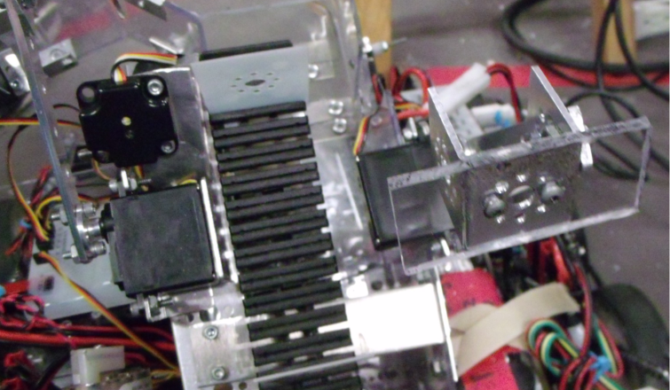

**Color sensor**

The servos would not do us much good without being able to read the color of the beacon. This meant that we needed a color sensor. Our next step was to attach the color sensor. From experimenting, we knew the height that the sensor would need to sit at in order to get an accurate reading. Therefore, we looked on the robot for a place where we could mount it at this height. We encountered a few problems with mounting, as the location we wanted to mount it was in the way of our servo arms. We got around this problem by mounting the sensor underneath the servo arm at an angle, facing up at the beacon.

The last thing we did for hardware was mount the new gyro. The gyro needed to be mounted for use for autonomies. We mounted it on a short piece of plastic attached to the front cross-beam on the chassis, putting it at the robot’s exact center for accuracy.

**When you get ready for battle what is one important component that you need?**

**SHIELDS!**

Even though our robots are not fighting, they still need shields. We are redoing the shields from the previous competition because the size and shape of the robot has changed. We made cardboard and duct-tape prototype shields on an extra meeting over the weekend, but we have now begun to make the shields we hope to use at the upcoming competitions. We bought a large sheet of impact-resistant polycarbonate and took measurements from the prototype shields. We then cut out the different parts of the shields we needed. We did have trouble measuring some of the parts, so we had to remake a couple of the parts a few times. These shields were to be beveled at the corners in order for us to glue them together. While we are not going to be using glue, we still beveled them. By using a belt sander, we were able to sand each needed edge down to a 45 degree angle, making perfect corners. We will hold the shields together at these corners with right-angle brackets and rivets. Then we will attach the shields to the robot with custom-made metal brackets.

**A quick review**

To quickly summarize what the robot has and what it can do. For autonomy, we have two little servos on the front of the robot. We have a color sensor so that we can read the color beacon. We also have a gyroscope so that we can know how much we have turned. In addition, for the tele-op we have eight-wheeled drive. We have a conveyor-like intake that has paddles that will take in the debris. We then have a chute on the one end of the intake. This allows us to hold the items that we have picked up. We also have a tape measure lift system. This allows us to pull ourselves up on the ramp and allows us to hang. When we pull ourselves up on the ramp, we can score the items using our chute. For when we hang, we also have two stabilization hooks that are deployed to take the full weight of the robot, relieving stress on the measuring tape.

# SOFTWARE

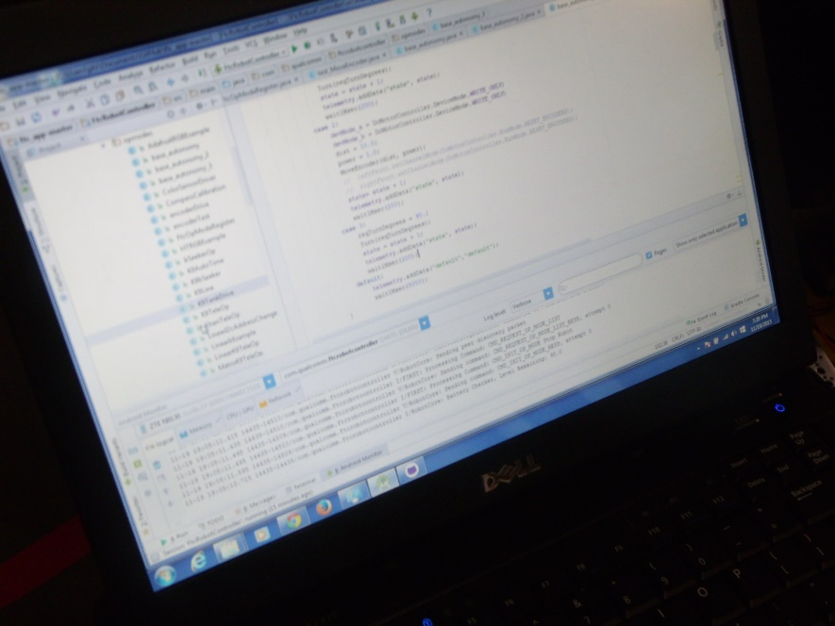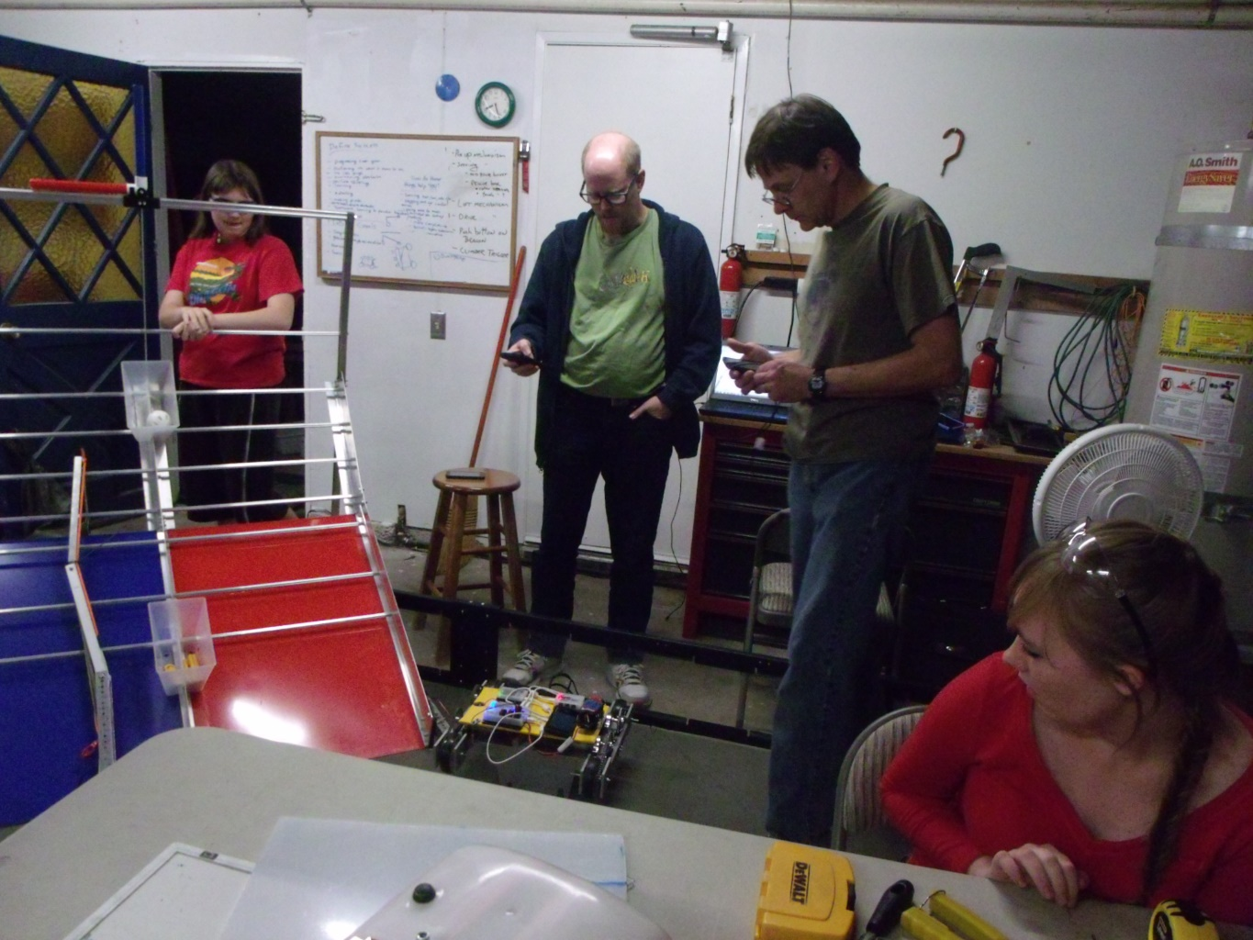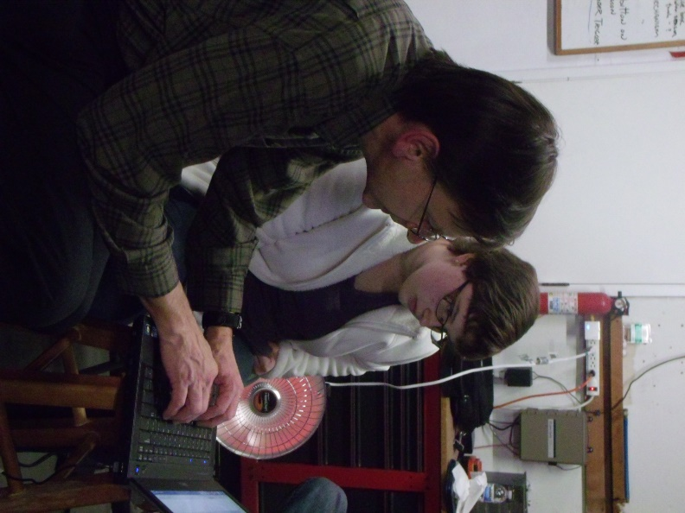

**Software**

**C to Java transition**

This year, FTC went from using Robot C and a LEGO NXT system to a Java-based Android phone system. This transition meant that all the old code no longer worked, and meant that the team would have to learn a new language. The team has been in the process of converting several consistent background functions from previous years that were written in C into Java, such as our gyro turn program and move function.

Although the transition has slowed the software team’s progress, it has also given them a chance to learn more about Java and become much more fluent in it. In order to speed up this process, we developed a test bot to give the programming team something to work with while the competition bot was still in development. This test bot enabled the software team to test their tele-ops and autonomies while the hardware team was working on the competition robot, leaving it inaccessible. This helped eliminate a problem that has occurred in previous years, where software was given little to no time to write their code when hardware development took longer than anticipated.

**Autonomies**

We incorporated two basic functions, a move function and our gyro turn program, into our autonomies. These functions helped us develop the autonomies we currently have.

Currently, we have one basic autonomy with two variations—plus a mirrored version for the opposite side of the field. From these autonomies we are working to build more advanced ones, such as ones that climb the ramp instead of simply driving into the parking zone. We have also begun working on a color-detection program that we hope will eventually be able to activate the beacon, however this program is still in very early testing. We hope to use it in later competitions now that we’ve finished most of our code conversions.

**Sensors**

We use a Modern Robotics Gyro to tell how far the robot has turned, and how far it still needs to turn. We are also developing a program that will allow the gyro to tell if the robot is going straight toward its goal or if it has been knocked off-course by debris or other field elements. We tested our gyro by setting it up with a print statement so we could read where it thought it was. While watching the print statement, we would move the robot. We were able to adjust our code accordingly, and soon our gyro was working well.

In addition, we use encoders in the move function to measure the shaft rotation to tell how far the robot has moved. This gives us a much more precise measurements than time-based measurements of the robot’s movements, and tells us how much farther it still has to go.

One downside to encoders is that if the wheel slips, then the distance reading will be off.

**Gyro**

We use the gyro in two ways. Firstly, we use it to tell how far the robot has moved and how far it needs to go when it makes a turn. This allows the robot to turn much more accurately than it would be able to if we used a time-based turn, or even an encoder-based turn.

Secondly, we use the gyro during our move function to tell if the robot has deviated from its course while it should be going straight, and to determine how far it needs to turn to get back on track. This gives the robot a new level of awareness that enables it to dynamically interact with its environment and provides a much larger margin for error. If, for example, the robot gets tripped up on a block and knocked off-course, the gyro will pick up on this and the robot will turn itself until it is once again facing the right direction.

Our gyro uses numerical integration to determine how far it has gone or turned. We used to need to do the numerical integration by hand in the code, but we recently got a new gyro that does the numerical integration for us (Modern Robotics gyro).

In brief, numerical integration is finding the area under the curve. Using a Cartesian coordinate system, if you made the y-coordinate the velocity of the robot and the x-coordinate the time and graphed that over a period of time and then connected the points, you’d have the graph of a line—a very wavy and erratic line, but a line nevertheless. Numerical integration finds the area under the curve of this line to determine the distance the robot has moved (rate times time equals distance).

**Color sensor**

In some of our more recent autonomies, we are working on implementing a color sensor. This would allow us to read the colors on the rescue beacon so that the robot can trigger the appropriate button. This feature is still somewhat experimental, however, and we are still in the process of debugging it.

**Parking zone autonomy**

Our current autonomy drives from one of two starting positions to the parking zone by the foot of the ramp. We park as far to the side as we can so that our alliance partner can still reach the beacon. The autonomy has mirrored versions, so that it works no matter which alliance color we are. Included here are the blue versions of the autonomy. The red versions are identical, but mirrored, so the turns are reversed. This program implements both a gyro turn and gyro tracking, to tell if the robot is moving in the correct direction.

**Code samples**

All code can be located in the appendices of this engineering notebook, located at the end of the document.

**Tele-Op**

The tele-op software is very important because it is how the driver communicates with the robot during the driver-controlled period of competition. Our tele-op is designed to help eliminate some human error by implementing safe-guards in the code. Below is a chart of how we programmed the robot to respond to our controller.

**Tele-Op Controller Layout 1 (Single-Stick Drive)**

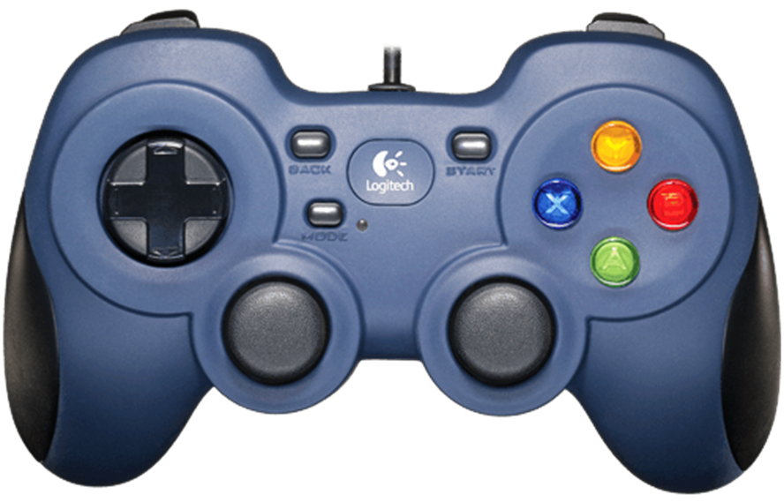

Raise Measuring Tape

Lift

Releases Side Flap

Lowers Measuring Tape

Hook Release

Intake Control

Drive Control

**Stick Shaping**

Stick shaping is how we control how our robot will move in tele-op. There are two different ways to do stick shaping; either with a calculus-based equation or an algebra-based equation. Algebra-based equations are linear in shape when graphed, thus they are much more predictable. Calculus-based equations are more parabolic in shape and are less predictable, but they allow for more precise movements at lower speeds. We began our year with an algebra-based equation, but decided a calculus-based one would be better for what we intended to do. We made a spreadsheet that allowed us to play with the equations and figure out how to alter our equation.

This is the graph of our equation when it was still algebra-based:

After playing around with the spreadsheet, we decided on an equation that gave us greater precision as well as a fair amount of predictability.

This is our new stick shaping equation:

# STRATEGIC / BUSINESS PLAN

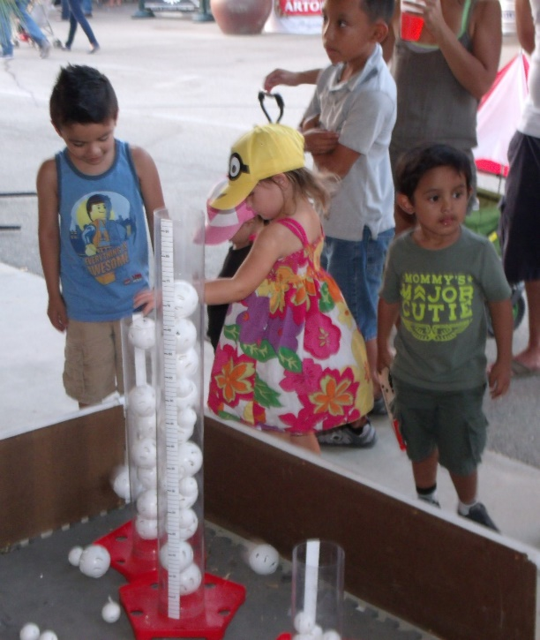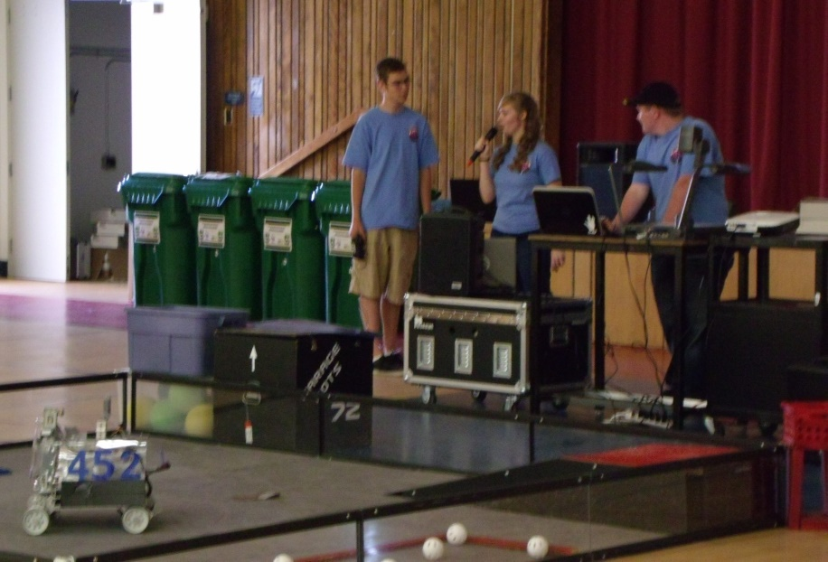

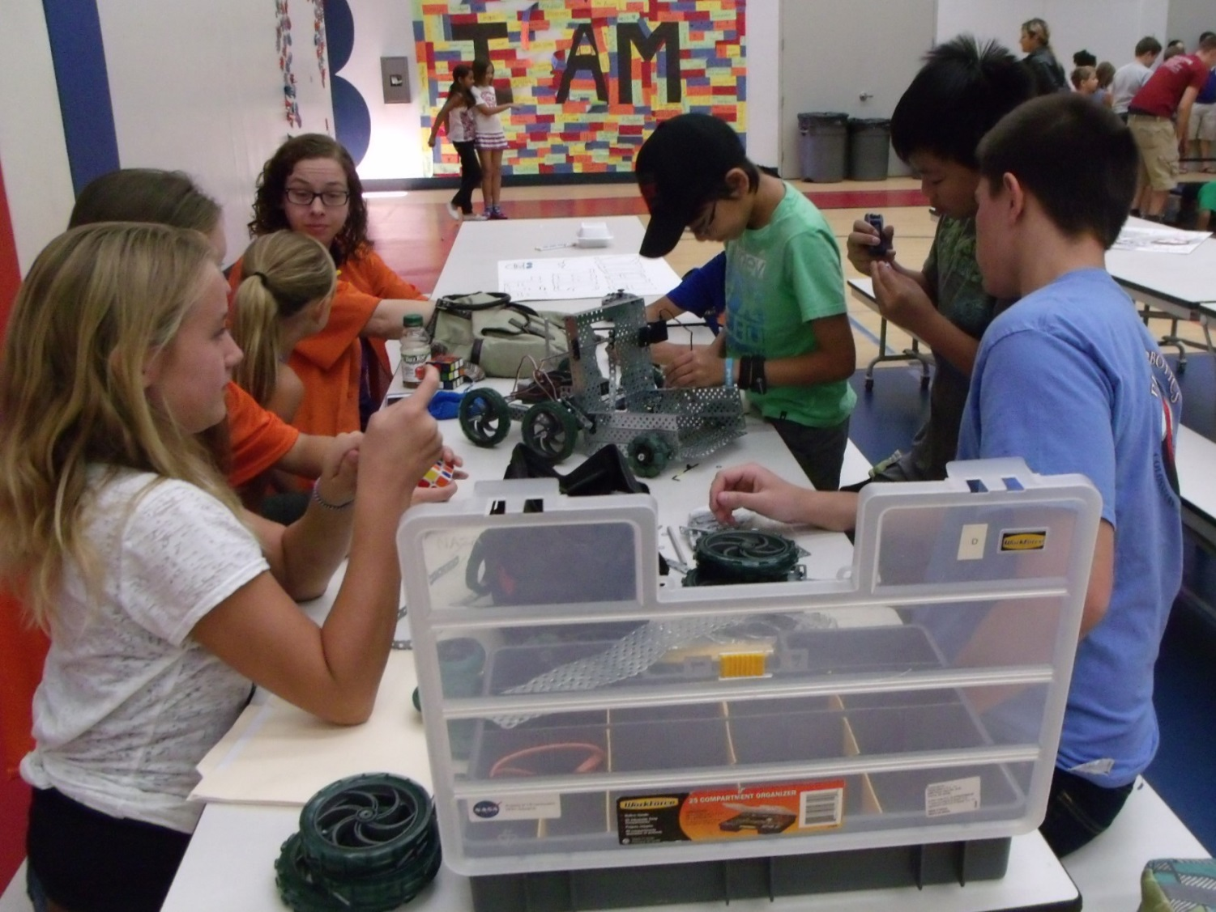

*Phi Omega’s Goals*

Every year, our team comes up with goals that we keep in mind throughout the rest of the year. Most years, our goals can be narrowed down into the same three things: Be Christ-like in everything we do, keep an honest budget, and promote FIRST and STEM to the community around us.

Goal #1 – Be Christ-like

The most important thing to us as a Christian team, is to show the love of Christ to those around us. Whether the hours we spend together in the garage, the time we spend with other teams at competitions, or the opportunities we have to reach out to the world around us, showing the kindness, the love, and the diligence of Christ is what we always strive to do.

Goal #2 – Keep an Honest Budget

Another important thing to the team is that we are honest, and responsible in the way we handle our money. We try not to ever spend money that we don’t have, and we hold regular fundraising events so that we always have something to fall back on. Some of the fundraisers we did this year included a day at Sweet Frog Frozen Yogurt, a night at a Jethawks Baseball game, and selling some discount cards. This year we have been especially diligent in our fundraising which has led to the benefits of extra hardware pieces and a 3D printer.

Goal #3 – Promote What We Do

We think it’s super important to share what we do with the community around us. Getting young people interested in STEM and FIRST is a step in shaping the future, and showing other people what we do helps promote interest in robotics in general. Also, by doing public outreach, we are able to show gracious professionalism to others. Some of the outreach events we did this year were the Lockheed Martin Family Day, Summer Robotics Workshop, Thursday Night on the Square, a night at Jethawks Baseball Stadium, and several weekends at the Antelope Valley Fair.

*OUTREACH*

Lockheed Martin Family Day

April 17, 2015

Author: Holly

The first outreach event we were able to have, after the heat of last season was over, took place at Lockheed Martin. Every year, they have a family day in which they set up booths and the Lockheed Martin employees get to spend a day enjoying food and entertainment with their families. One of our mentors is an employee for Lockheed Martin, so he arranged to get a booth for our team, our sister team Alpha, Phi Apprentice, and some other local teams to share.

We got there early in the morning, and set up some tables next to the other teams. We set up a handmade robot arena where we were able to drive our robot around along with the other team’s robots. We also set up our board, and handed out brochures so that anyone interested in the FIRST program could get the information they needed. Unfortunately, the robot wasn’t working a majority of the day, but the team members were able to look around at the other booths there, and interact with a lot of the people at the event, so overall it was a decent beginning to our outreach season.

Summer Robotics Workshop

June 22-27, 2015

Author(s): Eddie, Holly, and Sergei

The tournament portion of the workshop is run in a very similar way to a standard FTC competition, albeit shorter in duration. The kids come in, this time with their families, and take a seat on the provided bleachers. The day is opened with a salute to the American flag and the playing of the national anthem. Then, the kids are sent to their team tables to prepare their robots for competition.

This year’s game for the workshop was called *Mission Mars*. The goal of the game was to pick up scoring elements, such as FTC Ring it Up rings or dodgeballs, and score them in one of three zones. Each of the three zones was progressively harder to score in, but gained the team more points. Every thirty seconds, a “meteor shower” was launched. This consisted of a bucket of scoring elements being dumped on the field from the corners. This kept the game interesting, providing the teams obstacles to navigate through.

Each team competes in a series of qualifying matches to determine their standings for ranking. There is a short lunch break held about half of the way through the day. Then the qualifiers continue. Once they are completed, the teams are brought to the field for alliance selection. This process is run exactly how the FTC alliance selection is run. The top teams are asked which of the other teams they want to join them. These alliances are then put into quarterfinal matches. The workshop is organized each year with a perfect number of teams, allowing all teams to participate in at least the quarterfinals. The winning alliances of the quarterfinal matches are sent on to compete in a semifinals match. Lastly, the winning alliances of semifinals are sent up to the finals, where they compete in a best-two-of-three set of matches. This year, the alliance between Team 3 and Team 9 won, scoring the overall high score for the workshop.

The kids of the top three teams receive medals, but they are not the only ones to get awards. Before the workshop, a series of awards are decided, ranging from a clean-workspace award to a creative team name award. In this way, none of the kids are left out. Each kid also gets a certificate of participation showing the name of the workshop and the teams that volunteered.

On Thursday morning, we were able to join other local robotics teams from around the valley to give the kids at vex a presentation. We were able to tell the kids about our team, and what it is like being a part of an FTC robotics team. We explained the benefits of being involved in robotics and how amazing the experience can be. We also got to explain the building, and programming process, and show the kids how Khan, last year’s robot, worked. We were able to demonstrate our robot performing the actions we described. We were able to communicate the importance of the notebook, and the fundraising and outreach aspects of robotics, as well. Throughout the presentation, we were able to engage the kids in activities to help them better understand the concepts we presented. We were also given the opportunity to play the Cascade Effect promotional video so the kids could better understand the challenge we were faced with last year.

To end our presentation, we had a question and answer time, where we were able to answer any questions the kids’ had for us.

Every day of the workshop there is a period of time to build the robots that compete in the tournament. The point of the mentors is to try to lead each team through the building stages and to also help the team when it needs help not to build the robot for them. There are three main stages: 1 prototyping, 2 building the main ideas, and 3 finalizing and testing the robot.

We started by having the kids think up ideas for things they wanted the robot to do in the game. Then we helped theme come up with ways that the robot could accomplish them. The kids drew their ideas on paper and everyone on the team decided on ones that were good and we wanted to use. The mentors also gave pointers and tried to make them think more on how difficult something would be to build and whether we wanted something really complicated that could break and score lots of points or if they wanted something strong and simple but could not score as many points.

The ideas that were decided on then were tested the kids first built a chassis that everyone worked on. The mentors had to help teach the kids what parts did what and how to properly attach things. We then tested that chassis to see if it would go up the ramp if it did then we used it if it did not then we worked on a different idea. The team went through multiple designs for the drive train. We used treads, two big wheels two little, all big wheels until finally they decided on four medium wheels. After the kids built the chassis they had to build an arm to score elements. Most of the arms were pretty simple but some teams thought out of the box and built more complicated things.

After the robot was built we had to test the robot to make sure it ran right. If it did not we would have to modify if and fix things but if it ran okay we had the kids do drivers practice. After the kids drove we saw who drove the best and those kids then drove in the competition. After we drove it for a while we tried to decorate the robot while the batteries were charging. Then the robot was ready for the competition.

During the work shop we tried to teach the kids many thing like how motors worked or how to put things together we also worked on teamwork having everyone try to get to know the other team mates.

Thursday Night on the Square

July 9, 2015

Author(s): Becky, Hanna

This year we were able to participate in the Thursday Night on the Square event in Palmdale. During this event we were able to explain what the FIRST program is to a large amount of people.

The first thing we did once we arrived at TNOTS (Thursday Night on the Square), was set up our table. A few other FTC teams and FRC teams were also there to show off their robots.

Through the night, lots of different families visited our table. They asked questions about our robot, questions about the FIRST program, and questions about our team. The most common questions asked were, about what school(s) we went to, and what the functions of our robot has.

We drove our robot around and interacted with people. The kids that attended the event had a blast! They had the opportunity to feed the robot balls, follow the robot around, watch it score in the rolling goals, and high-five it. The kids also enjoyed giving it tasks to do, such as pulling the goal around the room and scoring in it. Our robot enjoyed playing with the kids, too. Our team found TNOTS to be successful and encouraging due to the fact that we had a large sum of people show an interest in joining FTC and ask about making contact to join our team.

Jethawks

August 29, 2015

Author: Eddie

During the off-season this year, PHI had the opportunity for a totally new fundraiser/outreach event. We were given the opportunity the opportunity through our local Minor League baseball team, the Jethawks, to sell tickets. After contacting a friendly FRC team from our area, we discovered that we would make back fifty percent of the money we sold the tickets for, something we almost couldn’t believe. On top of that, we would be given a table in the promenade of their stadium on game day to show off our team, as well as the challenges and fun of FTC, to spectators. Now excited for the chance to promote FIRST and their programs once again, we immediately began contacting the stadium for instructions.

Thanks to quick work on the part of our outreach manager, we were able to get tickets for a game reasonably soon after, August the 29th. After having gone in and purchased 100 tickets, we began the legwork to sell them to everybody we knew. Unfortunately, we were given less time to sell them off than we expected, and ended up only selling 59 of our 100. Along with this, a small miscommunication meant we did not get our money back for the tickets we did not sell. However, we did not lose any money and still were able to present on game day.

We arrived about an hour before seating began for the game in order to set up our table. Preparations passed quickly, and we soon had a good display set up. However, the pesky wind of the Antelope Valley gave us a hard time keeping our tablecloths from flying away. Great way to pass the time though! Due to presenting at our local fair at the same time of the month, Khan had minor damage and was not able to drive. Instead, we raised the bucket to maximum height and turned on our “Vegas” show lights to attract the attention of everyone within eyesight of our table.

During the three or so hours that we sat in the promenade, we swapped off crews of team members to allow those not on-duty to watch the game. Those that sat at the table were greeted by friendly spectators from the game and had several opportunities to talk with them about FIRST and what we do. One of the first people we talked to was actually a security guard for the stadium! He asked several questions about the Lego League programs, as he had younger children who were interested in what we were up to. We were able to give the man a good amount of information thanks to a few of our team members having mentored the three Lego League teams we support. Spectators came by about every fifteen minutes all asking similar questions about FIRST, our program, how our robot worked, and such. We happily engaged these people in long conversations, answering every question they asked and talking for as long as they would listen. Towards the end of the game, we were talked to for a half-hour by a man who actually worked in the field of robotics! He had worked for several years, designing and building CNC machines for larger companies and had accumulated a stockpile of motors over the years which he had no use for. The man’s first question was what we used for the power-train of the robot, fully intending to donate several of these motors to the team. Unfortunately, we had to explain the rules of FTC on motors, letting him know that we couldn’t. However, we were sure to show our great appreciation for his thought. We continued to talk with him about the rest of the electronics on our robot. The man expressed his appreciation for FIRST and our local teams for providing the next generation of engineers that would one day replace him.

Kick-off

September 12, 2015

Author: Hanna

Every year when the new game comes around we setup a kickoff party. We meet with our sister team, Alpha so that we have a wider variety of starting ideas. We started off the party by discussing what we hoped to accomplish during the season. One of our goals is to get more involved with are community. To go along with that goal, we hope to be more involved with the FLL teams we support. Another one of our goals was to work on having a better team dynamic. The team also talked about how important brainstorming and prototyping is, because the more we brainstorm and prototype the more likely our final product is to succeed. The team talked about which competitions we hoped to compete in this year. We decide that attempting to attend one in early December and then one in mid-January would be the best route for our team. Returning PHI members had the opportunity to explain the basics of the FIRST program to the new members.

We also watched the newly released video for “Res-Q”. After we watched the video, and it fully soaked in, we started brainstorming ideas. We talked about the possibility of using scoring mechanisms used in previous years, and ideas for brand new scoring mechanisms. The team talked about what kind of features we wanted this year’s chassis to consist of. A few of the features we decide on where; high ground clearance, light weight, and a fairly large mounting area. It turns out the designs we were describing were very similar to the Kraken chassis design we’ve used in past years.

Our team is off to a good start this year, but will only get better if we work well with our team members and work hard to accomplish. We feel confident that we’ll complete those goals and have a successful year this year whether we progress past the qualifiers or not.

Antelope Valley Fair

August 22-23, 2015

Authors(s): Sarah, Kaitlin, and Sergei

This Saturday, August 22, our robotics team visited the Antelope Valley Fair at the AV Fairgrounds. We were able to talk to many people not only about FIRST, but about PHI as well. We demonstrated the abilities of our robot to the people who came by driving Khan around, picking up balls, and dropping balls in the tubes. There were many children and teens who were interested. We passed out some candy to the children (and some adults as well to be honest) in the vicinity of our booth, regardless of whether or not they came and saw our robot demonstrations. Most people did, however, at least ask about the robots. We also passed out brochures to interested parents and older children. Most children were super excited to see robots moving around and completing tasks. This opened up opportunities to talk to the parents about enrolling their children in FIRST. One teen girl in particular got super excited when she saw the FRC team next to us. The team was Harry Potter themed, and she exclaimed excitedly to her mom many times, “Harry Potter *and* robots?! This is the best thing ever!” We even had several people who didn’t have children talk to us about their local schools and how to get them involved. One gentleman in particular was asking us where to get parts and how to set them up. His nephew had been put in charge of teaching electronics at his school, and due to a lack of knowledge on the subject, both of them were collecting as much information as possible on the subject. He talked to us for a while, and he was very grateful for all our input. While he talked to us, his wife also asked us questions. She wanted to know what kind of software we were using and how we were setting it up. She was very impressed with how much we were doing ourselves. Later in the evening, we set up our 3D printer and printed out small Star Trek logos as another demonstration. Being right at the entrance, we gathered a crowd sometimes, and we were able to talk to larger groups of people of all ages at one time.

Today we did an outreach at the Antelope Valley fair. We drove two different robots—Khan, our competition bot from the 2014-2015 season, and a test bot built with the new Android system. We brought both bots to contrast the old system with the new one. We also talked with some other teams about the new system and demonstrated it for them.

Despite some technical issues, we were able to get a fair amount of driving time in. We allowed some of our newer members to drive, in order to familiarize them with the controls, while some of the senior members interacted with the crowd. Visitors could watch the robots in action on the field, and speak to the team about FIRST robotics. Several people expressed interest, and some were even interested in starting an FLL team. Many people were amazed at how simple our robots were compared to common conceptions of robots.

Perkies Coffee House

January 9, 2016

Author: Sergei

Our team did an outreach /fundraiser at Perkies coffee house. They allowed us to bring the robot and drive around. When we first got there, we set all of our stuff up. We then had some people down at a busy street corner with a sign. We also had some people driving the robot and handing out fliers. Perkies was at a strip mal. Therefore, we could go into many of the places and giving out fliers and demonstrate the robot. We talked to many people about robotics. We would drive the robot along the sidewalk by the businesses. But we would also drive it along the street so that people driving by could see it.

We were able to talk to many people. There was one person and his little kid. The kid was really into building things. He was really into Legos. We were able to show him how the robot worked. He kept saying how cool it was. We then told his dad about FIRST and how you could get involved with it. We talked to him about the FLL and how first has a website. They seemed interested in joining a team.

We also talked to some grown up adults. We told them about FTC and our game. We then showed them how the robot could do the required things. We demonstrated the robot hanging off some ones finger. We also showed them how we used some phones that you could easily buy to control the robot.

The shop manager was really interested. So we showed him the game that we had to perform and how we did it. We then talked with him about how robots are the future. And how cool they are. He also posted on face book about us.

We had some people who were at the street corner telling about the fundraiser. We drove the robot around there to get some more attention. Having the robot with us raised lots of attention. Over all it was a worthwhile thing to do. We raised some support and we also got to tell lots of people about robotics. Many people showed interest in the robot as well.

*Sponsors and Fundraising*

PHI Robotics, a 501(c)(3) nonprofit organization, is the greater umbrella over both our team and our sister team PHI Alpha. Since we operate as one team, we share sponsors, funds, and a budget.

PHI is sponsored by corporations, private individuals, and our own fundraising events. Our corporate sponsors are Lockheed Martin, NASA, Jacobs and Northrop Grumman. A Northrop employee is also contributing to the team. Lockheed Martin has generously given us funds, and NASA buys us parts, machines custom parts for us, and pays our World Championship fees. Northrop also gives us funds.

Our fundraising events have included everything from sending out a sponsorship letter, selling baseball tickets, bringing in local business to a frozen yogurt shop, selling coupon cards, and having people make out-of-pocket donations just because they were interested in our cause.

We seek to use our money wisely, which includes using it to help other teams. We fund two local FIRST LEGO League teams, a Junior FLL team, and help fund another FTC team. In previous years we have also used our funds to host qualifying tournaments for the LA region.



*2015-2016*

*Budget*

**Income**

Member Dues   $350

Fund Raising   $460

FIRST Grant   $275

Corporate Sponsorships $3300

Total $4385

**Expenses**

Registration  $275

Android Kits  $660

Field Kit  $300

Tools/Parts $1300

3-D Printer $1000

Tournament Registration    $700

Total $4235

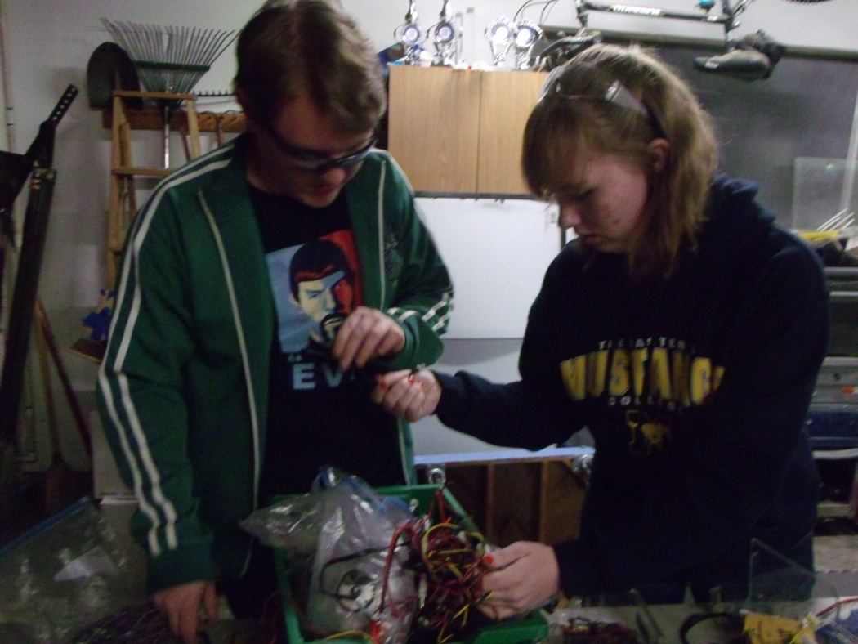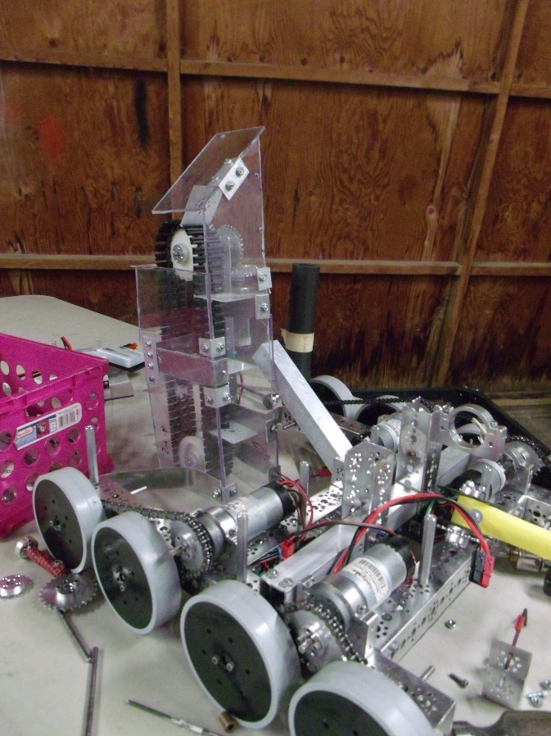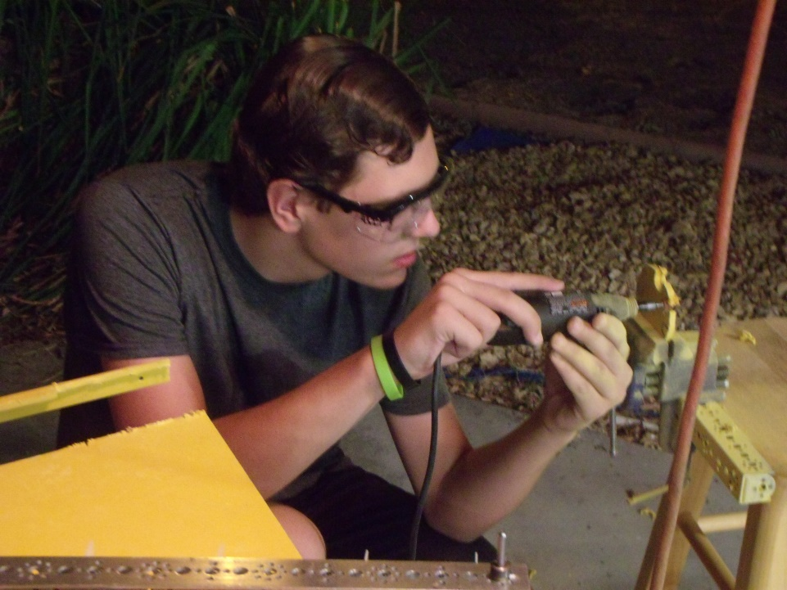

# TEAM ORGANIZATION

**TEAM ORGANIZATION:**

**PHI Omega and PHI Alpha:**

PHI Robotics actually isn’t registered as one team- it’s registered as two. However, even though PHI Omega and PHI Alpha compete as separate teams, build two different robots, and consist of different team members, they come together to form the organization PHI Robotics. Although most of the time we work independently of each other, members of both teams share ideas, prototypes, and help each other whenever help is needed.

PHI Alpha and PHI Omega also share funds and parts. They fundraise together, and also joint-hosted the 2014 High Desert Qualifying Tournament. All in all, even though the teams can look very different from the outside, they really come together to make up a larger team- PHI Robotics.

In the beginning of the year, PHI Robotics begins as one team, but as prototypes are developed and integrated onto basic chassis, the teams begin to form naturally. After a few months of working with this, PHI has usually naturally divided into PHI Alpha and PHI Omega. These teams don’t always change much from year to year, however, with the exception of new members joining the team and senior members’ graduation. Eddie, and Kaitlin have been members of PHI Omega since the 2012-2013 season.

**PHI Omega’s Organization:**

PHI Omega also has its own team structure. As the most senior member, Eddie leads the team over all, as well as taking leadership in the hardware area. This year he is mentoring two newer members-Hanna, and Sergei-to become the new hardware leads for next year.

Kaitlin, Becky, and Sarah make up the software team and are responsible for programming the robot. Because all of the software is brand new this year, and none of our software members have done software before, we do not have a software lead.

Holly coordinates the Engineering Notebook. Even though she coordinates the notebook, the rest of the team works primarily on their respective sections- the hardware team handles the hardware section, the software team the software section, and so on. All members work on the meeting log, as well as adding to the outreach section and other general sections.

Holly also does the majority of coordinating the fundraising and outreach events the team takes part in.

**The Mentors:**

Of course, no team would be complete without their mentors. Although PHI works primarily on its own, its mentors offer feedback on their designs, keep the teams focused, and help them plan and manage their time wisely. By helping us learn these skills, they help prepare us for life.

The Stinsons ran PHI for seven years as an FTC team, and for even longer since PHI was first a VEX robotics team. Over the years they have generously opened up their house to us, first allowing PHI to work in an upper room and then, as the team expanded, giving the team their entire garage. Even after Dylan graduated from robotics, they continued to host the team and keep it running.

This year, the Stinsons decided to step back from being a major part of the team and only run our finances. We are very grateful for everything they have put into the team over the years!

The team now meets in the Creech’s (Holly & Hanna’s family) garage, and Mr. Pierce and Mr. Cox are Omega’s mentors. This is their second year mentoring PHI, but both have had experience mentoring an FLL team with their kids in past years.

# Appendices

## Teleop

*/* Copyright (c) 2014 Qualcomm Technologies Inc  
All rights reserved.  
Redistribution and use in source and binary forms, with or without modification,  
are permitted (subject to the limitations in the disclaimer below) provided that  
the following conditions are met:  
Redistributions of source code must retain the above copyright notice, this list  
of conditions and the following disclaimer.  
Redistributions in binary form must reproduce the above copyright notice, this  
list of conditions and the following disclaimer in the documentation and/or  
other materials provided with the distribution.  
Neither the name of Qualcomm Technologies Inc nor the names of its contributors  
may be used to endorse or promote products derived from this software without  
specific prior written permission.  
NO EXPRESS OR IMPLIED LICENSES TO ANY PARTY'S PATENT RIGHTS ARE GRANTED BY THIS  
LICENSE. THIS SOFTWARE IS PROVIDED BY THE COPYRIGHT HOLDERS AND CONTRIBUTORS  
"AS IS" AND ANY EXPRESS OR IMPLIED WARRANTIES, INCLUDING, BUT NOT LIMITED TO,  
THE IMPLIED WARRANTIES OF MERCHANTABILITY AND FITNESS FOR A PARTICULAR PURPOSE  
ARE DISCLAIMED. IN NO EVENT SHALL THE COPYRIGHT OWNER OR CONTRIBUTORS BE LIABLE  
FOR ANY DIRECT, INDIRECT, INCIDENTAL, SPECIAL, EXEMPLARY, OR CONSEQUENTIAL  
DAMAGES (INCLUDING, BUT NOT LIMITED TO, PROCUREMENT OF SUBSTITUTE GOODS OR  
SERVICES; LOSS OF USE, DATA, OR PROFITS; OR BUSINESS INTERRUPTION) HOWEVER  
CAUSED AND ON ANY THEORY OF LIABILITY, WHETHER IN CONTRACT, STRICT LIABILITY,  
OR TORT (INCLUDING NEGLIGENCE OR OTHERWISE) ARISING IN ANY WAY OUT OF THE USE  
OF THIS SOFTWARE, EVEN IF ADVISED OF THE POSSIBILITY OF SUCH DAMAGE. */***package** com.qualcomm.ftcrobotcontroller.opmodes;  
  
**import** com.qualcomm.robotcore.eventloop.opmode.OpMode;  
**import** com.qualcomm.robotcore.hardware.DcMotor;  
**import** com.qualcomm.robotcore.hardware.Servo;  
**import** com.qualcomm.robotcore.util.Range;  
  
*/**  
 * TeleOp Mode  
 * <p>  
 * Enables control of the robot via the gamepad  
 */***public class** Unicorn2 **extends** OpMode {  
  
 **final static double** tmservo_MIN_RANGE = 0.20;  
 **final static double** tmservo_MAX_RANGE = 1.0;  
  
 **final static double** flapservo_MIN_RANGE = 0.20;  
 **final static double** flapservo_MAX_RANGE = 1.0;  
  
 **final static double** hookservo_MIN_RANGE = 0.20;  
 **final static double** hookservo_MAX_RANGE = 1.0;  
  
 *// position of the tmservo servo* **double** tmservoPosition;  
  
 *// position of the flapservo servo* **double** flapservoPosition;  
  
 *// position of the hookservo servos* **double** hookservoPosition;  
  
 *// amount to change the tmservo servo position by* **double** tmservoDelta = 0.0025;  
  
 **int** tanktoggle = 0;  
  
 DcMotor leftFront;  
 DcMotor leftRear;  
 DcMotor rightFront;  
 DcMotor rightRear;  
 DcMotor intake;  
 Servo tmservo;  
 Servo flapservo;  
 Servo lhookservo;  
 Servo rhookservo;  
 DcMotor lift;  
 */**  
 * Constructor  
 */* **public** Unicorn2() {  
  
 }  
  
 */*  
 * Code to run when the op mode is initialized goes here  
 *  
 * @see com.qualcomm.robotcore.eventloop.opmode.OpMode#init()  
 */* @Override  
 **public void** init() {  
  
  
 */*  
 * Use the hardwareMap to get the dc motors and servos by name. Note  
 * that the names of the devices must match the names used when you  
 * configured your robot and created the configuration file.  
 */* rightFront = hardwareMap.dcMotor.get(**"rightFront"**);  
 rightRear = hardwareMap.dcMotor.get(**"rightRear"**);  
 leftFront = hardwareMap.dcMotor.get(**"leftFront"**);  
 leftRear = hardwareMap.dcMotor.get(**"leftRear"**);  
 intake = hardwareMap.dcMotor.get(**"intake"**);  
 lift = hardwareMap.dcMotor.get(**"lift"**);  
  
 rightFront.setDirection(DcMotor.Direction.REVERSE);  
 rightRear.setDirection(DcMotor.Direction.REVERSE);  
  
 *//Tape Measure* tmservo = hardwareMap.servo.get(**"servo_6"**);  
 tmservoPosition = 0.6;  
 tmservo.setPosition(tmservoPosition);  
 telemetry.addData(**"pos"**, tmservo.getPosition());  
  
 flapservo = hardwareMap.servo.get(**"servo_1"**);  
 flapservoPosition = 0.5;  
 flapservo.setPosition(flapservoPosition);  
 telemetry.addData(**"pos"**, flapservo.getPosition());  
  
 lhookservo = hardwareMap.servo.get(**"servo_2"**);  
 rhookservo = hardwareMap.servo.get(**"servo_3"**);  
 hookservoPosition = lhookservo.getPosition();  
 rhookservo.setPosition(0.0);  
 lhookservo.setPosition(1.0);  
 telemetry.addData(**"rhook posn"**, rhookservo.getPosition());  
 telemetry.addData(**"lhook posn"**, lhookservo.getPosition());  
 }  
  
 */*  
 * This method will be called repeatedly in a loop  
 *  
 * @see com.qualcomm.robotcore.eventloop.opmode.OpMode#run()  
 */* @Override  
 **public void** loop() {  
  
 Drive();  
 }  
  
 *//when we press the button, we want the motors to move to turn the conveyor  
 //R1 will be intake, R2 is outtake  
 //R1 will be counterclockwise, R2 will be clockwise  
 //one motor  
 //We need to name the motor and define counterclockwise and clockwise  
 /*  
 * Code to run when the op mode is first disabled goes here  
 *   
 * @see com.qualcomm.robotcore.eventloop.opmode.OpMode#stop()  
 */* @Override  
 **public void** stop() {  
  
 }  
  
 **public void** Drive()  
 {  
 *//Define storage variables* **int** deadband = 0;  
 **double** rawX = 0;  
 **double** rawY = 0;  
 **double** shapedX, shapedY;  
 **double** leftPower, rightPower;  
  
 **double** scl_power = 3.0;  
  
 *//Check if the joystick is being used on any axis* **if** (Math.abs(gamepad1.left_stick_x) > deadband)  
 rawX = gamepad1.left_stick_x - (sgn(gamepad1.left_stick_x) * (**float**)deadband); *//Set variables and subtract deadband from total to avoid jump* **if** (Math.abs(gamepad1.left_stick_y) > deadband)  
 rawY = gamepad1.left_stick_y - (sgn(gamepad1.left_stick_y) * (**float**)deadband); *//Set variables and subtract deadband from total to avoid jump  
 // Shape the powers based on equation: y = (2/225)(x*abs(x))+(14/45)x  
 // Shortened constants from 16 decimal places to 12* shapedX = (**float**)0.25 * (rawX * Math.abs(rawX)) + (**float**)0.07 * rawX;  
 shapedY = (**float**)0.25 * (rawY * Math.abs(rawY)) + (**float**)0.07 * rawY;  
  
  
  
 shapedX=shapedX*scl_power;  
 shapedY=shapedY*scl_power;  
  
 **if** (shapedX > 1.0) shapedX= 1.0;  
 **if** (shapedX < -1.0) shapedX= -1.0;  
 **if** (shapedY > 1.0) shapedY = 1.0;  
 **if** (shapedY < -1.0) shapedY = -1.0;  
  
 *//Determine power of each side by slowing one side and increasing the other appropriately* leftPower = shapedY + shapedX;  
 rightPower = shapedY - shapedX;  
  
  
 **if** (leftPower > 1.0) leftPower= 1.0;  
 **if** (leftPower < -1.0) leftPower= -1.0;  
 **if** (rightPower > 1.0) rightPower = 1.0;  
 **if** (rightPower < -1.0) rightPower= -1.0;  
  
 telemetry.addData(**"leftPower"**,leftPower);  
 telemetry.addData(**"rightPower"**,rightPower);  
 *//Finally, set the power to the motors* leftFront.setPower(leftPower);  
 leftRear.setPower(leftPower);  
 rightFront.setPower(rightPower);  
 rightRear.setPower(rightPower);  
 *//intake power* **float** intakePower = 1.0F;  
 **float** winchPower = 1.0F;  
  
 *//INTAKE* **if** (gamepad1.right_bumper)  
 {  
 intake.setPower(-intakePower);  
 } *//intake* **else if** (gamepad1.right_trigger > 0)  
 {  
 intake.setPower(intakePower);  
 } *//output* **else** {  
 intake.setPower(0.0F);  
 }  
 *//WINCH* **if** (gamepad1.left_bumper)  
 {  
 lift.setPower(-winchPower);  
 } *//intake* **else if** (gamepad1.left_trigger > 0)  
 {  
 lift.setPower(winchPower);  
 } *//output* **else** {  
 lift.setPower(0.0F);  
 }  
  
 *// update the position of the tape measure servo* **if** (gamepad1.y) {  
 tmservoPosition += tmservoDelta;  
 telemetry.addData(**"gamepadY"**, **"Y pressed"**);  
 }  
  
 **if** (gamepad1.a) {  
 tmservoPosition -= tmservoDelta;  
 telemetry.addData(**"gamepadA"**, **"A pressed"**);  
 }  
 telemetry.addData(**"tmservoposition"**, tmservoPosition);  
 *// clip the position values so that they never exceed their allowed range.* tmservoPosition = Range.clip(tmservoPosition, tmservo_MIN_RANGE, tmservo_MAX_RANGE);  
  
 *// write position values to the wrist and tmservo servo* tmservo.setPosition(tmservoPosition);  
  
 **if** (gamepad1.x)  
 {  
 **if** (flapservoPosition > 0.5)  
 {  
 flapservoPosition = 0.5;  
 }  
 **else** {  
 flapservoPosition = 1.0;  
 telemetry.addData(**"inside else- x pressed"**, gamepad1.x);  
 }  
  
 }  
  
  
 telemetry.addData(**"flapservoposition"**, flapservoPosition);  
 *// clip the position values so that they never exceed their allowed range.* flapservoPosition = Range.clip(flapservoPosition, flapservo_MIN_RANGE, flapservo_MAX_RANGE);  
  
 *// write position values to the wrist and tmservo servo* flapservo.setPosition(flapservoPosition);  
  
 **if** (gamepad1.b)  
 {  
 **if** ( hookservoPosition < 0.25)  
 {  
 hookservoPosition = 0.5;  
 lhookservo.setPosition(hookservoPosition);  
 rhookservo.setPosition(hookservoPosition);  
  
 }  
 **else** {  
 hookservoPosition = 0.0;  
 lhookservo.setPosition(hookservoPosition);  
 rhookservo.setPosition(hookservoPosition);  
 }  
 }  
  
 telemetry.addData(**"hookservoposition"**, hookservoPosition);  
 *// clip the position values so that they never exceed their allowed range.* hookservoPosition = Range.clip(hookservoPosition, hookservo_MIN_RANGE, hookservo_MAX_RANGE);  
 */*  
 * Send telemetry data back to driver station. Note that if we are using  
 * a legacy NXT-compatible motor controller, then the getPower() method  
 * will return a null value. The legacy NXT-compatible motor controllers  
 * are currently write only.  
 */* telemetry.addData(**"Text"**, **"*** Robot Data***"**);  
 telemetry.addData(**"tmservo"**, **"tmservo: "** + String.format(**"%.2f"**, tmservoPosition));  
 }  
  
  
 **private float** sgn(**float** num)  
 {  
 **if** (num > 0)  
 **return** 1;  
 **return** -1;  
 }  
  
}

## Autonomy

**Gyro Turn**

This is our current gyro turn program. It is basically complete, except for occasional minor tweaks.

**package** com.qualcomm.ftcrobotcontroller.opmodes;  
  
**import** android.os.SystemClock;  
  
**import** com.qualcomm.robotcore.eventloop.opmode.LinearOpMode;  
**import** com.qualcomm.robotcore.hardware.DcMotor;  
**import** com.qualcomm.robotcore.hardware.GyroSensor;  
  
*/**  
 * Created by phi on 10/8/2015.  
 */***public class** GyroTurn **extends** LinearOpMode {  
  
 DcMotor **leftFront**;  
 DcMotor **leftRear**;  
 DcMotor **rightFront**;  
 DcMotor **rightRear**;  
 GyroSensor **gyro**;  
 Double **reqTurnDegrees**;  
 Float **biasSetter**;  
  
 **double gyroActual**;  
 **double bias**;  
 **int ii**=0;  
 **int jj**=0;  
 **int rotDirection**;  
  
  
  
 @Override  
 **public void** runOpMode() **throws** InterruptedException {  
 **gyro** = **hardwareMap**.**gyroSensor**.get(**"gyro"**);  
 *// wait for the start button to be pressed.* waitForStart();  
 **double** gyroBias;  
 **double** Angle = 0.0;  
 **double** angle_o = 0.0;  
 gyroBias = getBias();  
 **double** time_old = 0.0;  
 **double** GyroOld = 0.0;  
 **double** delta_time;**double** time100 = 0.;  
 **double** GyroNew;  
 **reqTurnDegrees** = 90.0;  
 **int** ii=1;  
 **int** ns=20;  
 **double** gyroBias_sum = 0;  
**while** (opModeIsActive()) {**double** t1 = **this**.**time**;  
 **bias** = getBias();  
 **time** = t1;  
 delta_time = **time** - time_old;  
 **telemetry**.addData(**"time"**, **time**);  
 **telemetry**.addData(**"time_old"**, time_old);  
 **telemetry**.addData(**"delta_time"**, delta_time);  
 GyroNew = -(**gyro**.getRotation() - gyroBias);  
 **telemetry**.addData(**"gyroOld"**, GyroOld);  
 **telemetry**.addData(**"gyroNew"**, GyroNew);  
 **telemetry**.addData(**"gyroBias"**, gyroBias);  
 *//temp ck integration*

Angle = Angle + delta_time * 0.5 * (GyroNew + GyroOld); *//- angle_o;* time_old = **time**;  
 GyroOld = GyroNew;  
 **if** (ii==1) angle_o= Angle;  
 **telemetry**.addData(**"Angle"**, Angle);  
 **telemetry**.addData(**"angle_o"**,angle_o);  
  
waitOneFullHardwareCycle();  
 ii = 2;  
 }  
 }  
  
  
 *//Gets the bias for the gyro* **double** getBias()  
 {  
 **return gyro**.getRotation();  
 }  
  
  
 *// Executes the gyro turn* **void** Turn (**double** turnDegrees) **throws** InterruptedException {  
 **double** Angle = 0.0;  
 **double** t1 = SystemClock.*uptimeMillis*() / 1000.0;  
 **double** time_old = 0.0;  
 **double** GyroOld = 0.0;  
 **double** maxVelocity = 180.0;  
 **double** motorSpeed = 0.0;  
 **double** DegreeGain = 5.0;  
 **long** MAX_GYRO_SPEED = 85; *//maximum motor speed allowed in turns* **long** MIN_GYRO_SPEED = 40; *//minimum motor speed allowed in turns* **gyro** = **hardwareMap**.**gyroSensor**.get(**"gyro"**);  
 **rightFront** = **hardwareMap**.**dcMotor**.get(**"rightFront"**);  
 **rightRear** = **hardwareMap**.**dcMotor**.get(**"rightRear"**);  
 **leftFront** = **hardwareMap**.**dcMotor**.get(**"leftFront"**);  
 **leftRear** = **hardwareMap**.**dcMotor**.get(**"leftRear"**);  
  
 **leftFront**.setDirection(DcMotor.Direction.***REVERSE***);  
 **leftRear**.setDirection(DcMotor.Direction.***REVERSE***); *//Runs motors at very low power to stop backlash* motorSpeed = 5;  
 **leftRear**.setPower(-**rotDirection** * motorSpeed);  
 **leftFront**.setPower(-**rotDirection** * motorSpeed);  
 **rightRear**.setPower(**rotDirection** * motorSpeed);  
 **rightFront**.setPower(**rotDirection** * motorSpeed);  
 wait1Msec(10);  
**telemetry**.addData(**"t1_pre_exec"**, t1);  
 **ii**=**ii**+1;  
 **telemetry**.addData(**"pre_exec"**, **ii**);  
 executeTurn(turnDegrees, Angle, t1, time_old, GyroOld, maxVelocity, motorSpeed, DegreeGain, MAX_GYRO_SPEED, MIN_GYRO_SPEED);  
 *// since we have now reached the target rotation (the while loop is done), stop all drive motors* **leftRear**.setPower(0);  
 **leftFront**.setPower(0);  
 **rightRear**.setPower(0);  
 **rightFront**.setPower(0);}  
  
 **void** executeTurn (**double** turnDegrees, **double** Angle, **double** t1, **double** time_old, **double** GyroOld, **double** maxVelocity, **double** motorSpeed, **double** DegreeGain, **long** MAX_GYRO_SPEED, **long** MIN_GYRO_SPEED) **throws** InterruptedException {  
 **double** delta_time;**double** time100 = 0.;  
 **double** GyroNew;  
 **double** gyroBias = 0;  
 **double** degreesToGo;  
 **jj**=**jj**+1;  
 **telemetry**.addData(**"in_exec,"**,**jj**);  
 **if** (turnDegrees < 0) **rotDirection** = -1;  
 **else rotDirection** = 1;  
  
 *// read the gyro sensor minus the bias offset. GyroBias must be declared and  
 // computed in the calling program.* GyroNew = -(**gyro**.getRotation() - gyroBias);  
 **telemetry**.addData(**"t1_inexec"**, t1);  
 **time** = t1; *// this timer wraps around* delta_time = Math.*abs*(**time** - time_old); *// delta time in s* **if** (delta_time < .001) *// protect against divide by zero* {  
 delta_time = .001;  
 }  
  
  
 *// limit the gyro to the max achievable by the bot to minimize data spikes.* **if** (Math.*abs*(GyroNew) > maxVelocity) GyroNew = Math.*signum*(GyroNew) * maxVelocity;  
  
 *// deadband for the gyro to eliminate drift due to noise* **if** (Math.*abs*(GyroNew) <= 0.2) GyroNew = 0.0;  
  
 *// compute the integral of the angular rate using a trapazoidal approximation  
 //* [*http://en.wikipedia.org/wiki/Numerical_integration*](http://en.wikipedia.org/wiki/Numerical_integration)

Angle = Angle + (**float**) delta_time * 0.5 * (GyroNew + GyroOld);  
  
 **telemetry**.addData(**"delta_time"**, delta_time);  
 **telemetry**.addData(**"time"**, **time**);  
 **telemetry**.addData(**"time_old"**, time_old);  
 *// update the old values for the next time through the loop* time_old = **time**;  
 **telemetry**.addData(**"time_old_2"**, time_old);  
 GyroOld = GyroNew;  
  
 *// Calculate the rotation remaining* degreesToGo = Math.*abs*(turnDegrees) - Math.*abs*(Angle);  
  
 *// motor speed is proportional to the amount of rotation remaining* motorSpeed = (**int**) (DegreeGain * Math.*abs*(degreesToGo));  
  
 *// limit the motor speed to be greater than 15 and less than 75* **if** (Math.*abs*(motorSpeed) > MAX_GYRO_SPEED) motorSpeed = MAX_GYRO_SPEED;  
 **if** (Math.*abs*(motorSpeed) < MIN_GYRO_SPEED) motorSpeed = MIN_GYRO_SPEED;  
  
 **telemetry**.addData(**"GyroOld"**, GyroOld);  
 **telemetry**.addData(**"GyroNew"**, GyroNew);  
 **telemetry**.addData(**"gyroBias"**, gyroBias);  
 **telemetry**.addData(**"delta_time"**, delta_time);  
 **telemetry**.addData(**"t1"**, t1);  
 **telemetry**.addData(**"Angle"**, Angle);  
  
  
  
 *//tc: modified so that the 'time100' is incremented every frame* time100 = delta_time + time100;  
 **telemetry**.addData(**"time100"**, time100);  
 **double** t2 = SystemClock.*uptimeMillis*() / 1000.0;  
 wait1Msec(20); *// wait 20 ms to allow a reasonable period for the integration* **double** t3 = SystemClock.*uptimeMillis*() / 1000.0;  
 **double** tw=t3-t2;  
 **telemetry**.addData(**"dt_20"**,tw); *// } // End while rotation remaining* **telemetry**.addData(**"Angle_afterWhile"**,Angle);  
  
  
 }  
  
 *//Waits 1t milliseconds* **void** wait1Msec (**long** time) **throws** InterruptedException {  
 *//tc: added sleep function so it waits* sleep(time);  
 }  
}

**Blue Inner**

**package** com.qualcomm.ftcrobotcontroller.opmodes;  
  
**import** com.qualcomm.ftccommon.DbgLog;  
**import** com.qualcomm.robotcore.eventloop.opmode.LinearOpMode;  
**import** com.qualcomm.robotcore.hardware.DcMotor;  
**import** com.qualcomm.robotcore.hardware.DcMotorController;  
**import** com.qualcomm.robotcore.hardware.GyroSensor;  
**import** com.qualcomm.robotcore.hardware.Servo;  
  
*/**  
 * Created by phi on 11/19/2015.  
 */***public class** blue_auto_zone_in **extends** LinearOpMode {  
  
 DcMotor **leftFront**;  
 DcMotor **leftRear**;  
 DcMotor **rightFront**;  
 DcMotor **rightRear**;  
 DcMotor **intake**;  
 Servo **lhookservo**;  
 Servo **rhookservo**;  
 Servo **tmservo**;  
 DcMotorController **dc_1**;  
 DcMotorController **dc_2**;  
 GyroSensor **gyro**;  
 DcMotorController.DeviceMode **devMode_a**;  
 DcMotorController.DeviceMode **devMode_b**;  
  
 **int rotDirection**;  
 **int state** = 0;  
  
 *// wheel and motor info to calculate the # of counts on encoder per inch of distance 'cnts_distin'* **double diam** = 4.0;  
 **long cnts_motorrev** = 1440;  
 *//long cnts_motorrev = 1120;* **double dist_wheelrev** = 3.1416 * **diam**;  
 **double motorrev_wheelrev** = 1.0;  
 **double cnts_distin** = **cnts_motorrev** * **motorrev_wheelrev** / **dist_wheelrev**;  
  
  
 @Override  
 **public void** runOpMode() **throws** InterruptedException {  
 **gyro** = **hardwareMap**.**gyroSensor**.get(**"gyro"**);  
 **rightFront** = **hardwareMap**.**dcMotor**.get(**"rightFront"**);  
 **rightRear** = **hardwareMap**.**dcMotor**.get(**"rightRear"**);  
 **leftFront** = **hardwareMap**.**dcMotor**.get(**"leftFront"**);  
 **leftRear** = **hardwareMap**.**dcMotor**.get(**"leftRear"**);  
 **intake** = **hardwareMap**.**dcMotor**.get(**"intake"**);  
 **lhookservo** = **hardwareMap**.**servo**.get(**"servo_2"**);  
 **rhookservo** = **hardwareMap**.**servo**.get(**"servo_3"**);  
 **tmservo** = **hardwareMap**.**servo**.get(**"servo_6"**);  
 **dc_1** = **hardwareMap**.**dcMotorController**.get(**"dc_1"**);  
 **dc_2** = **hardwareMap**.**dcMotorController**.get(**"dc_2"**);  
  
  
 **leftFront**.setDirection(DcMotor.Direction.***REVERSE***);  
 **leftRear**.setDirection(DcMotor.Direction.***REVERSE***);  
  
  
 *// wait for the start button to be pressed.* waitForStart();  
  
 **double** reqTurnDegrees;  
 **double** power;  
 **double** dist;  
  
 **rhookservo**.setPosition(0.0);  
 **lhookservo**.setPosition(1.0);  
 **tmservo**.setPosition(0.6);  
  
 **leftFront**.setChannelMode(DcMotorController.RunMode.***RESET_ENCODERS***);  
 **rightFront**.setChannelMode(DcMotorController.RunMode.***RESET_ENCODERS***);  
 *//leftFront.setChannelMode(DcMotorController.RunMode.RUN_TO_POSITION);  
 //rightFront.setChannelMode(DcMotorController.RunMode.RUN_TO_POSITION);* **telemetry**.addData(**"dc_runmode"**, **dc_1**.getMotorControllerDeviceMode());  
  
 *//time.startTime();* **while** (opModeIsActive()) {  
 **switch** (**state**) {  
 **case** 0:  
 dist = 10.0;  
 power = 1.0;  
 MoveEncoder(dist, power);  
 **telemetry**.addData(**"state"**, **state**);  
 **state** = **state** + 1;  
 wait1Msec(200);  
 **break**;  
 **case** 1:  
 reqTurnDegrees = -40;  
 Turn(reqTurnDegrees);  
 **telemetry**.addData(**"state"**, **state**);  
 **state** = **state** + 1;  
 wait1Msec(200);  
 **break**;  
 **case** 2:  
 **intake**.setPower(-1.0F);  
 dist = 14.0;  
 power = 1.0;  
 MoveEncoder(dist, power);  
 **telemetry**.addData(**"state"**, **state**);  
 **state** = **state** + 1;  
 wait1Msec(200);  
 **break**;  
 **case** 3:  
 reqTurnDegrees = -20;  
 Turn(reqTurnDegrees);  
 **telemetry**.addData(**"state"**, **state**);  
 **state** = **state** + 1;  
 wait1Msec(200);  
 **break**;  
 **case** 4:  
 dist = 3.0;  
 power = 1.0;  
 MoveEncoder(dist, power);  
 **intake**.setPower(0.0F);  
 **telemetry**.addData(**"state"**, **state**);  
 **state** = **state** + 1;  
 wait1Msec(200);  
 **break**;  
 **default**:  
 **dc_1**.setMotorControllerDeviceMode(DcMotorController.DeviceMode.***READ_ONLY***);  
 **dc_2**.setMotorControllerDeviceMode(DcMotorController.DeviceMode.***READ_ONLY***);  
 wait1Msec(20);  
 **telemetry**.addData(**"default"**, **"default"**);  
 **telemetry**.addData(**"left front curr enc"**,**leftFront**.getCurrentPosition());  
 **telemetry**.addData(**"getTargetPosn_LF"**, **leftFront**.getTargetPosition());  
 wait1Msec(5000);  
 **break**;  
 }  
  
 waitOneFullHardwareCycle();  
  
 }  
 }  
  
  
 *//Gets the bias for the gyro* **double** getBias() {  
 **return gyro**.getRotation();  
 }  
  
  
 *// Executes the gyro turn* **void** Turn(**double** turnDegrees) **throws** InterruptedException {  
 **double** Angle = 0.0;  
 **double** t1 = **this**.**time**;  
 **double** time_old = 0.0;  
 **double** GyroOld = 0.0;  
 **double** maxVelocity = 180.0;  
 **double** motorSpeed = 0.5;  
 **double** DegreeGain = 1.0;  
 **double** MAX_GYRO_SPEED = .85; *//maximum motor speed allowed in turns* **double** MIN_GYRO_SPEED = .40; *//minimum motor speed allowed in turns* executeTurn(turnDegrees, Angle, t1, time_old, GyroOld, maxVelocity, motorSpeed, DegreeGain, MAX_GYRO_SPEED, MIN_GYRO_SPEED);  
  
 *// since we have now reached the target rotation (the while loop is done), stop all drive motors  
 // tc: may want to move after while-loop in 'execute turn', but it should not matter...* motorSpeed = 0.0;  
 **leftRear**.setPower(motorSpeed);  
 **leftFront**.setPower(motorSpeed);  
 **rightRear**.setPower(motorSpeed);  
 **rightFront**.setPower(motorSpeed);  
  
  
 }  
  
 **void** executeTurn(**double** turnDegrees, **double** Angle, **double** t1, **double** time_old, **double** GyroOld, **double** maxVelocity, **double** motorSpeed, **double** DegreeGain, **double** MAX_GYRO_SPEED, **double** MIN_GYRO_SPEED) **throws** InterruptedException {  
 **double** delta_time;  
 **double** time100 = 0.;  
 **double** GyroNew;  
 **double** degreesToGo;  
 **long** rotDirection;  
 *//int ii;  
 //int ns = 20;  
 // double gyroBias;  
 // double gyroBias_sum=0.;* **double** gyroBias = getBias();  
 *// tc: may want to average the gyro bias over a few frames instead of just the first value  
 //for (ii=1; ii==ns; ii++) {  
 //gyroBias = getBias();  
 // gyroBias_sum=gyroBias + gyroBias_sum;  
 // }  
 //gyroBias=gyroBias_sum/ns;* **if** (turnDegrees < 0) rotDirection = -1;  
 **else** rotDirection = 1;  
  
 *//Runs motors at very low power to stop backlash* motorSpeed = .05;  
 **leftRear**.setPower(rotDirection * motorSpeed);  
 **leftFront**.setPower(rotDirection * motorSpeed);  
 **rightRear**.setPower(-rotDirection * motorSpeed);  
 **rightFront**.setPower(-rotDirection * motorSpeed);  
 wait1Msec(10);  
  
  
 *//set first time_old to be current time. Since delta_time tends to be 10-12 millisecs. The wait1Msec(10) is appropriate* time_old = t1;  
  
 **while** ((Math.*abs*(turnDegrees) - Math.*abs*(Angle)) > 3) {  
  
 *// read the gyro sensor minus the bias offset. GyroBias must be declared and  
 // computed in the calling program.* GyroNew = -(**gyro**.getRotation() - gyroBias);  
  
 *// this timer wraps around* t1 = **this**.**time**;  
 **time** = t1;  
 delta_time = Math.*abs*(**time** - time_old); *// delta time in s  
  
  
 //tc: since the 'delta_time' is in secs changed the '1' to '.001'* **if** (delta_time < .001) *// protect against divide by zero* {  
 delta_time = .001;  
 }  
  
  
 *// limit the gyro to the max achievable by the bot to minimize data spikes.* **if** (Math.*abs*(GyroNew) > maxVelocity) GyroNew = Math.*signum*(GyroNew) * maxVelocity;  
  
 *// deadband for the gyro to eliminate drift due to noise* **if** (Math.*abs*(GyroNew) <= 0.2) GyroNew = 0.0;  
  
 *// compute the integral of the angular rate using a trapazoidal approximation  
 // http://en.wikipedia.org/wiki/Numerical_integration  
  
 //tc: since the 'delta_time' is in secs already took out the .001\** Angle = Angle + delta_time * 0.5 * (GyroNew + GyroOld);  
  
  
 *// update the old values for the next time through the loop* time_old = **time**;  
 GyroOld = GyroNew;  
  
 *// Calculate the rotation remaining* degreesToGo = Math.*abs*(turnDegrees) - Math.*abs*(Angle);  
  
 *// motor speed is proportional to the amount of rotation remaining* motorSpeed = (DegreeGain * Math.*abs*(degreesToGo));  
  
 *// limit the motor speed to be greater than .40 and less than .85* **if** (Math.*abs*(motorSpeed) > MAX_GYRO_SPEED) motorSpeed = MAX_GYRO_SPEED;  
 **if** (Math.*abs*(motorSpeed) < MIN_GYRO_SPEED) motorSpeed = MIN_GYRO_SPEED;  
  
  
 **leftRear**.setPower(rotDirection * motorSpeed);  
 **leftFront**.setPower(rotDirection * motorSpeed);  
 **rightRear**.setPower(-rotDirection * motorSpeed);  
 **rightFront**.setPower(-rotDirection * motorSpeed); *// side moves forward for (+) CW rotation\  
  
 //tc: modified so that the 'time100' is incremented every frame* time100 = delta_time + time100;  
  
  
 wait1Msec(20); *// wait 20 ms to allow a reasonable period for the integration* **if** (time100 > 10.0) **break**; *// if the bot is not done turning in 5 sec, quit* } *// end while loop* }  
  
 **void** MoveEncoder(**double** dist, **double** power) **throws** InterruptedException {  
 **double** leftFrontCurrentEncoder = 0;  
 **double** rightFrontCurrentEncoder = 0;  
 **double** t1;  
 **long** tdly=50;  
  
 *//Runs motors at very low power to stop backlash  
 /* leftRear.setPower(.05);  
 leftFront.setPower(.05);  
 rightRear.setPower(.05);  
 rightFront.setPower(.05);  
 wait1Msec(10);  
//Runs motors at very low power to stop backlash  
 leftRear.setPower(.0);  
 leftFront.setPower(.0);  
 rightRear.setPower(.0);  
 rightFront.setPower(.0);  
 wait1Msec(10); */* **leftFront**.setChannelMode(DcMotorController.RunMode.***RESET_ENCODERS***);  
 **rightFront**.setChannelMode(DcMotorController.RunMode.***RESET_ENCODERS***);  
 wait1Msec(tdly);  
 **leftRear**.setChannelMode(DcMotorController.RunMode.***RESET_ENCODERS***);  
 **rightRear**.setChannelMode(DcMotorController.RunMode.***RESET_ENCODERS***);  
 wait1Msec(tdly);  
 **leftFront**.setChannelMode(DcMotorController.RunMode.***RUN_USING_ENCODERS***);  
 **rightFront**.setChannelMode(DcMotorController.RunMode.***RUN_USING_ENCODERS***);  
 wait1Msec(tdly);  
 **leftRear**.setChannelMode(DcMotorController.RunMode.***RUN_USING_ENCODERS***);  
 **rightRear**.setChannelMode(DcMotorController.RunMode.***RUN_USING_ENCODERS***);  
  
 wait1Msec(tdly);  
 *//leftFront.setChannelMode(DcMotorController.RunMode.RUN_TO_POSITION);  
 //rightFront.setChannelMode(DcMotorController.RunMode.RUN_TO_POSITION);  
 // wait1Msec(20);  
  
 // devMode_a = dc_1.getMotorControllerDeviceMode();  
 // devMode_b = dc_2.getMotorControllerDeviceMode();  
 // wait1Msec(20);* **double** cnt_target = **cnts_distin** * dist;  
 *// telemetry.addData("cnt_target", (int) cnt_target);  
 // telemetry.addData("ii", ii);  
 // only necessay to set target if using run to position  
 // leftFront.setTargetPosition((int) cnt_target);  
 // rightFront.setTargetPosition((int) cnt_target);  
 // leftRear.setTargetPosition((int) cnt_target);  
 // rightRear.setTargetPosition((int) cnt_target);* **if** (dist < 0) power = -power;  
  
 *// telemetry.addData("left device mode", devMode_a);  
 // telemetry.addData("right device mode", devMode_b);* **if** (dist < 0) {  
  
 **dc_1**.setMotorControllerDeviceMode(DcMotorController.DeviceMode.***READ_ONLY***);  
 **dc_2**.setMotorControllerDeviceMode(DcMotorController.DeviceMode.***READ_ONLY***);  
 wait1Msec(tdly);  
 **telemetry**.addData(**"dist less 0"**,**"dist less 0"**);  
 **telemetry**.addData(**"power"**, power);  
 **telemetry**.addData(**"cnt_target"**,cnt_target);  
 **telemetry**.addData(**"left front curr enc"**, leftFrontCurrentEncoder);  
 *// telemetry.addData("getTargetPosn_LF", leftFront.getTargetPosition());* DbgLog.*msg*(String.*format*(**"Data3-leftFront.getPower- %.03f"**, (**float**) **leftFront**.getPower()));  
 DbgLog.*msg*(String.*format*(**"Data3-TargetPosn - %.03f"**, (**float**) cnt_target));  
 DbgLog.*msg*(String.*format*(**"Data3-LeftFrontEncoder- %.03f"**, (**float**) leftFrontCurrentEncoder));  
 **dc_1**.setMotorControllerDeviceMode(DcMotorController.DeviceMode.***WRITE_ONLY***);  
 **dc_2**.setMotorControllerDeviceMode(DcMotorController.DeviceMode.***WRITE_ONLY***);  
 wait1Msec(8000);  
 }  
 **telemetry**.addData(**"power"**, power);  
  
 **leftFront**.setPower(power);  
 **rightFront**.setPower(power);  
 **leftRear**.setPower(power);  
 **rightRear**.setPower(power);  
 wait1Msec(tdly);  
  
  
 *//wait1Msec(200);* **dc_1**.setMotorControllerDeviceMode(DcMotorController.DeviceMode.***READ_ONLY***);  
 **dc_2**.setMotorControllerDeviceMode(DcMotorController.DeviceMode.***READ_ONLY***);  
 wait1Msec(tdly);  
  
 */* telemetry.addData("leftFront Power", leftFront.getPower());  
 telemetry.addData("rightFront power", rightFront.getPower());  
 telemetry.addData("leftRear Power", leftRear.getPower());  
 telemetry.addData("rightRear power", rightRear.getPower());*/  
  
 /* telemetry.addData("right front curr enc", rightFrontCurrentEncoder);  
 telemetry.addData("getTargetPosn_RF",rightFront.getTargetPosition());  
 telemetry.addData("left front curr enc", leftFrontCurrentEncoder);  
 telemetry.addData("getTargetPosn_LF",leftFront.getTargetPosition()); */  
  
  
 // would like to try || instead of &&  
 // while (rightFrontCurrentEncoder < cnt_target && leftFrontCurrentEncoder < cnt_target) {* **while** ( Math.*abs*(leftFrontCurrentEncoder) < Math.*abs*(cnt_target)) {  
  
 t1 = **this**.**time**;  
 *// If we've switched to read mode, we can read data from the NXT device.  
 // Only necessary on NXT devices.  
  
 // Update the reads after some loops, when the command has successfully propagated through.* **telemetry**.addData(**"leftFront Power"**, **leftFront**.getPower());  
 **telemetry**.addData(**"rightFront power"**, **rightFront**.getPower());  
 **telemetry**.addData(**"leftRear Power"**, **leftRear**.getPower());  
 **telemetry**.addData(**"rightRear power"**, **rightRear**.getPower());  
  
 *// telemetry.addData("left device mode", devMode_a);  
 // telemetry.addData("right device mode", devMode_b);* rightFrontCurrentEncoder = **rightFront**.getCurrentPosition();  
 leftFrontCurrentEncoder = **leftFront**.getCurrentPosition();  
  
 *// rightRearCurrentEncoder = rightRear.getCurrentPosition();  
 // leftRearCurrentEncoder = leftRear.getCurrentPosition();* **telemetry**.addData(**"right front curr enc"**, rightFrontCurrentEncoder);  
 *// telemetry.addData("getTargetPosn_RF", rightFront.getTargetPosition());* **telemetry**.addData(**"cnt_target"**, cnt_target);  
 **telemetry**.addData(**"left front curr enc"**, leftFrontCurrentEncoder);  
 **telemetry**.addData(**"getTargetPosn_LF"**, **leftFront**.getTargetPosition());  
 wait1Msec(tdly);  
 DbgLog.*msg*(String.*format*(**"Data2-Time- %.03f"**, t1));  
 DbgLog.*msg*(String.*format*(**"Data2-RightFrontEncoder- %.03f"**, (**float**) rightFrontCurrentEncoder));  
 DbgLog.*msg*(String.*format*(**"Data2-leftFront.getPower- %.03f"**, (**float**) **leftFront**.getPower()));  
 DbgLog.*msg*(String.*format*(**"getTargetPosn_LF - %.03f"**, (**float**) **leftFront**.getTargetPosition()));  
 DbgLog.*msg*(String.*format*(**"Data2-LeftFrontEncoder- %.03f"**, (**float**) leftFrontCurrentEncoder));  
  
 *//wait1Msec(2000);  
 // Only needed on Nxt devices, but not on USB devices* }  
  
 **dc_1**.setMotorControllerDeviceMode(DcMotorController.DeviceMode.***WRITE_ONLY***);  
 **dc_2**.setMotorControllerDeviceMode(DcMotorController.DeviceMode.***WRITE_ONLY***);  
 wait1Msec(tdly);  
 **telemetry**.addData(**"inside loop"**, **"yes"**);  
 **leftFront**.setPower(0.0);  
 **rightFront**.setPower(0.0);  
 **rightRear**.setPower(0.0);  
 **leftRear**.setPower(0.0);  
 wait1Msec(tdly);  
 **leftFront**.setChannelMode(DcMotorController.RunMode.***RESET_ENCODERS***);  
 **rightFront**.setChannelMode(DcMotorController.RunMode.***RESET_ENCODERS***);  
 wait1Msec(tdly);  
 **leftRear**.setChannelMode(DcMotorController.RunMode.***RESET_ENCODERS***);  
 **rightRear**.setChannelMode(DcMotorController.RunMode.***RESET_ENCODERS***);  
 wait1Msec(tdly);  
 **leftFront**.setChannelMode(DcMotorController.RunMode.***RUN_WITHOUT_ENCODERS***);  
 **rightFront**.setChannelMode(DcMotorController.RunMode.***RUN_WITHOUT_ENCODERS***);  
 wait1Msec(tdly);  
 **leftRear**.setChannelMode(DcMotorController.RunMode.***RUN_WITHOUT_ENCODERS***);  
 **rightRear**.setChannelMode(DcMotorController.RunMode.***RUN_WITHOUT_ENCODERS***);  
 }  
  
 **private boolean** withinMarginOfError(**int** goal, **int** value) {  
 **int** lowerMargin = goal - 5;  
 **int** upperMargin = goal + 5;  
 **return** (value >= lowerMargin && value <= upperMargin);  
 }  
  
 *//Waits 1t milliseconds* **void** wait1Msec(**long** time) **throws** InterruptedException {  
 Thread.*sleep*(time);  
 **return**;  
 }  
}

**Blue Outer**

**package** com.qualcomm.ftcrobotcontroller.opmodes;  
  
**import** com.qualcomm.ftccommon.DbgLog;  
**import** com.qualcomm.robotcore.eventloop.opmode.LinearOpMode;  
**import** com.qualcomm.robotcore.hardware.DcMotor;  
**import** com.qualcomm.robotcore.hardware.DcMotorController;  
**import** com.qualcomm.robotcore.hardware.GyroSensor;  
**import** com.qualcomm.robotcore.hardware.Servo;  
  
*/**  
 * Created by phi on 11/19/2015.  
 */***public class** blue_auto_zone_out **extends** LinearOpMode {  
  
 DcMotor **leftFront**;  
 DcMotor **leftRear**;  
 DcMotor **rightFront**;  
 DcMotor **rightRear**;  
 DcMotor **intake**;  
 Servo **lhookservo**;  
 Servo **rhookservo**;  
 Servo **tmservo**;  
 DcMotorController **dc_1**;  
 DcMotorController **dc_2**;  
 GyroSensor **gyro**;  
 DcMotorController.DeviceMode **devMode_a**;  
 DcMotorController.DeviceMode **devMode_b**;  
  
 **int rotDirection**;  
 **int state** = 0;  
  
 *// wheel and motor info to calculate the # of counts on encoder per inch of distance 'cnts_distin'* **double diam** = 4.0;  
 **long cnts_motorrev** = 1440;  
 *//long cnts_motorrev = 1120;* **double dist_wheelrev** = 3.1416 * **diam**;  
 **double motorrev_wheelrev** = 1.0;  
 **double cnts_distin** = **cnts_motorrev** * **motorrev_wheelrev** / **dist_wheelrev**;  
  
  
 @Override  
 **public void** runOpMode() **throws** InterruptedException {  
 **gyro** = **hardwareMap**.**gyroSensor**.get(**"gyro"**);  
 **rightFront** = **hardwareMap**.**dcMotor**.get(**"rightFront"**);  
 **rightRear** = **hardwareMap**.**dcMotor**.get(**"rightRear"**);  
 **leftFront** = **hardwareMap**.**dcMotor**.get(**"leftFront"**);  
 **leftRear** = **hardwareMap**.**dcMotor**.get(**"leftRear"**);  
 **intake** = **hardwareMap**.**dcMotor**.get(**"intake"**);  
 **lhookservo** = **hardwareMap**.**servo**.get(**"servo_2"**);  
 **rhookservo** = **hardwareMap**.**servo**.get(**"servo_3"**);  
 **tmservo** = **hardwareMap**.**servo**.get(**"servo_6"**);  
 **dc_1** = **hardwareMap**.**dcMotorController**.get(**"dc_1"**);  
 **dc_2** = **hardwareMap**.**dcMotorController**.get(**"dc_2"**);  
  
  
 **leftFront**.setDirection(DcMotor.Direction.***REVERSE***);  
 **leftRear**.setDirection(DcMotor.Direction.***REVERSE***);  
  
  
 *// wait for the start button to be pressed.* waitForStart();  
  
 **double** reqTurnDegrees;  
 **double** power;  
 **double** dist;  
 **rhookservo**.setPosition(0.0);  
 **lhookservo**.setPosition(1.0);  
 **tmservo**.setPosition(0.6);  
  
 **leftFront**.setChannelMode(DcMotorController.RunMode.***RESET_ENCODERS***);  
 **rightFront**.setChannelMode(DcMotorController.RunMode.***RESET_ENCODERS***);  
 *//leftFront.setChannelMode(DcMotorController.RunMode.RUN_TO_POSITION);  
 //rightFront.setChannelMode(DcMotorController.RunMode.RUN_TO_POSITION);* **telemetry**.addData(**"dc_runmode"**, **dc_1**.getMotorControllerDeviceMode());  
  
 *//time.startTime();* **while** (opModeIsActive()) {  
 **switch** (**state**) {  
 **case** 0:  
 dist = 5.0;  
 power = 1.0;  
 MoveEncoder(dist, power);  
 **telemetry**.addData(**"state"**, **state**);  
 **state** = **state** + 1;  
 wait1Msec(200);  
 **break**;  
 **case** 1:  
 reqTurnDegrees = -45;  
 Turn(reqTurnDegrees);  
 **telemetry**.addData(**"state"**, **state**);  
 **state** = **state** + 1;  
 wait1Msec(200);  
 **break**;  
 **case** 2:  
 **intake**.setPower(-1.0F);  
 dist = 26.0;  
 power = 1.0;  
 MoveEncoder(dist, power);  
 **telemetry**.addData(**"state"**, **state**);  
 **state** = **state** + 1;  
 wait1Msec(200);  
 **break**;  
 **case** 3:  
 reqTurnDegrees = -20;  
 Turn(reqTurnDegrees);  
 **telemetry**.addData(**"state"**, **state**);  
 **state** = **state** + 1;  
 wait1Msec(200);  
 **break**;  
 **case** 4:  
 dist = 3.0;  
 power = 1.0;  
 MoveEncoder(dist, power);  
 **intake**.setPower(0.0F);  
 **telemetry**.addData(**"state"**, **state**);  
 **state** = **state** + 1;  
 wait1Msec(200);  
 **break**;  
 **default**:  
 **dc_1**.setMotorControllerDeviceMode(DcMotorController.DeviceMode.***READ_ONLY***);  
 **dc_2**.setMotorControllerDeviceMode(DcMotorController.DeviceMode.***READ_ONLY***);  
 wait1Msec(20);  
 **telemetry**.addData(**"default"**, **"default"**);  
 **telemetry**.addData(**"left front curr enc"**,**leftFront**.getCurrentPosition());  
 **telemetry**.addData(**"getTargetPosn_LF"**, **leftFront**.getTargetPosition());  
 wait1Msec(5000);  
 **break**;  
 }  
  
 waitOneFullHardwareCycle();  
  
 }  
 }  
  
  
 *//Gets the bias for the gyro* **double** getBias() {  
 **return gyro**.getRotation();  
 }  
  
  
 *// Executes the gyro turn* **void** Turn(**double** turnDegrees) **throws** InterruptedException {  
 **double** Angle = 0.0;  
 **double** t1 = **this**.**time**;  
 **double** time_old = 0.0;  
 **double** GyroOld = 0.0;  
 **double** maxVelocity = 180.0;  
 **double** motorSpeed = 0.5;  
 **double** DegreeGain = 1.0;  
 **double** MAX_GYRO_SPEED = .85; *//maximum motor speed allowed in turns* **double** MIN_GYRO_SPEED = .40; *//minimum motor speed allowed in turns* executeTurn(turnDegrees, Angle, t1, time_old, GyroOld, maxVelocity, motorSpeed, DegreeGain, MAX_GYRO_SPEED, MIN_GYRO_SPEED);  
  
 *// since we have now reached the target rotation (the while loop is done), stop all drive motors  
 // tc: may want to move after while-loop in 'execute turn', but it should not matter...* motorSpeed = 0.0;  
 **leftRear**.setPower(motorSpeed);  
 **leftFront**.setPower(motorSpeed);  
 **rightRear**.setPower(motorSpeed);  
 **rightFront**.setPower(motorSpeed);  
  
  
 }  
  
 **void** executeTurn(**double** turnDegrees, **double** Angle, **double** t1, **double** time_old, **double** GyroOld, **double** maxVelocity, **double** motorSpeed, **double** DegreeGain, **double** MAX_GYRO_SPEED, **double** MIN_GYRO_SPEED) **throws** InterruptedException {  
 **double** delta_time;  
 **double** time100 = 0.;  
 **double** GyroNew;  
 **double** degreesToGo;  
 **long** rotDirection;  
 *//int ii;  
 //int ns = 20;  
 // double gyroBias;  
 // double gyroBias_sum=0.;* **double** gyroBias = getBias();  
 *// tc: may want to average the gyro bias over a few frames instead of just the first value  
 //for (ii=1; ii==ns; ii++) {  
 //gyroBias = getBias();  
 // gyroBias_sum=gyroBias + gyroBias_sum;  
 // }  
 //gyroBias=gyroBias_sum/ns;* **if** (turnDegrees < 0) rotDirection = -1;  
 **else** rotDirection = 1;  
  
 *//Runs motors at very low power to stop backlash* motorSpeed = .05;  
 **leftRear**.setPower(rotDirection * motorSpeed);  
 **leftFront**.setPower(rotDirection * motorSpeed);  
 **rightRear**.setPower(-rotDirection * motorSpeed);  
 **rightFront**.setPower(-rotDirection * motorSpeed);  
 wait1Msec(10);  
  
  
 *//set first time_old to be current time. Since delta_time tends to be 10-12 millisecs. The wait1Msec(10) is appropriate* time_old = t1;  
  
 **while** ((Math.*abs*(turnDegrees) - Math.*abs*(Angle)) > 3) {  
  
 *// read the gyro sensor minus the bias offset. GyroBias must be declared and  
 // computed in the calling program.* GyroNew = -(**gyro**.getRotation() - gyroBias);  
  
 *// this timer wraps around* t1 = **this**.**time**;  
 **time** = t1;  
 delta_time = Math.*abs*(**time** - time_old); *// delta time in s  
  
  
 //tc: since the 'delta_time' is in secs changed the '1' to '.001'* **if** (delta_time < .001) *// protect against divide by zero* {  
 delta_time = .001;  
 }  
  
  
 *// limit the gyro to the max achievable by the bot to minimize data spikes.* **if** (Math.*abs*(GyroNew) > maxVelocity) GyroNew = Math.*signum*(GyroNew) * maxVelocity;  
  
 *// deadband for the gyro to eliminate drift due to noise* **if** (Math.*abs*(GyroNew) <= 0.2) GyroNew = 0.0;  
  
 *// compute the integral of the angular rate using a trapazoidal approximation  
 // http://en.wikipedia.org/wiki/Numerical_integration  
  
 //tc: since the 'delta_time' is in secs already took out the .001\** Angle = Angle + delta_time * 0.5 * (GyroNew + GyroOld);  
  
  
 *// update the old values for the next time through the loop* time_old = **time**;  
 GyroOld = GyroNew;  
  
 *// Calculate the rotation remaining* degreesToGo = Math.*abs*(turnDegrees) - Math.*abs*(Angle);  
  
 *// motor speed is proportional to the amount of rotation remaining* motorSpeed = (DegreeGain * Math.*abs*(degreesToGo));  
  
 *// limit the motor speed to be greater than .40 and less than .85* **if** (Math.*abs*(motorSpeed) > MAX_GYRO_SPEED) motorSpeed = MAX_GYRO_SPEED;  
 **if** (Math.*abs*(motorSpeed) < MIN_GYRO_SPEED) motorSpeed = MIN_GYRO_SPEED;  
  
  
 **leftRear**.setPower(rotDirection * motorSpeed);  
 **leftFront**.setPower(rotDirection * motorSpeed);  
 **rightRear**.setPower(-rotDirection * motorSpeed);  
 **rightFront**.setPower(-rotDirection * motorSpeed); *// side moves forward for (+) CW rotation\  
  
 //tc: modified so that the 'time100' is incremented every frame* time100 = delta_time + time100;  
  
  
 wait1Msec(20); *// wait 20 ms to allow a reasonable period for the integration* **if** (time100 > 10.0) **break**; *// if the bot is not done turning in 5 sec, quit* } *// end while loop* }  
  
 **void** MoveEncoder(**double** dist, **double** power) **throws** InterruptedException {  
 **double** leftFrontCurrentEncoder = 0;  
 **double** rightFrontCurrentEncoder = 0;  
 **double** t1;  
 **long** tdly=50;  
  
 *//Runs motors at very low power to stop backlash  
 /* leftRear.setPower(.05);  
 leftFront.setPower(.05);  
 rightRear.setPower(.05);  
 rightFront.setPower(.05);  
 wait1Msec(10);  
//Runs motors at very low power to stop backlash  
 leftRear.setPower(.0);  
 leftFront.setPower(.0);  
 rightRear.setPower(.0);  
 rightFront.setPower(.0);  
 wait1Msec(10); */* **leftFront**.setChannelMode(DcMotorController.RunMode.***RESET_ENCODERS***);  
 **rightFront**.setChannelMode(DcMotorController.RunMode.***RESET_ENCODERS***);  
 wait1Msec(tdly);  
 **leftRear**.setChannelMode(DcMotorController.RunMode.***RESET_ENCODERS***);  
 **rightRear**.setChannelMode(DcMotorController.RunMode.***RESET_ENCODERS***);  
 wait1Msec(tdly);  
 **leftFront**.setChannelMode(DcMotorController.RunMode.***RUN_USING_ENCODERS***);  
 **rightFront**.setChannelMode(DcMotorController.RunMode.***RUN_USING_ENCODERS***);  
 wait1Msec(tdly);  
 **leftRear**.setChannelMode(DcMotorController.RunMode.***RUN_USING_ENCODERS***);  
 **rightRear**.setChannelMode(DcMotorController.RunMode.***RUN_USING_ENCODERS***);  
  
 wait1Msec(tdly);  
 *//leftFront.setChannelMode(DcMotorController.RunMode.RUN_TO_POSITION);  
 //rightFront.setChannelMode(DcMotorController.RunMode.RUN_TO_POSITION);  
 // wait1Msec(20);  
  
 // devMode_a = dc_1.getMotorControllerDeviceMode();  
 // devMode_b = dc_2.getMotorControllerDeviceMode();  
 // wait1Msec(20);* **double** cnt_target = **cnts_distin** * dist;  
 *// telemetry.addData("cnt_target", (int) cnt_target);  
 // telemetry.addData("ii", ii);  
 // only necessay to set target if using run to position  
 // leftFront.setTargetPosition((int) cnt_target);  
 // rightFront.setTargetPosition((int) cnt_target);  
 // leftRear.setTargetPosition((int) cnt_target);  
 // rightRear.setTargetPosition((int) cnt_target);* **if** (dist < 0) power = -power;  
  
 *// telemetry.addData("left device mode", devMode_a);  
 // telemetry.addData("right device mode", devMode_b);* **if** (dist < 0) {  
  
 **dc_1**.setMotorControllerDeviceMode(DcMotorController.DeviceMode.***READ_ONLY***);  
 **dc_2**.setMotorControllerDeviceMode(DcMotorController.DeviceMode.***READ_ONLY***);  
 wait1Msec(tdly);  
 **telemetry**.addData(**"dist less 0"**,**"dist less 0"**);  
 **telemetry**.addData(**"power"**, power);  
 **telemetry**.addData(**"cnt_target"**,cnt_target);  
 **telemetry**.addData(**"left front curr enc"**, leftFrontCurrentEncoder);  
 *// telemetry.addData("getTargetPosn_LF", leftFront.getTargetPosition());* DbgLog.*msg*(String.*format*(**"Data3-leftFront.getPower- %.03f"**, (**float**) **leftFront**.getPower()));  
 DbgLog.*msg*(String.*format*(**"Data3-TargetPosn - %.03f"**, (**float**) cnt_target));  
 DbgLog.*msg*(String.*format*(**"Data3-LeftFrontEncoder- %.03f"**, (**float**) leftFrontCurrentEncoder));  
 **dc_1**.setMotorControllerDeviceMode(DcMotorController.DeviceMode.***WRITE_ONLY***);  
 **dc_2**.setMotorControllerDeviceMode(DcMotorController.DeviceMode.***WRITE_ONLY***);  
 wait1Msec(8000);  
 }  
 **telemetry**.addData(**"power"**, power);  
  
 **leftFront**.setPower(power);  
 **rightFront**.setPower(power);  
 **leftRear**.setPower(power);  
 **rightRear**.setPower(power);  
 wait1Msec(tdly);  
  
  
 *//wait1Msec(200);* **dc_1**.setMotorControllerDeviceMode(DcMotorController.DeviceMode.***READ_ONLY***);  
 **dc_2**.setMotorControllerDeviceMode(DcMotorController.DeviceMode.***READ_ONLY***);  
 wait1Msec(tdly);  
  
 */* telemetry.addData("leftFront Power", leftFront.getPower());  
 telemetry.addData("rightFront power", rightFront.getPower());  
 telemetry.addData("leftRear Power", leftRear.getPower());  
 telemetry.addData("rightRear power", rightRear.getPower());*/  
  
 /* telemetry.addData("right front curr enc", rightFrontCurrentEncoder);  
 telemetry.addData("getTargetPosn_RF",rightFront.getTargetPosition());  
 telemetry.addData("left front curr enc", leftFrontCurrentEncoder);  
 telemetry.addData("getTargetPosn_LF",leftFront.getTargetPosition()); */  
  
  
 // would like to try || instead of &&  
 // while (rightFrontCurrentEncoder < cnt_target && leftFrontCurrentEncoder < cnt_target) {* **while** ( Math.*abs*(leftFrontCurrentEncoder) < Math.*abs*(cnt_target)) {  
  
 t1 = **this**.**time**;  
 *// If we've switched to read mode, we can read data from the NXT device.  
 // Only necessary on NXT devices.  
  
 // Update the reads after some loops, when the command has successfully propagated through.* **telemetry**.addData(**"leftFront Power"**, **leftFront**.getPower());  
 **telemetry**.addData(**"rightFront power"**, **rightFront**.getPower());  
 **telemetry**.addData(**"leftRear Power"**, **leftRear**.getPower());  
 **telemetry**.addData(**"rightRear power"**, **rightRear**.getPower());  
  
 *// telemetry.addData("left device mode", devMode_a);  
 // telemetry.addData("right device mode", devMode_b);* rightFrontCurrentEncoder = **rightFront**.getCurrentPosition();  
 leftFrontCurrentEncoder = **leftFront**.getCurrentPosition();  
  
 *// rightRearCurrentEncoder = rightRear.getCurrentPosition();  
 // leftRearCurrentEncoder = leftRear.getCurrentPosition();* **telemetry**.addData(**"right front curr enc"**, rightFrontCurrentEncoder);  
 *// telemetry.addData("getTargetPosn_RF", rightFront.getTargetPosition());* **telemetry**.addData(**"cnt_target"**, cnt_target);  
 **telemetry**.addData(**"left front curr enc"**, leftFrontCurrentEncoder);  
 **telemetry**.addData(**"getTargetPosn_LF"**, **leftFront**.getTargetPosition());  
 wait1Msec(tdly);  
 DbgLog.*msg*(String.*format*(**"Data2-Time- %.03f"**, t1));  
 DbgLog.*msg*(String.*format*(**"Data2-RightFrontEncoder- %.03f"**, (**float**) rightFrontCurrentEncoder));  
 DbgLog.*msg*(String.*format*(**"Data2-leftFront.getPower- %.03f"**, (**float**) **leftFront**.getPower()));  
 DbgLog.*msg*(String.*format*(**"getTargetPosn_LF - %.03f"**, (**float**) **leftFront**.getTargetPosition()));  
 DbgLog.*msg*(String.*format*(**"Data2-LeftFrontEncoder- %.03f"**, (**float**) leftFrontCurrentEncoder));  
  
 *//wait1Msec(2000);  
 // Only needed on Nxt devices, but not on USB devices* }  
  
 **dc_1**.setMotorControllerDeviceMode(DcMotorController.DeviceMode.***WRITE_ONLY***);  
 **dc_2**.setMotorControllerDeviceMode(DcMotorController.DeviceMode.***WRITE_ONLY***);  
 wait1Msec(tdly);  
 **telemetry**.addData(**"inside loop"**, **"yes"**);  
 **leftFront**.setPower(0.0);  
 **rightFront**.setPower(0.0);  
 **rightRear**.setPower(0.0);  
 **leftRear**.setPower(0.0);  
 wait1Msec(tdly);  
 **leftFront**.setChannelMode(DcMotorController.RunMode.***RESET_ENCODERS***);  
 **rightFront**.setChannelMode(DcMotorController.RunMode.***RESET_ENCODERS***);  
 wait1Msec(tdly);  
 **leftRear**.setChannelMode(DcMotorController.RunMode.***RESET_ENCODERS***);  
 **rightRear**.setChannelMode(DcMotorController.RunMode.***RESET_ENCODERS***);  
 wait1Msec(tdly);  
 **leftFront**.setChannelMode(DcMotorController.RunMode.***RUN_WITHOUT_ENCODERS***);  
 **rightFront**.setChannelMode(DcMotorController.RunMode.***RUN_WITHOUT_ENCODERS***);  
 wait1Msec(tdly);  
 **leftRear**.setChannelMode(DcMotorController.RunMode.***RUN_WITHOUT_ENCODERS***);  
 **rightRear**.setChannelMode(DcMotorController.RunMode.***RUN_WITHOUT_ENCODERS***);  
 }  
  
 **private boolean** withinMarginOfError(**int** goal, **int** value) {  
 **int** lowerMargin = goal - 5;  
 **int** upperMargin = goal + 5;  
 **return** (value >= lowerMargin && value <= upperMargin);  
 }  
  
 *//Waits 1t milliseconds* **void** wait1Msec(**long** time) **throws** InterruptedException {  
 Thread.*sleep*(time);  
 **return**;  
 }  
}

*What Does Gracious Professionalism Mean to Us?*

*Gracious professionalism is showing respect for all teams, helping them when they need it, and displaying the love of Christ in everything we do. -Eddie*

*Gracious professionalism is being a good sport, win or lose, and being a friend to others—no matter what team they’re on. -Kaitlin*

*Gracious professionalism means helping other teams, even if it’s to our disadvantage. -Holly*

*Gracious professionalism means being kind and courteous to others, even when you’re upset or not in “the mood”. -Sarah*

*Gracious professionalism means displaying Christ’s love to others, especially when it’s not to my advantage. -Hanna*

*Gracious professionalism means congratulating a team, even if they beat you. –Becky*

*Gracious professionalism means supporting other teams in everything. –Sergei*